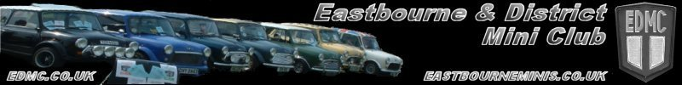

Rolling Road Day 2008 Application Form
Use BLOCK CAPITALS Please

Personal Details
Forename
Surname
Telephone (Home)
Telephone (Mobile)
Email Address
EDMC Membership Number

Car Details
Car Registration
Year
Make (i.e. Austin / Morris / Rover etc.)
Model (i.e. City / Mayfair / Cooper etc)
Colour(s)

Engine Details for use in the Mini World Article
Capacity (cc)
Type (i.e. ‘A’ series)
Air filter, fuel delivery, throttle control
Ignition control (Points/MEMS ECU)
Cylinder Head
Cam/Valve train
Block, crank, piston, oil distribution build
Coolant System
Manifold & exhaust system
Drop gears, gearbox, final drive
Drive shafts, CV, hubs, wheels
Brakes

http://www.edmc.co.uk/ • http://www.eastbourneminis.co.uk/ • http://minigt5.proboards45.com/

