
* EDMC Newsletter *
Winter ‘08
Issue # 23

Long time no see….
And it will be the last one you’ll see from me too. But EDMC needs you!! We need a new newsletter editor for 2009, as well as some other volunteers for committee roles. The AGM is the place to be for your chance to stand for or vote on the committee members, so be there – it’s your club Regards Josie

AGM Agenda
As a pre-meeting invite, see below notes for this year’s AGM agenda, which will be held on Monday 8th December:
- Committee Roles (stand down & vote in)
- Financial review
- Pilgrimage 2009
- 2009 charity picking
- Events for next year

Pilgrimage Pledge
To make EDMC’s Pilgrimage 2009 a bigger event, we need support from members to help organise & raise money for our chosen charity of the year (to be picked at AGM)
Rachel has taken the reigns of the Pilgrimage this year & we can all agree that she did rather well! That does include all those helpers along the way too, so be proud of anything you did towards the event. Next year, we plan to have a bigger & more well known event, of which organisation is already taking place! If you would like to help or have further suggestions & ideas for next years’ event, please speak to Rachel at the club meetings, or e-mail edmcpilgrimage@fsmail.net
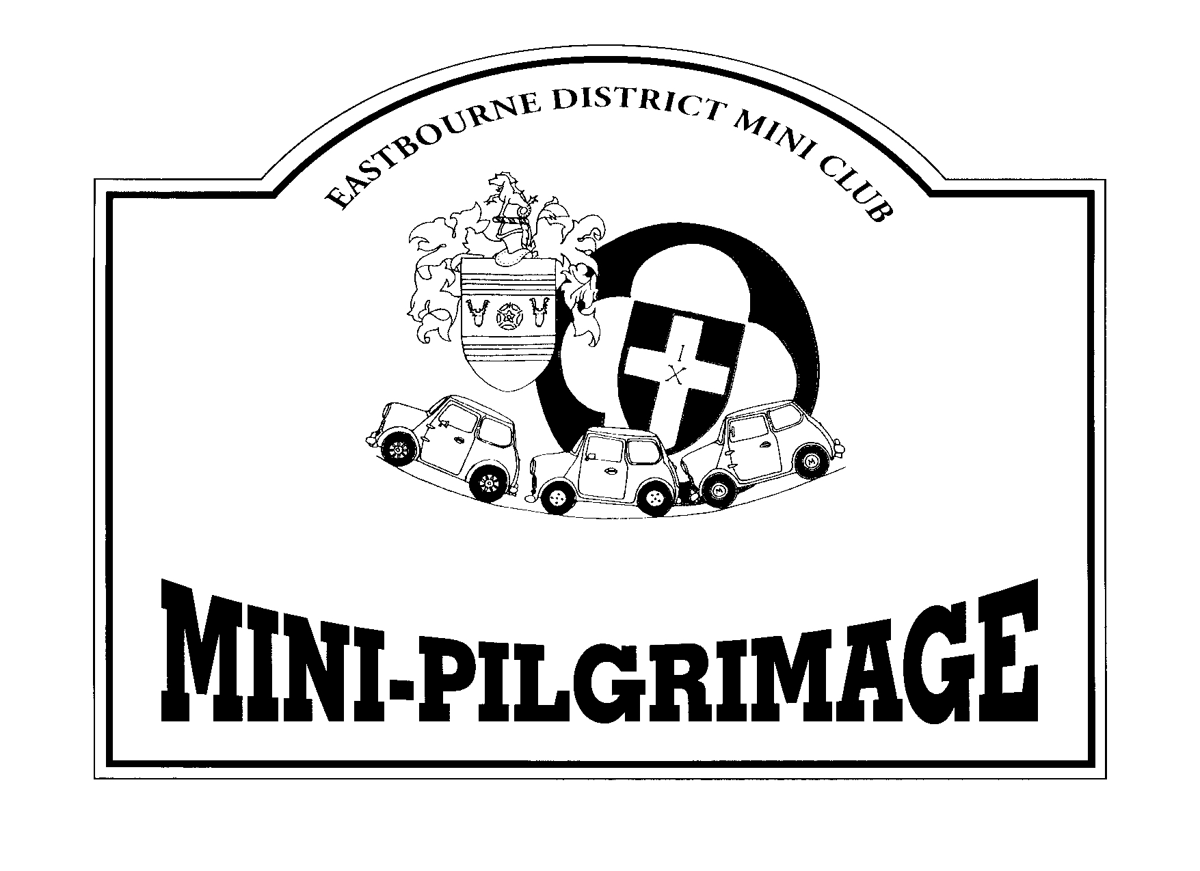

Round The Long Way – Longest Charity Mini Run
Round the UK the long way. Mini owner Stevie Mann is planning to drive his mini round the UK visiting every lifeboat station on the way. This will take part next year to raise money to buy a lifeboat that will be called "mini 1". He is raising money by selling stickers at £1 or £2 each. For more details have a look at his website www.mini-rnli.co.uk. He will be passing along the Sussex coast on Tuesday, 9th October next year & club members are welcome to meet him & accompany him on his journey.

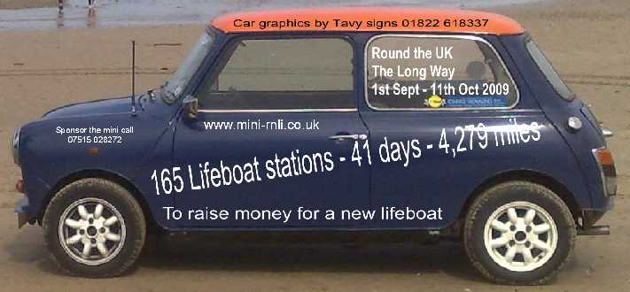

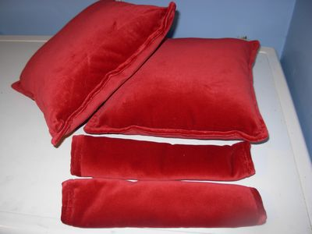
Hand made cushions for your Mini!

Club member Carol Button, is putting her sewing skills to work & offering to make car cushions & seat belt pads for your mini for reasonable prices from £10 (better than show prices!). Speak to her at a club meet or through a committee member to discuss requirements etc.

Though it’s been a hard year financially, mechanically, & personally for some, you can still look back at the 2008 & say that EDMC still know when to have a ball!
Here are some memorable photos from a fun year with EDMC!

We’ve had plenty of good events to enjoy & participate in………

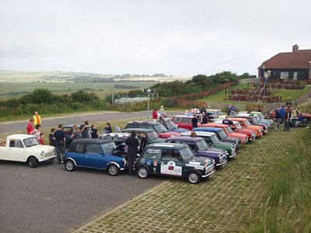

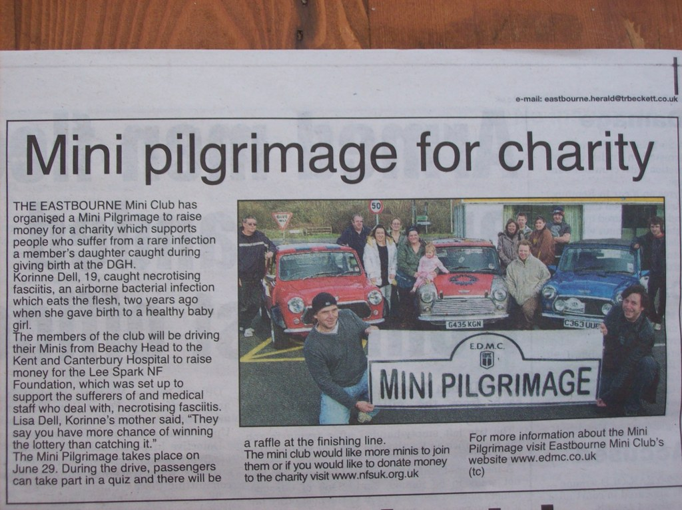
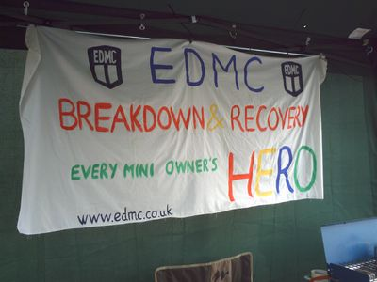
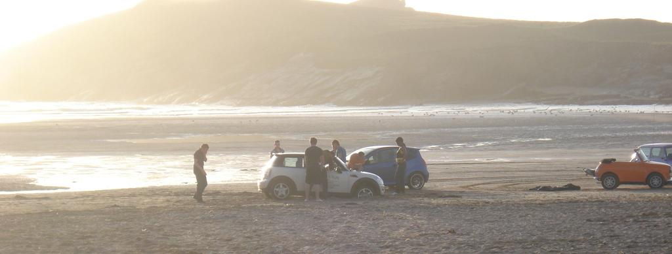
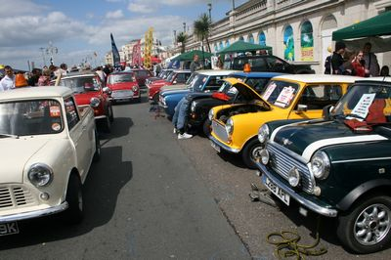
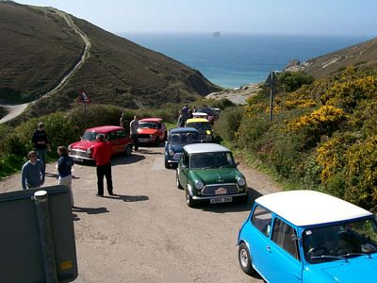
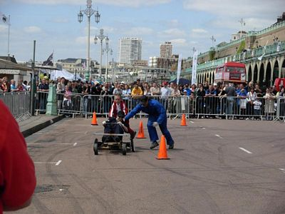
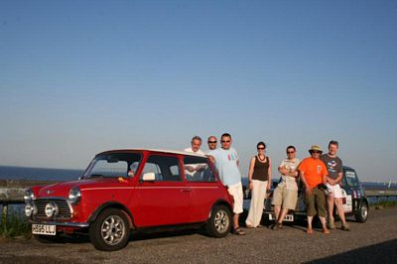

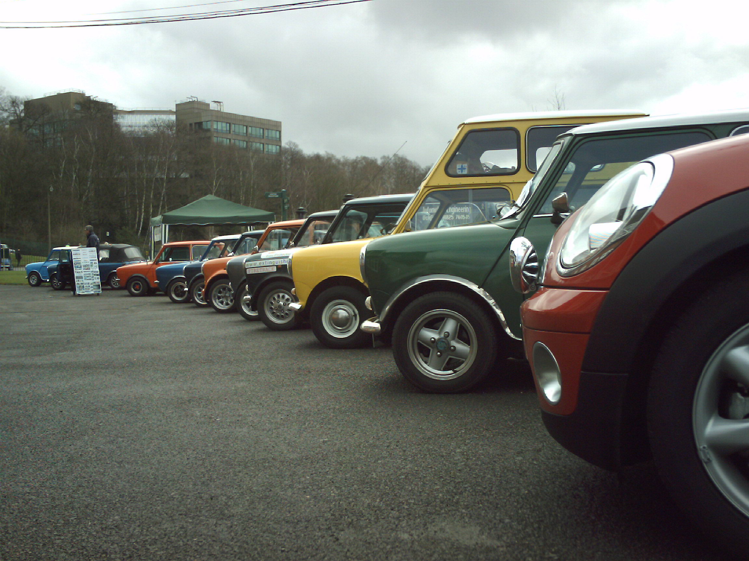
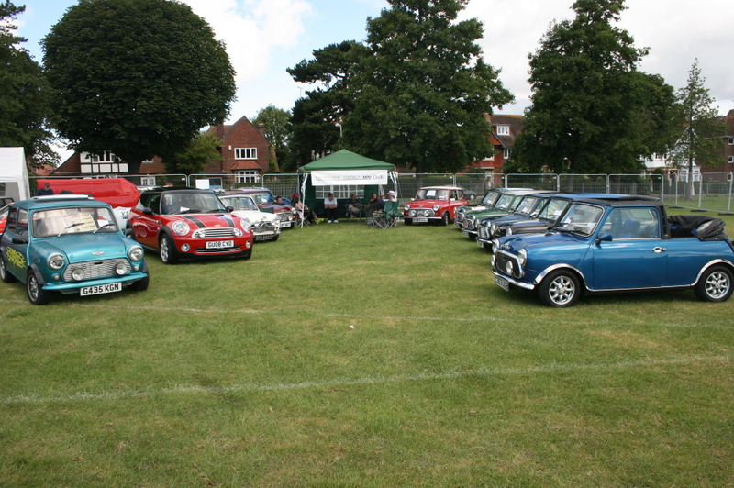
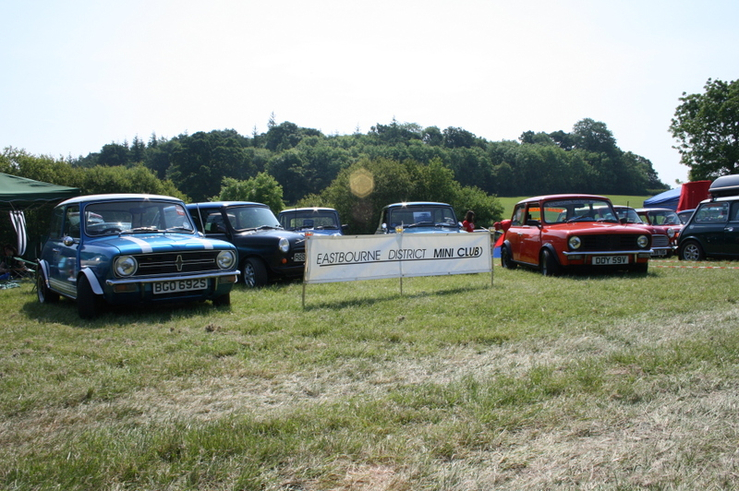
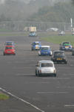
We’ve had good fun with our cars…………………………….
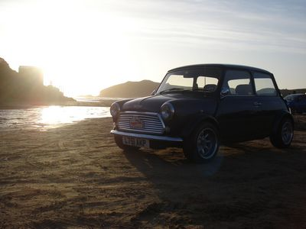
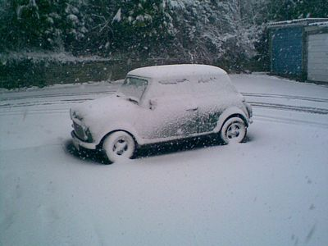
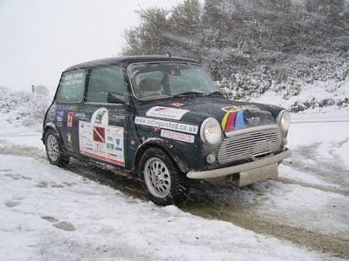


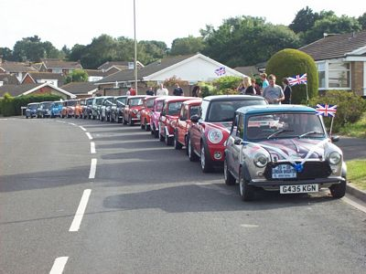

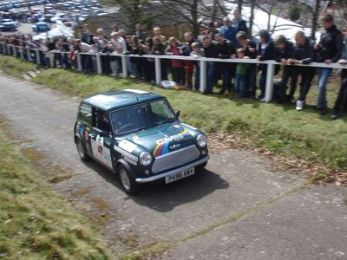

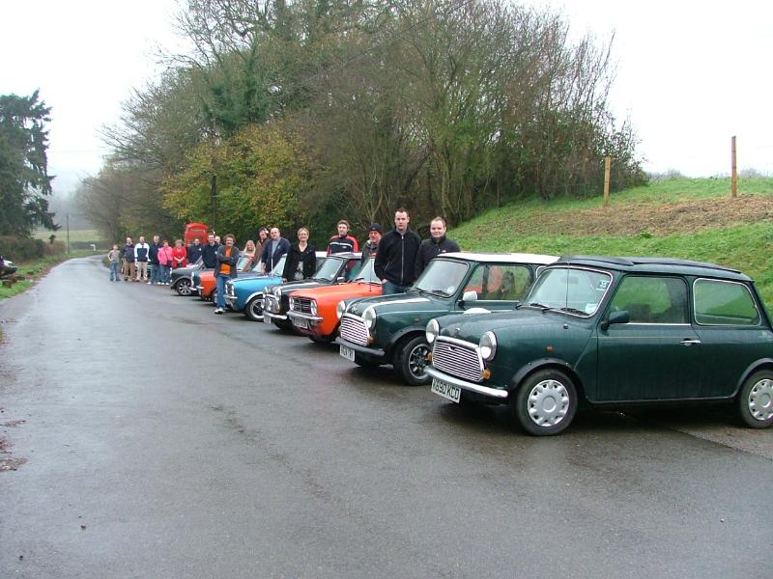

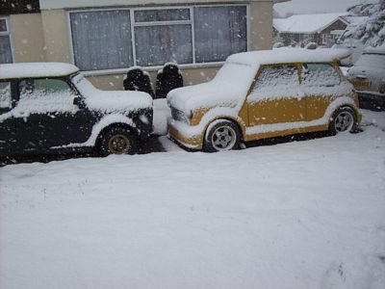
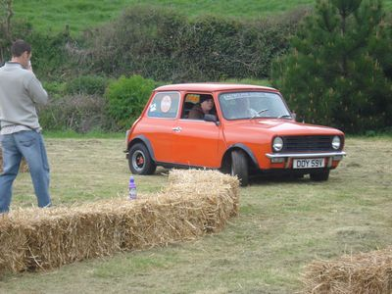

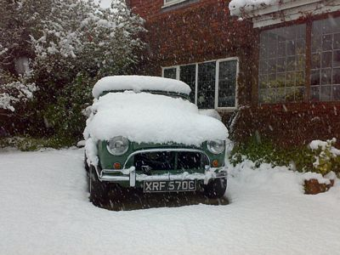
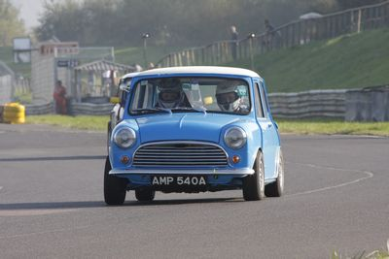

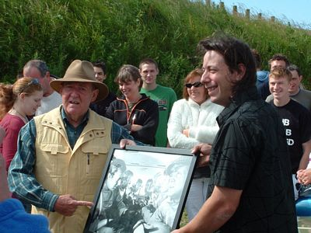
………and we’ve had a good laugh with friends!
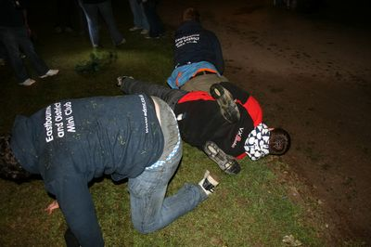
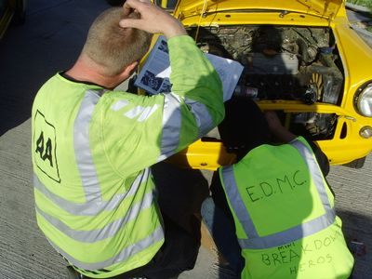

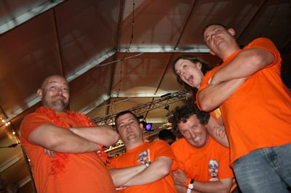
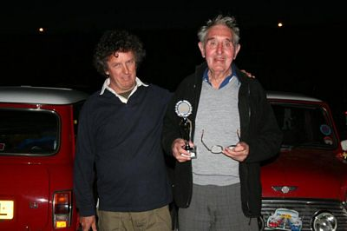


So, give a toast for year just gone, & raise your glasses for the 50th Anniversary year of the Mini – 2009!
Many thanks to all those who put forward their write-ups & photos in the EDMC Newsletter over the past 3 years! Your work has been appreciated, & I hope you will continue your support for the next news Editor, & for EDMC generally! I hope that everyone has enjoyed reading!

Kind Regards & Merry Christmas
Josie - Editor
2009 Diary Planner – Dates for your Diary!

Club Meet nights – 2nd Monday of each month, at Langley Sports Club

29th March - Brooklands Mini Day, Surrey, (www.brooklandsmuseum.com)
3rd/4th May - Magnificant Motors, Eastbourne Seafront
2nd-4th May – Riviera Run, Newquay, Cornwall (www.rivierarun.co.uk)
10th May – British Mini Day, Himley Hall, Dudley
17th May – London to Brighton Run
12th – 14th June – Lakeland Tour, Lake District mini event
14th June – Beaulieu National Mini Cooper Day, New Forest
28th June – EDMC Mini Pilgrimage rally
4th-5th July – Gaydon Mini Festival, Oxfordshire
11th-12th July – British Mini Showdown, Mini only drag racing, Stratford-upon-Avon
7th-9th August – International Mini Meet (IMM), Longbridge, Birmingham (www.imm2009.com)
8th-9th August – Mini 50 UK – Runs alongside IMM at Longbridge. (www.mini50.co.uk)
16th August – Mini in the Park, Santa Pod Raceway,
6th September – Mini’s by the Sea, Worthing
13th September – National Mini Show, Stanford Hall
26th September – Mini World Action Day, Castle Combe Race Track

Ace Café – Mods ‘n’ Mini Nights
1st Jan 2nd Apr 9th July 5th Nov
5th Feb 7th May 6th Aug 3rd Dec
5th Mar 4th June 3rd Sept

Other events to be aware of:
BMC Mini’s on the Wreck – June/July Eastbourne Motor Show - July
Festival of Transport – August Cuckoo Fair – Laughton - May
Southern Mini Days – August Laughton Country Fair – September

