
Changes to the Newsletter
* EDMC Newsletter *
October ‘07
Issue # 18

As you may have guessed, Septembers’ newsletter was ‘postponed’ from the last club meeting.
Firstly; apologies go to those who are not on the EDMC forum & were unaware of the issues arising!
From the recent trials & tribulations, it’s been decided to return to a Bi-monthly letter as when it first started, but in addition to this, information leaflets will be provided in the months between – which will include any important details to event plans or changes that need to be seen before the next Newsletter.
We endeavour to print the latest news & reports for you within reasonable time, however if you wish to see anything different or would like to add in your own reports or news, please let me know! Either catch me at the club meet or e-mail me on the address at the bottom of the page.
We hope that changes to the EDMC Newsletter will not be of any inconvenience & hope to continue giving you what you want!
New Membership
Just a reminder that all new memberships paid for during or after September will be valid to the end of 2008. Also, please note that it’s important to read the Club Constitution as well, which can be available from the EDMC website & at club meetings.

Jim & Shirley’s Rampage!
In the words of the Old Git himself, “REMEMBER LAST YEAR? I DO! LET’S DO IT AGAIN!!”
As the Old Git’s Rampage last year was such a hit, they’ve decided to do it again. The idea is to have a fun day with some great laughs as well as trying to raise some club funds along the way.
The run route will be the same as last year, seeing as everyone seemed to like it so much. Will approximately be a 60 mile round trip starting from Stonecross to Hastings, with two planed stops to regroup, then ending at Jim & Shirley’s place for BBQ, fun & games, & additionally a raffle!
The run starts at 10:30am on Sunday 14th October & will end when you have had enough or get kicked out of the house! If you can’t make the start time you can always meet up with us later on route or at the house.
For those who couldn't make it last year, & new members alike, take a look at gallery 2006 for pictures of day (see Jim's b’day run )
The cost for day will be adults £5, & a small donation for Children. This will include BBQ & wine (any other drinks you want please bring with you). All profits will be going to club funds – so all members will benefit from it in the future!
There will be a raffle so bring along any unwanted but usable mini bits or anything else people might buy a ticket for!
Some games have already been planned, but if you have any other ideas, please let Jim or Shirley know. Remember it’s YOUR CLUB & we want to have fun raising some funds for it.
Please let Jim or Shirley know ASAP if you will be able to make it so they know numbers for catering.
More details will be posted on the forum nearer the date or P.M/talk to Jim for any information.

North Devon Run Result!
EDMC Club member Dez, has annually taken part in the North Devon Run, raising money for the Children’s Hospice South West charity.
Over £35,000 was raised in total, & Dez thanks everyone who sponsored him. In addition, the run also managed to make it into the Guinness book of Records for the longest Mini convoy, with a total of 310 little Minis along a straight stretch of road. Well done to Dez & all of the other Mini owners & cars that took part in the run!

Reminders For Up Coming Events!
Rolling Road – Places still available. Please get your deposits in ASAP to secure your place. See downloadable forms from the main website or speak to Simon (edmcwebeditor@fsmail.net)
Basic Training – If you are interested in this please get your forms in so that lessons can be planned. We are looking at opening it up to Brighton Mini Club as well. For more info please see the EDMC forum link or pervious Newsletters.
Laughton Country Fair –
a sunny day out!
Quotations from club members:
“A nice relaxing family day out at a local show, thanks to Dave for organising the club entry & we all got a mention in the programme! We had a great time, with the usual good company. The kids (large & small) had fun with food, grass & finally water fights!”
“Was an enjoyable day out & made a nice change to look at some other nice classics. Loved the radio controlled tanks ‘n stuff & had great fun playing with the other more playful members! Some grown ups just don’t understand. Mum told me off when she got me home.”
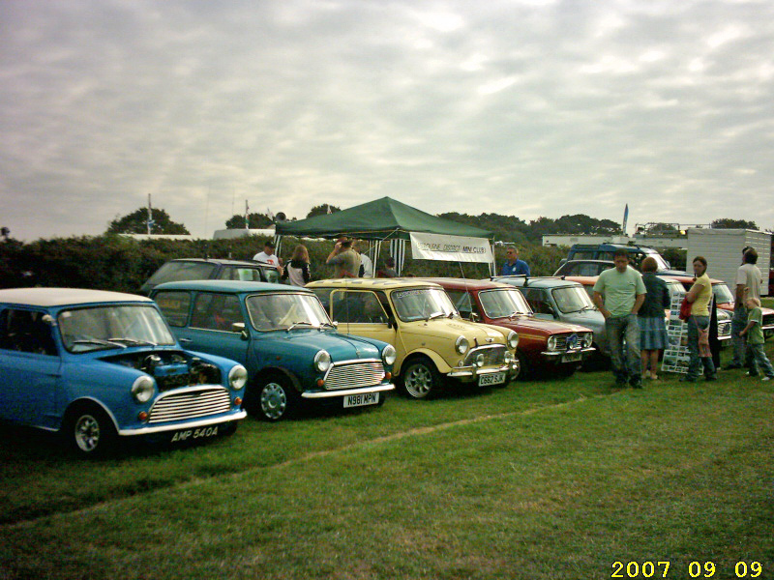
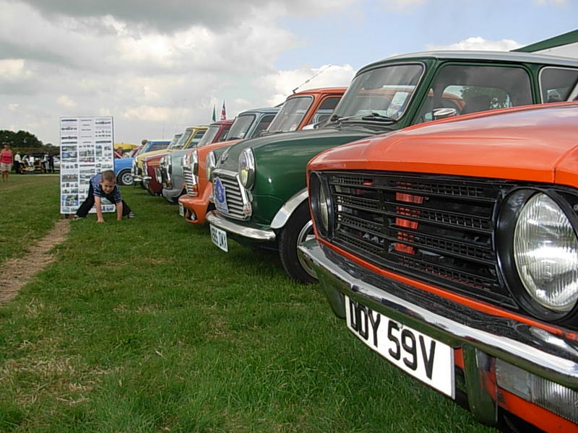

Charity Cruise & Go-Kart: Report
A fun day had by all! With the initial start at Beachy Head, to Scaynes Hill, then Hever Castle, back down to Filching Manor & ending for some good old pub carvery at Pevensey – it was certainly a long day but with non-stop mini fun.
Steve Medhurst lead the day with carefully created run notes in typical Italian Job style. 3 minis started off from Eastbourne, (by passing the 2 closed off roads that wasn’t part of the plan) & by the time we left the ‘Farmers’ in Scaynes Hill, a band of minis from Sussex MOC joined in. Some great country roads were to be had, & the sun stayed out long enough to get a quick beer in at Hever Castle before racing off down south in time for classic Go-Karting at Filching Manor. The group were also privileged to walk amongst the lock-ups of vintage cars, bikes & boats – some of which belonged to the famous Malcolm Campbell. A brief nose around the Manor house itself was also had, before jumping back in the cars for the final leg for some grub!
All in all, a great day out with lots of positive feedback! Well done Steve & Lesley for their hard work put into the day. We hope that there were plenty of donations for the Italian Job charity!
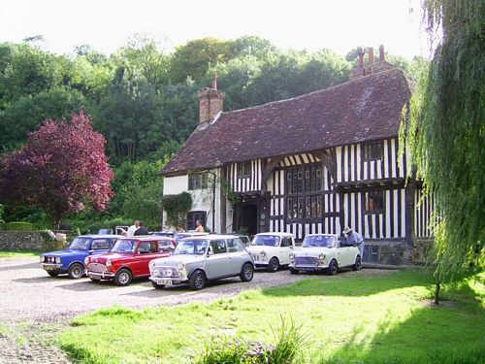
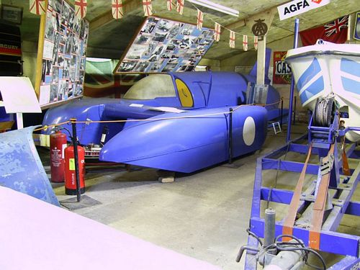

The Lee Sparks NF Foundation - highlighted charity
If you’re wondering what charity to donate to next, spare a thought for the ‘Lee Sparks NF Foundation’ – the UK’s only support group for the sufferers, families & medical staff alike, who have been affected by Severe Streptococal infections or Necrotising Fasciitis (NF).
The term NF comes from the words ‘necrosis’, which means death of a portion of tissue (flesh) & ‘fascia’, the name given to the sheets or bands of fibrous tissue which enclose & connect the muscles. NF is a severe infection involving the soft tissue below the skin, particularly the fascia. It can affect any part of the body but it is most common on the legs.
NF may be caused by a number of bacteria; one of these is Streptococcus pyogenes (also known as Strep. pyogenes or Group A streptococcus). Streptococcal NF is a rare condition, with approximately 1000 reported cases a year in this country – it could happen to anyone, but hardly anyone knows about it!
You’re probably wondering why the random article in our EDMC Newsletter, but it’s closer to home than you think. EDMC members Lisa & Matt’s family have had encounters of NF & the traumas that come with it. After battling with it along with their daughter for so long (see NF – Korinnes’ Story), they have requested if EDMC can make their mark & help raise funds & awareness for the foundation, as it purely relies on charity donations & support in events. Suggestions have already been made to combine fundraising with the Mini Pilgrimage next year. However, if you have any ideas or would like to know more about the subject & the Foundation itself, please visit www.nfsuk.org.uk .

NF – Korinnes’ Story
By Lisa

‘Our daughter Korinne had a baby girl on Wednesday 7th Dec 2005 by c-section, due to complications during labour. Thursday & Friday came round but she was still not feeling well, however, following good blood tests results she was sent home. Over the weekend, she seemed to be coming down with the flu; shivering & then feeling really cold. On the following Monday, the midwife came to see her & noticed a large purple bruise on her c-section wound but thought this was only a result from the operation but as Korinne was feeling ill, she sent her to the doctors where she was given antibiotics for an infection. But on the Tuesday, Korinne took a bad turn; she could not get out of bed, the wound had large purple weeping blisters on it & the smell was something I had never smelt before! They told me at hospital it is like a decomposing body! I rung an ambulance & she went to hospital at 10 in the morning, saw a doctor & was then treated for an outer skin infection. Matt, myself & the new baby stayed with her. At 6.30 that evening, her doctor who performed the c-section came to see her. He had a look at the wound & said ‘this is not right’ then left the room. 5mins later, he came back with 2 other doctors. They also took a look & told us that she needed
to go straight to theatre as she was very ill! We where gob-smacked to be honest!
They had to remove all infected tissue then leave the wound open before having another op the next day to remove anymore infection. She then went into intensive care, with the wound still left open. She was on morphine & very strong antibiotics & it was several days before we knew it had all gone. Korinne then had to have a
‘vac’ fitted in the wound which helped to pump out any infection & also helped new tissue form.
She spent a while in hospital, until she was able to come home (still with the ‘vac’) & nurses had to come in every day to treat her. Eventually the wound got smaller until it closed.
Korinne has now made a good recovery, with her last Op back in Oct 2006, as she had lost most of her stomach muscles. As a result of the infection, she had to have a large piece of mesh put there, as she ended up with a big hernia. If she wants more children, the doctors don’t know if she will be able to carry a baby to full term as they had not come across this before, & with the
mesh they don’t know how much give its got in it so she will have see what happens!
This is supposedly a really rare infection, but if you look on-line at the stories there, loads of people have had it, or sadly have not lived to tell their tale. Korinne is a very lucky woman!’

Worthing Minis by the Sea
A brief account – by Darren
A very relaxing & popular day out by the sea in Worthing! 3 minis & a ‘Punto’ turned up for this local event on 2nd September; with the weather holding out for the whole day, which isn’t the norm for this show!
Whilst I made numerous amounts of trips to the toilet on the promenade with Marc, others wandered around the show ground. Some of us went into town for some grub.
As the day drew to a close, the charity auction kicked off, after what seemed an age until the raffle, & I still didn’t win!!
Anyway, again a very good local show without the hype of a full blown show! We would recommend for next year as a must if you haven’t been before!
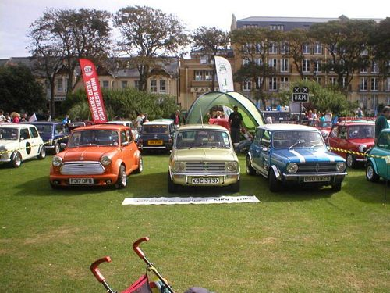

Mini In The Park – Santa Pod!
Account of the day
Interesting show but much like the rest this year; traders & cheap chrome laden cars. Some interesting full spec mini’s & of course a lot of the feature cars from the mini magazine. A good turn out but the heavy rain the day before & a grass venue were a bad combination. The drive there & back in non-stop rain was interesting, but travelling with other members made it all a bit more reassuring. Think Carl had fun with his huge water leak! The show was on par with Glastonbury for mud. It was a bit irritating waiting two hours to wash the wheels & arches of all the mud collected from simply parking in the car park in order to get onto the strip! I took action, finding lots of deep puddles on the hard standing; it was fun flying through the puddles rather than waiting another hour in the queue. We all did our wander round the traders & some good deals were found by all.
But then there was the drag strip!! The jet car was really something. Think we'll be going back for the high fuellers another day. The ‘silly car’ did the ¼ mile in 6 & a bit seconds. The fastest minis were 11 seconds at best! It was great, after getting bored of parked cars & bling, we got to watch the mini's perform! Wow! Some mini's can fly! We watched 'Shed Racing' smash out after a burst coolant hose & a few others came close just after the launch. Some just had too much power & weaved dangerously. I was quietly concerned about a cherished car & driver who went out... but Josie had a ball! She went out against a variety of cars, improving her time, every time. Think she was getting addicted! Josie took her time from 20 something seconds down to 19.6!!
I can't wait until next year; especially to take my car down the strip! But it is a must to go back to at least enjoy Santa Pod itself!
(Report by Simon)
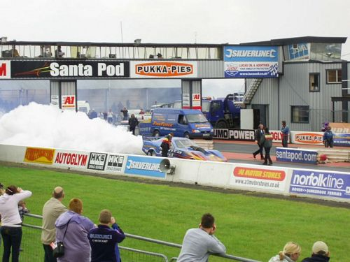
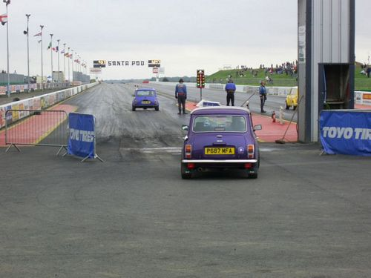
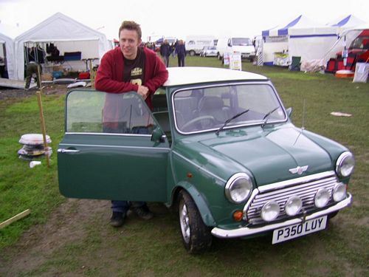
Castle Combe Track day!
(account of the day)
On a cold, damp, autumn morning we gathered at the Newmarket lay-by, at the rarely seen time of 4am, for our long trek to Castle Combe. Dave led the 12 mini convoy through the country roads of Sussex, Hampshire & Wiltshire, giving us a chance to practice our cornering. After a couple of stops to refuel ourselves & our cars, we met up with Sarah & Tom in Devizes. By now there was a steady drizzle & we realised that we were in for a wet day on the track!
We arrived at the race track at 8.30 & were soon parked up in our allocated area. Most of us then made our way to the drivers briefing to receive our instructions & wrist bands.
As time was getting on, we all decided to get our exhausts checked so we would be ready for when our track time came around.
The first 6 drivers from the club to take to the track were Daz in ‘Manky’, Tony, Carl, Paul in the ‘Duckling’, Jim & Josie; with me as co-driver. It was the first time either Josie or I had been on a track & we spent a few nervous minutes giving each other a pep talk whilst waiting for the green light! Josie decided she would take things easy on the first lap, just to get a feel for the conditions & get an understanding of the track layout. She was doing really well until we saw Jim lose grip further round the track & before we knew it, we found ourselves pirouetting across the grass until we came to a halt - looked at each other, checked to see we were both OK, took a deep breath, & then Josie rejoined the track! We spent the rest of the time laughing about what had happened & wondering if anyone had captured the moment on camera.
All too soon it was over, & time to head back to our club stand to exchange stories with others who had been out at the same time. It seems that the wet conditions had made it so slippery that just about everyone had either lost grip or spun off. Luckily there was no damage to either members or their Minis.
Following a quick drink & change of car, Josie became my co-driver & we joined Dave, Simon, Des, Shawn & John for the second of the club’s sessions. The rain had eased a bit, but the track was still wet. I was determined not to spin off & didn’t care if I was to be the slowest car on the track; I just wanted to enjoy myself! The moment we joined the track Dave sped past us & we followed Des round for a couple of laps before finding a suitable moment to overtake. I soon realised that I was far too slow to be able to catch or overtake any of the other drivers, so I settled down to enjoy the drive, & we had a bit of a girlie giggle too! My dream of not getting lapped by any club member was shattered almost at the end as Dave, with Al as co-driver, sped past me for a second time.
It was then back to the stand again to hear of others stories & mishaps. Simon & Paul in the ‘Duckling’ probably spent more time off the track than any other member judging by the amount of grass he collected & the warning Yellow Card!
The afternoon was spent shopping, eating, drinking & taking part in the slow cruise & the slightly faster parade laps.
Late afternoon, we wearily started to head home. It was difficult staying together through the towns & eventually the convoy got split up into two groups, with Jim going on a solo tour of the A27. Most of us eventually joined up again along the A23 before stopping for a final re-fuelling & goodbyes.
It was a very long & tiring day, but probably the most fun I have ever had in a mini! Really, really can’t wait till next year!
(By Rachel Cornell )
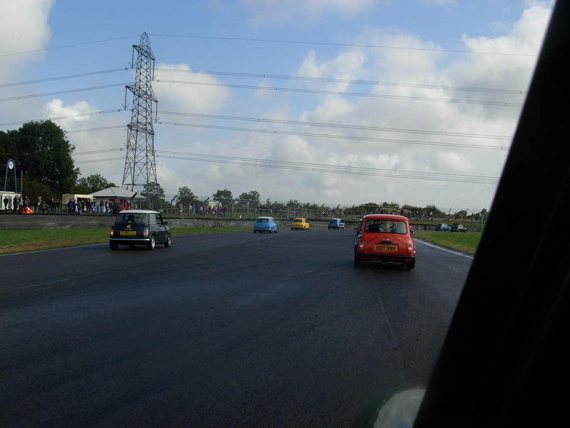
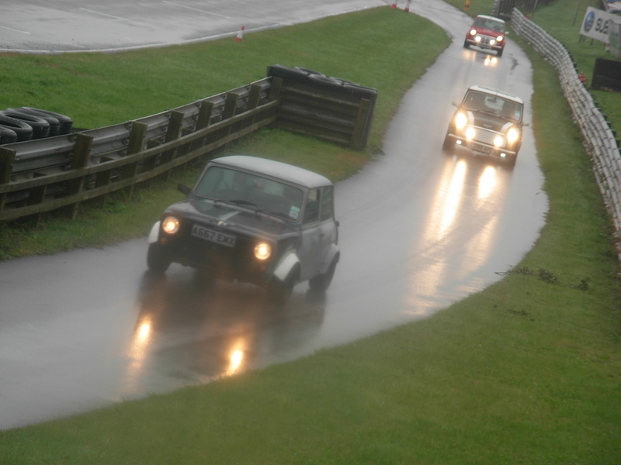
FOR SALE

Mk1 Mini Pick-up for restoration – See/speak to Dave for more details or viewings.

Standing Down
Sadly, Dave has decided to stand down from his role as Events Co-ordinator this year due to other commitments. Rachel will also be standing down from the Secretary role as of Decembers AGM, in order to allow other members the opportunity to be involved.
On behalf of all club members, we would like to say that Dave & Rachel have both done wonderful jobs over the past couple of years for EDMC & we all appreciate the work & time they have both put into the roles.
As there are no other big events happening after the end of September, & a new events co-ordinator will be elected/ volunteered at the December AGM. In the mean time, please forward any events enquiries to Daz at edmcboss@fsmail.net or
edmceventsco-ordinator@fsmail.net, also please continue to forward any enquires to the secretary via edmcsecretary@fsmail.net

In addition to this, Simon has also expressed that he will be stepping aside from the Web Editor position in December, in order to pursue another role within the committee, but will offer training & services for the next Web Editor, including a copy of the ‘Dream Weaver’ software used to run the Website.

As we approach the AGM in December, full details will be produced explaining the job roles of the committee in order for those wishing to stand to get a better idea of what is involved. If you have any questions, have a chat to a current Committee member.

Rachel’s Rally
Rachel is currently organising a Rally as part of her day job’s fundraising events at the Co-op, & decided that EDMC members can take part too!
The rally takes place on Sunday, 28th October starting in Eastbourne at 10am. The finish is approximately 3 hours later in Winchelsea, where a BBQ lunch will be available for a small cost.
The aim of the rally is to start at her Co-op shop in Framfield Way, Eastbourne & end at the Co-op in Winchelsea, visiting 12 other stores in between.
Sound easy?? Depends how you get there!
This will be a rally, not a race & details of the stores to be visited will be available to those wishing to take part in advance so they can plan their route. All stores need to be visited, but the order you choose is up to you!
You will be given a form at the start, which needs to be stamped at each store & a till receipt attached to show the approximate time of visit...please note though that you will NOT need to make a purchase to receive a receipt.
There is an entry fee of £1 per person, which will be donated to the Co-op's charity of the year; The Children's Society.
Prizes will be awarded to the first team to finish, the last team to finish & "best dressed car".
Teams are also asked to bring an item up to £5 in value to be raffled at the end of the rally.
There are NO ADVANTAGES in being a Co-op employee as they don’t necessarily know exactly where all the stores are either! Plus, you don’t have to do it in a Mini, so any car can take part!
If you are interested in taking part, please let Rachel know so she can forward you more details.

Stop!! Press!!
In relation to the Eastbourne & RAM club, on the 31st of October is a Navigational Training evening held at the Langney Sports club from 8pm. This is in preparation of the 12 car Rally that the ERMC will be organising, which starts on the 11th November at 6.30pm at ‘The Horseshoe’ in Windmill Hill. The next 12 car rally will be held on 25th November, (start time TBA). For more information, please visit the ERMC website or get in touch with Simon.
Paul & Simon from EDMC are hoping to take part after their previous success in the ERMC regularity trial recently, & hope that other EDMC members will join them!

