

‘Mini-News Feed’

Hi there! Welcome to our first issue of ‘Mini-News Feed’, our new Daughter issue of the EDMC Newsletter!

This month, we’d like to highlight a few items.

12th November Club night meeting will be welcoming a special guest for the evening in the form of A.C Dodd, from ML Motor Sport, who will be chatting to us in a questions and answers session for the evening. Similarly to last year, Adrian will endeavour to answer your burning technical questions on engines, gear boxes, suspension and modifications, (amongst other things), with the help of diagrams etc. Lots of members will agree it was a useful and interesting session last time, and we are happy that Adrian can attend once again!

Also at the next Club meeting prior to the tech talk, we will be briefly discussing news on the Mini Pilgrimage 2008 plans, Committee role Job descriptions, and plans for the AGM in December.

End of Season do/ Xmas party:

From discussions throughout the year, instead of setting a Christmas party that’s likely to clash with our generally working day dos, an ‘End Of Season’ gathering has been set for Saturday 24th November. This will be held at the Polegate Community Centre, of which Club funds are able to cover hiring of the hall. All kids; old and young are welcome!

Soft drinks will be provided for free, but you can bring any drinks along with you; alcoholic or not, or drinks can be brought at the Windsor Club bar just along the corridor!
For food, the plans are to do a ‘bring along a plate’ buffet, of which Rachel has prepared a list of items that people can chose to contribute (and so we don’t end up all bringing sausage rolls!)

Apart from this, there are no other contributions to be made – except for your attendance and generally party spirit! The party starts at 7.30pm!
In addition – there will also be a small ‘Awards Ceremony’ for those who have done something ‘out of the usual’ for 2007, or have just been unlucky with their Minis!
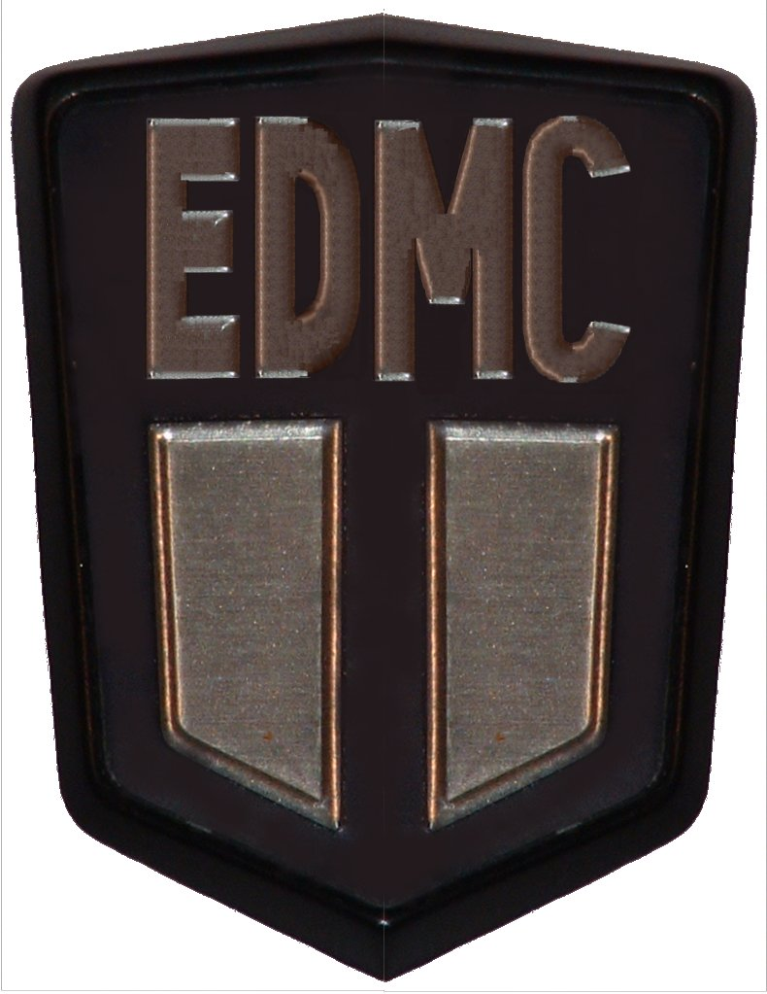
More information will be given at the club meet, or check out the Forum for further updates!

