
Those cold starts & winter frosts!
* EDMC Newsletter *
Brrrr!! Certainly getting colder as winter draws closer, which means so is Christmas! Most of us will be searching for winter storage for our pride & joys; hibernating, ready to appear in the spring for a fresh mini year! But nothing rests for the members of EDMC, as plans are being made & ideas clubbed together for what’s to come in the present & future! Regards, Josie.

EDMC AGM – 11th December
As previously mentioned in the last newsletter, the Club’s Annual General Meeting will be held at The Pubb, on 11th December at the usual Monday meeting time. If you have any ideas, comments and/or suggestions, (including ways to fundraise for club funds) please pass them to Daz or another committee member prior to the AGM, so it can be added to the agenda for the evening.
Additionally, on Monday 27, for those members who wishes to actively contribute to the running of the club or has creative ideas to take the club forward again next year, can attend a ‘brainstorming’ session, prior to the AGM. This session will help with pitching big ideas and also build towards the agenda for the AGM

Riviera Run 2007 – Plans part 1
As 2006 was a great roller coaster of a weekend for some EDMC members, plans are being made for MiniWorlds’ ‘Riviera Run’ in Newquay.
Dates are confirmed as the 5-7th May Bank Holiday weekend. However, general feeling is that for those who are intending to attend this event, will be leaving on possibly late Thursday (3rd) or early Friday (4th), in order to get as much out of the trip as possible, of which plans are still being discussed. Accommodation will be at the Trevelgue campsite, which will be booked prior. More details will be appearing very soon as I will keep you up to date, but also keep your eye on the forum under events!
For more information about the event, contact Dave at edmceventsco-ordinator@fsmail.net, on the forum or catch him at the Club meet.
Rolling Road – 2nd December
November ‘06
Issue No. 9
Places are all taken for the Dyno power run, taking place at Gerald Dale Motor Sport. This event will be featured in the Miniworld Magazine with 'Monty Watkins' in attendance.
See Geralds web site (www.geralddale.co.uk) & click on 'contact us' for the location. This will be an all day event. The club photo shoot for the article will be at 11:00, but other photos will be taken throughout the day. The dyno run will be ten/fifteen minutes on the rollers (30minutes including set-up time) job. This will take our cars through the rpm range to record the power (Bhp) and acceleration (Torque). The rpm will not exceed normal driving or your requested level.
October ‘06
Issue # 8
This is our 1st big feature in the Mini World magazine, so please feel free to drop in at 11ish to join in the photo.

Potential EDMC Lottery?
As part of the plan to help raise club funds, Daz has the idea of setting up our own EDMC Lottery Draw. This subject is yet to be discussed thoroughly during the November meet, but the basic idea is as follows: Each month, 3-4 random numbers are drawn using a random generator ‘calculator’ via the forum; of which only the website admin staff can access. (You may have already noticed these displayed in the Club Forum) Rest assured, these numbers are TRULY random generated! Members can choose combinations of either 3 or 4 numbers (just like the National Lotto) between 1 & 10, and pay £1 per row. You can play as many rows as you like. The money goes into a ‘kitty’ & each month the numbers can be drawn/generated at the club meetings. Whoever matches the winning numbers will receive a percentage of the ‘kitty’, the other percentage going towards the club funds to help with purchasing insurance and other potential club projects (i.e. club stands, memorabilia etc. ) If there is no winner, it will be a rollover! As previously mentioned, this idea is still in discussion, but if you would like to ask questions or provide ideas or support etc, please contact Daz, alternately, raise them at the meeting or on the forum.

Beverage & Chocolate Shop!
Shawn (MiniHaven) has come up with a plan… crossing the water to France / Belgium via the ferry from Dover to pick up some ‘cheap’ Christmas shopping, or just goodies for the home! The idea is to travel into Belgium, as well as France, for the stocking up of foods and wines for Christmas on the Saturday. Then, the group stops over for the night in a B&B/Formula 1 hotel place (booked prior to the trip) to then go out & enjoy an evening in respected company. The next day, get packed up & brekkie fed, spend some time sightseeing or more shopping, then jump on ferry for return journey home with a car packed with goodies!
If you are interested in this ‘Mini Adventure’ expedition & would like to know more, please contact Shawn via the forum, or have a chat to him at the Club meet.

Xmas party!
Just to remind you all that the Club’s joint Christmas party & Birthday celebrations is happening on the 9th December at ‘The Junction’ in Polegate, starting at 7.30pm. Rachel needs to know numbers within the next couple of weeks (by the end of November) in order to obtain food for catering. She assures everyone that the food won’t be your normal buffet vol-a-vons & quiche! The more the merrier & all kids are very welcome!

‘Club Expo’, 25th November
The ‘Club Expo’, held at the Heritage Motor Centre, Gaydon, is the UK's only show for voluntary membership clubs & groups. It includes seminars & an exhibition, giving club organisers an opportunity to meet with potential suppliers, representatives from first-aid & ambulance services, gain advice about health & safety, membership management & more. Already, 3 committee members will be attending the event, but if you are also interested in going, tickets cost £15.50, which includes lunch & museum entry. Please let Daz know at the November meeting if you are interested, so he can book tickets.
Alternately, if any member has anything that they would like the committee members to research about, please detail ideas & comments & pass them to Daz (Chairman), Rachel (Club Secretary) or Dave (Events Co-ordinator)
Subjects already to be researched include t-shirts, stickers, insurance & fundraising ideas.

Back in Blighty!
Neil, our club Website editor, has finally returned back in the country after been away in Singapore for the last 4-5 months working! He has regretfully missed out on a lot of the Club’s events & fun, but hopefully his re-payment for being away at work will help him towards another Mini! (as you would expect!)
Welcome Home Neil! 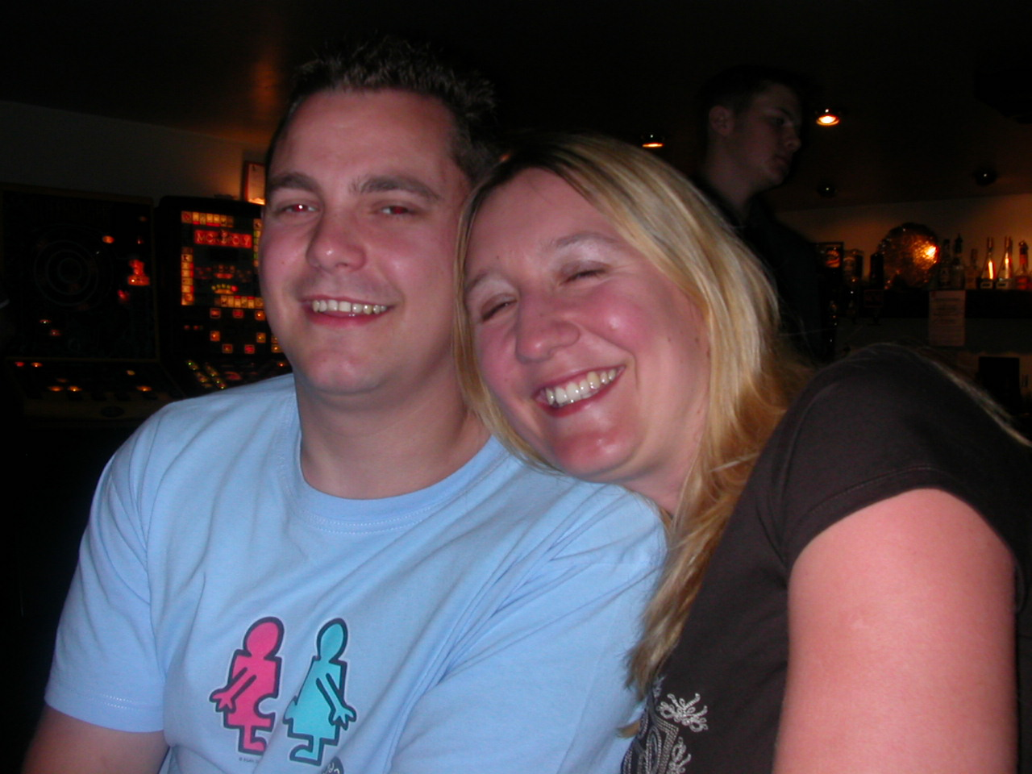

Jim ‘Old Git’ Rampage Run!
For Jim’s 50th, he kindly put on a great mini run with a few surprises…some he didn’t know about himself! Around 20 cars turned up to celebrate & we were awarded with special plaques for the day! Here are a few photos to rekindle the memory, in case you needed it Jim!!
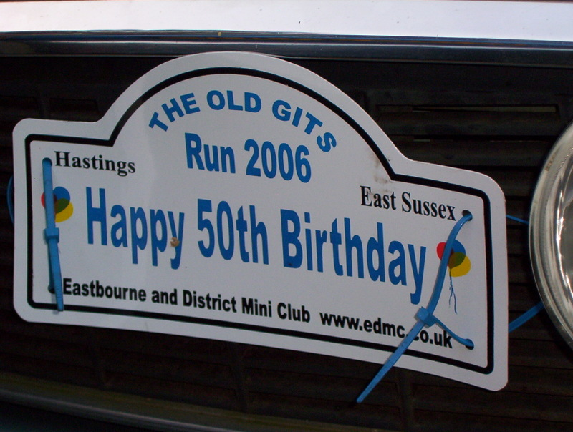
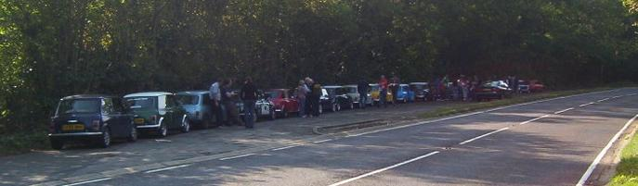
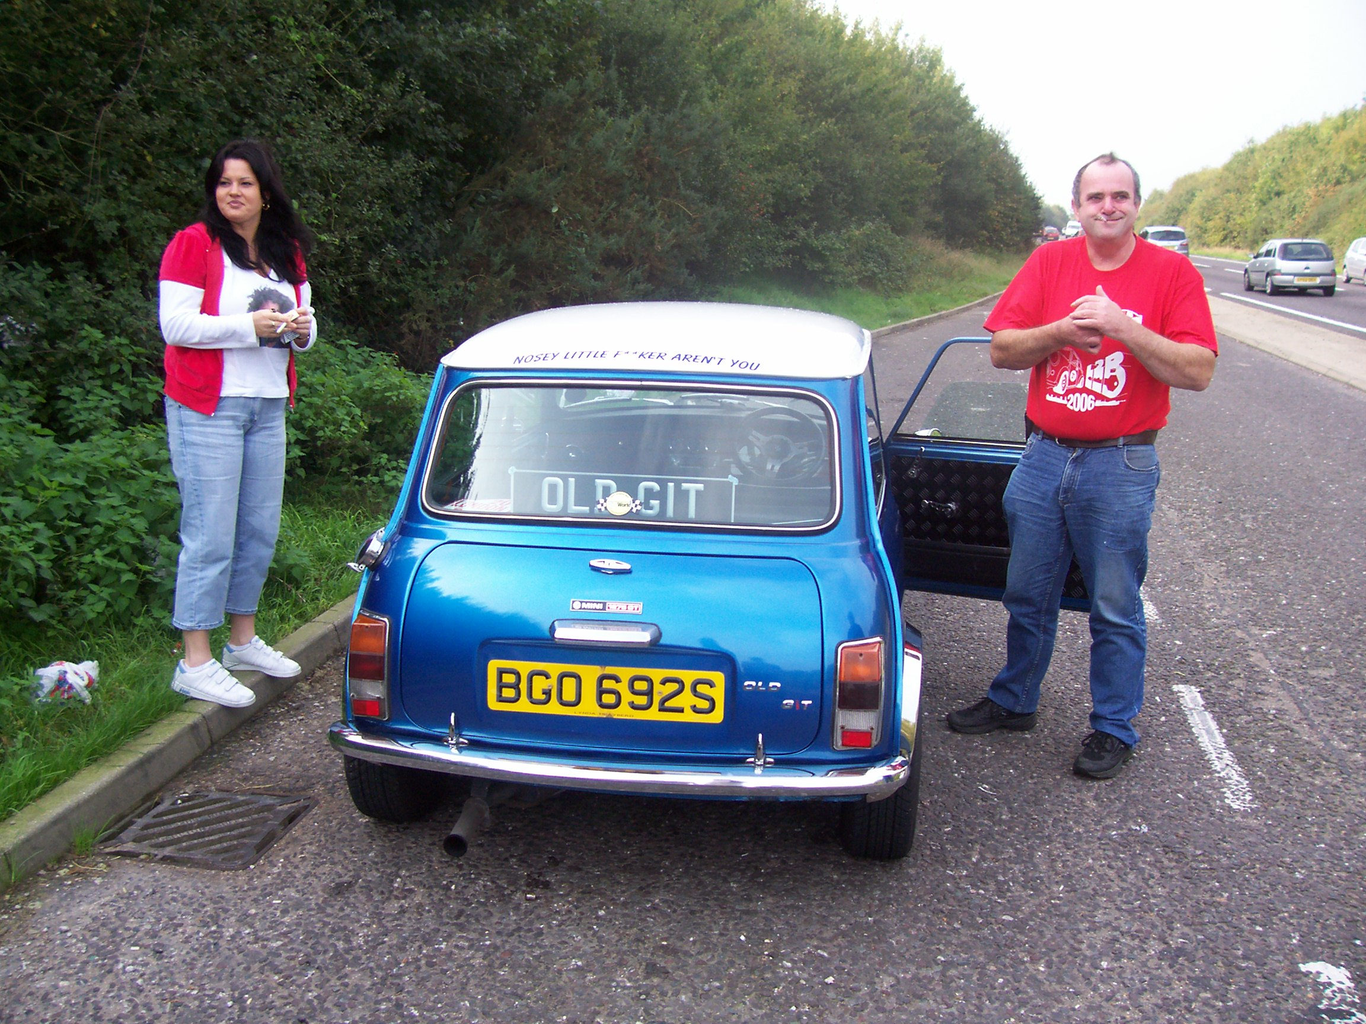

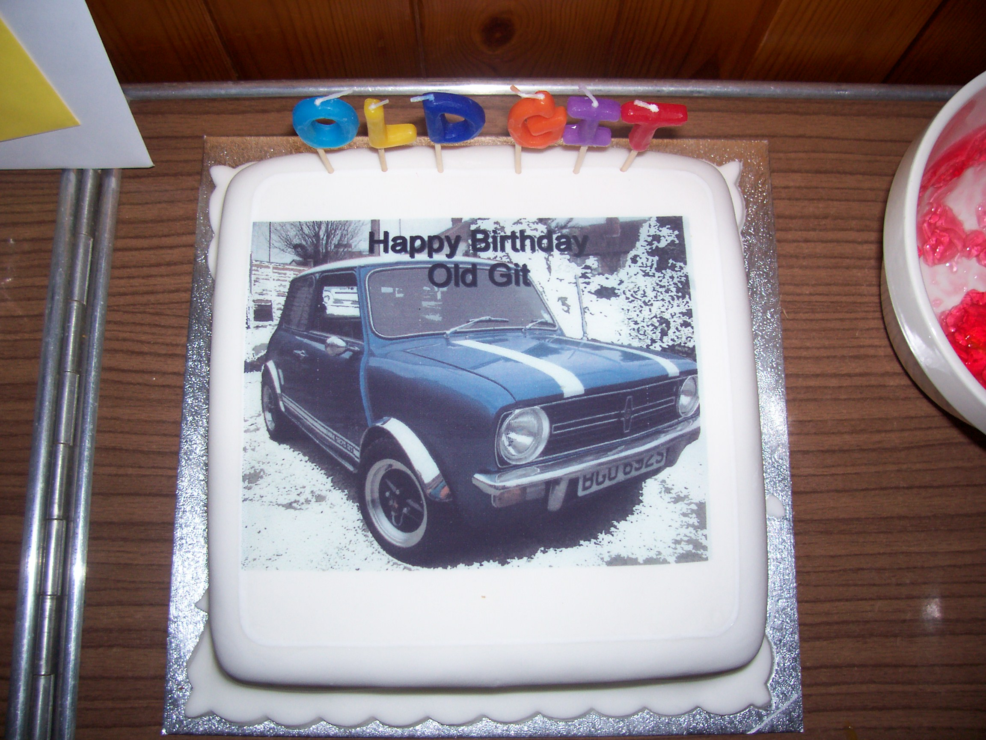

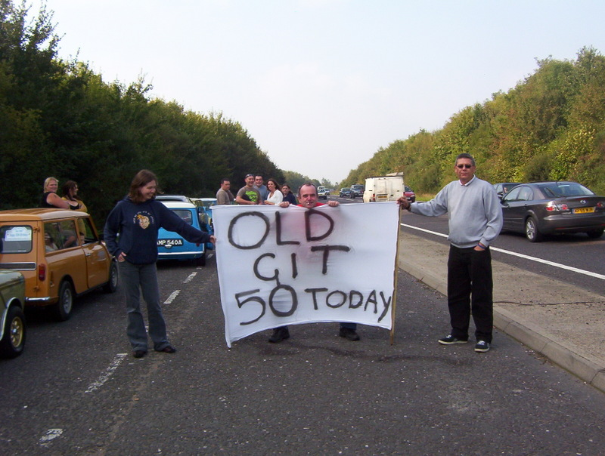

“If you would like to tell your story of a mini event or want to add your views on anything, please send your subject& write up to the contact details on the bottom of the page – Thanks”
Next Month……
Christmas Special Issue!!!

Insurance prices
The following article has been passed for your interests:

WANT TO BEAT THE CAR INSURANCE PRICE RISES? Talk to a broker.

The direct insurers use standard computer data to base their car insurance quotes on. Their staff can't usually move from the 'screen rate', however happy they'd like to quote you. The problem can be exacerbated by overseas call centres, where staff may have even less leeway. On the other hand, these same big companies sometimes offer loss-leaders to get business. Eventually, though, they have to put prices back up - just like Norwich Union did recently.
So where do you go to get a better deal, if you can't find anyone offering loss-leader premiums? Ideally you need to talk to someone who can give you cheaper insurance if you can persuade them you deserve it. …….In other words, talk to a broker.
Gerry Bucke works for car specialist Adrian Flux Insurance. "If a broker thinks you're a lower-than-standard risk, they can quote a lower-than-standard rate - so they can get you a cheaper deal than the direct insurers," he says.
It's all down to the broker and their relationship with their underwriters, who actually provide your insurance cover. If the underwriters trust the broker, they may offer them a 'delegated-authority' scheme. Basically it means the underwriter is happy for the broker to use their knowledge and judgement to offer a lower premium, provided the broker thinks you deserve it.
"This is especially true for specialist brokers, since they will know their particular market very well," says Gerry Bucke. "There are brokers who specialise in various vehicle types, such as 4x4s or performance cars, and those who look after types of people - women, over 50s, convicted drivers and so on.
"In these cases, a broker can get you a better deal than the direct insurer."
There are all sorts of ways to prove you are a lower-than-standard risk, from parking in a garage every night to belonging to a car owners' club. Showing you're a dependable citizen can help - for example, Flux offers discounts to motor bikers who take an 'Emergency Aid For Bikers' course.
"Any broker will try to beat whatever quotes you've already been given," says Gerry Bucke. "All you have to do is give them the ammunition to cut the premium down."
Adrian Flux has a huge range of policies for the motoring enthusiast. For details contact the Adrian Flux quote line on 0800 505 3000, email the company at quotes@adrianflux.co.uk, or see the Flux homepage on www.adrianflux.co.uk

