

We kick started the show season on March 28th with a trip up to Brooklands motor museum. We all gathered at our regular meeting point at the newmarket layby and started our convoy up there. Our journey went well with only 1 break down.
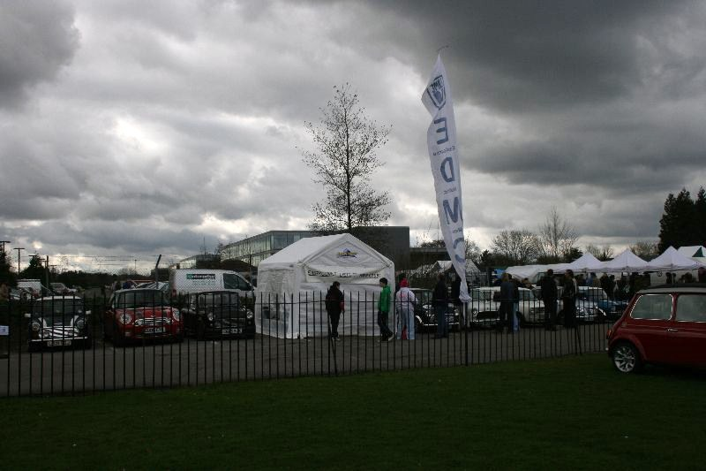

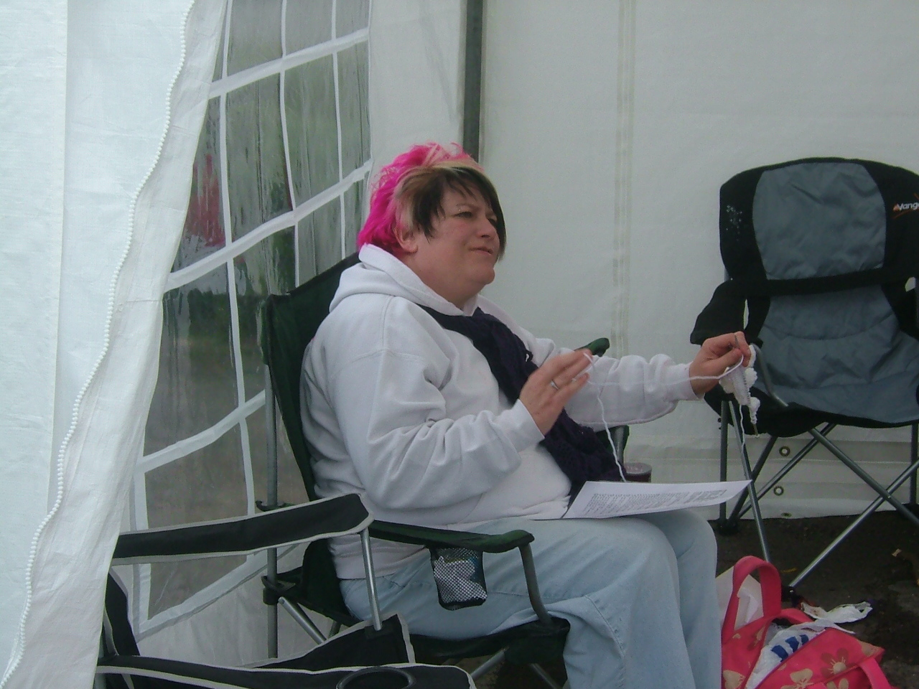
We arrived and got our spot for our club stand and erected the new tent. There were many minis there and a few trade stands but regrettably it was not as big as last year. We littered as many minis as we could with flyers to promote our pilgrimage run

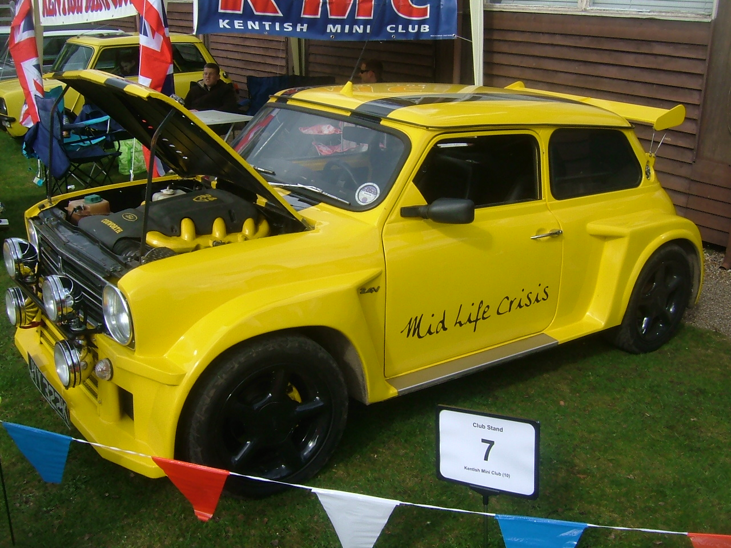

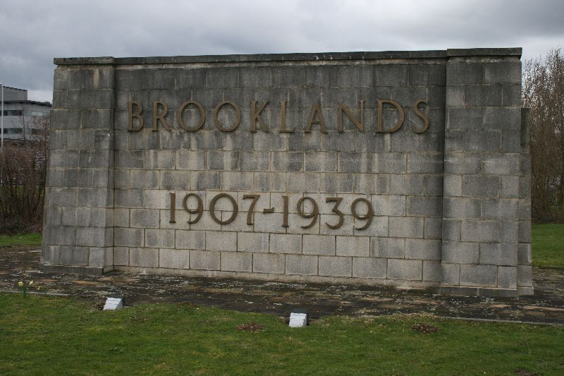

Here is a picture of a modified mini at brooklands with a cosworth engine that was abit disappointing on the hill run

As the were not many trade stands to go around we all found others was to amuse ourselves. Including Tony and his rust repairs

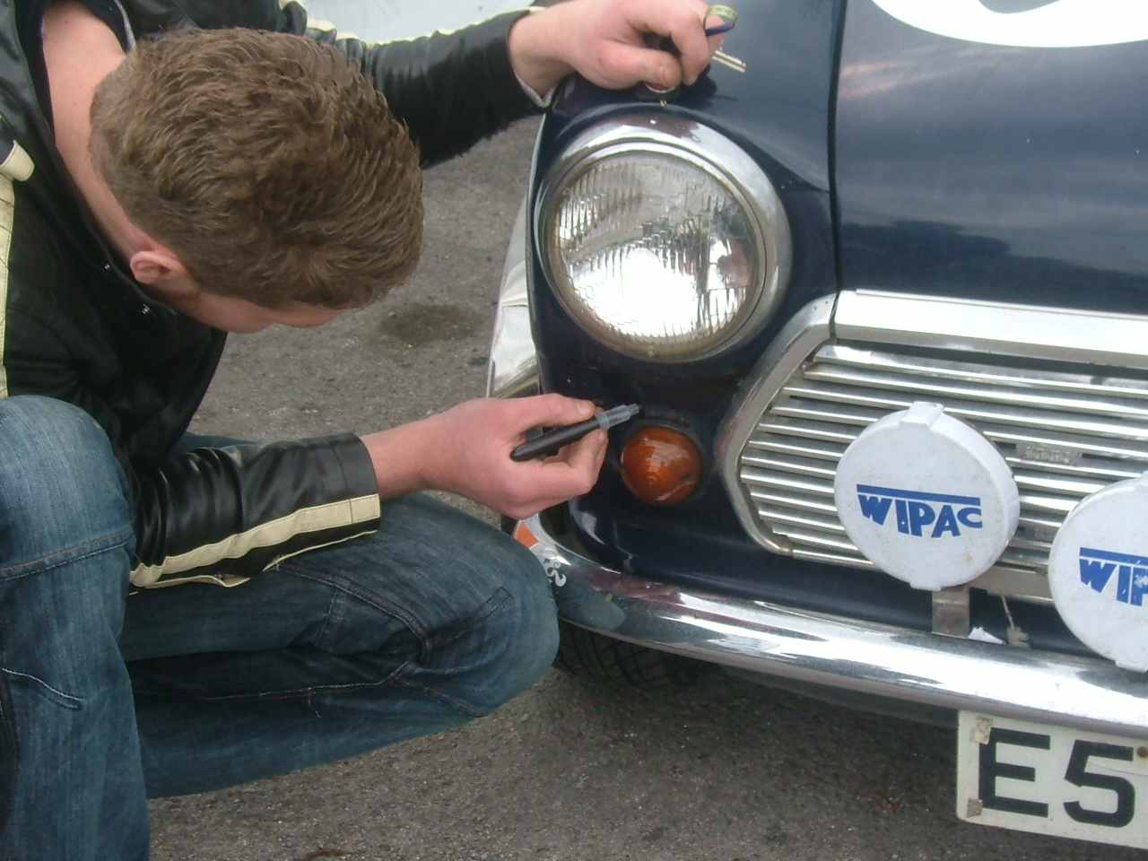

And Lisa with her knitting.

Although the weather was cast over and it was a bit smaller than the previous year I think a good day was had by all.

Easter monday run

A few minis went on this trip but unfortunately not as many as we had hoped for. The run started at about 11.30 and took everyone one on some nice roads with a bit of a laugh on a hairpin as a few had to reverse to get round it.
The run also took the minis through some water which unfortunately caused a few problems
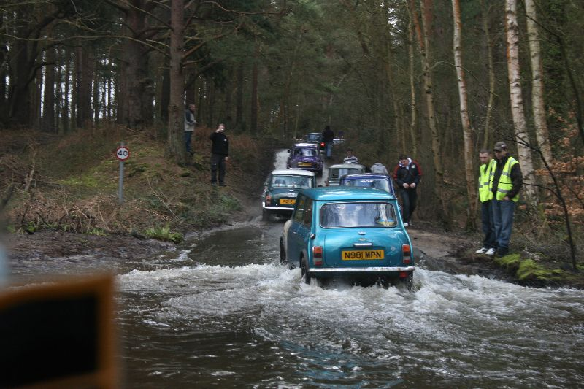

The run was not even halfway though when they stopped for lunch at about 2.30 so unfortunately the minis that went had to call it a day as by the time the run would have finished it would have been about 6pm and with prize giving and the journey home it would have been a very long and late day.

Riv run
1st-3rd may
It’s a great show, cheap for the whole weekend, and the tin mine is one not to miss
We will meet up for the start of The 2010 EDMC Riviera Run at the Newmarket Pub layby on the westbound A27 just past Lewes.
Meeting time 4.15am
leaving time 4.30am
Travelogues post code for those with a Sat Nav is TR8 4AS .
Speak to Dave if you have any questions

Magnificent motors

Saturday 1st & Sunday 2nd may
this a nice local Eastbourne show it’s free and if you not attending riv run this is a nice alternative.
Please see event organizers for details

EDMC Arndale Centre takeover - 12/13th June

As part of our fundraising for charity, as well as spreading the awareness of EDMC & it’s Pilgrimage run, we are booked for a 2 day stint within Eastbournes’ main shopping centre; where we can have 3 cars on display.

We are looking for some ideas & volunteers for these dates at the Arndale in order to do the following:
- Raise awareness of CWCF (leaflets available)
- Raise awareness of EDMC (applications forms available)
- Advertise the 5th Pilgrimage & encourage people to join the run including giving out leaflets & talking to Joe public
- Collect donations
- Help run the "sign the mini for a £" project (still TBC)
- Generally helping out!
The plan is to have 3 minis there:
1x BMW
1x chequered mini for ‘sign the mini’ project
1x other classic
Still to be confirmed though, is whether the cars have to be there for the duration of the two days. Keep an eye on the forum for further information. If we have enough volunteers - we could do a shift pattern for those who may not be able to do the whole day.
If you wish, please feel free to put yourselves forward for volunteering your body or car, & whether you can do Saturday or Sunday or both. Thank you.

Pilgrimage News
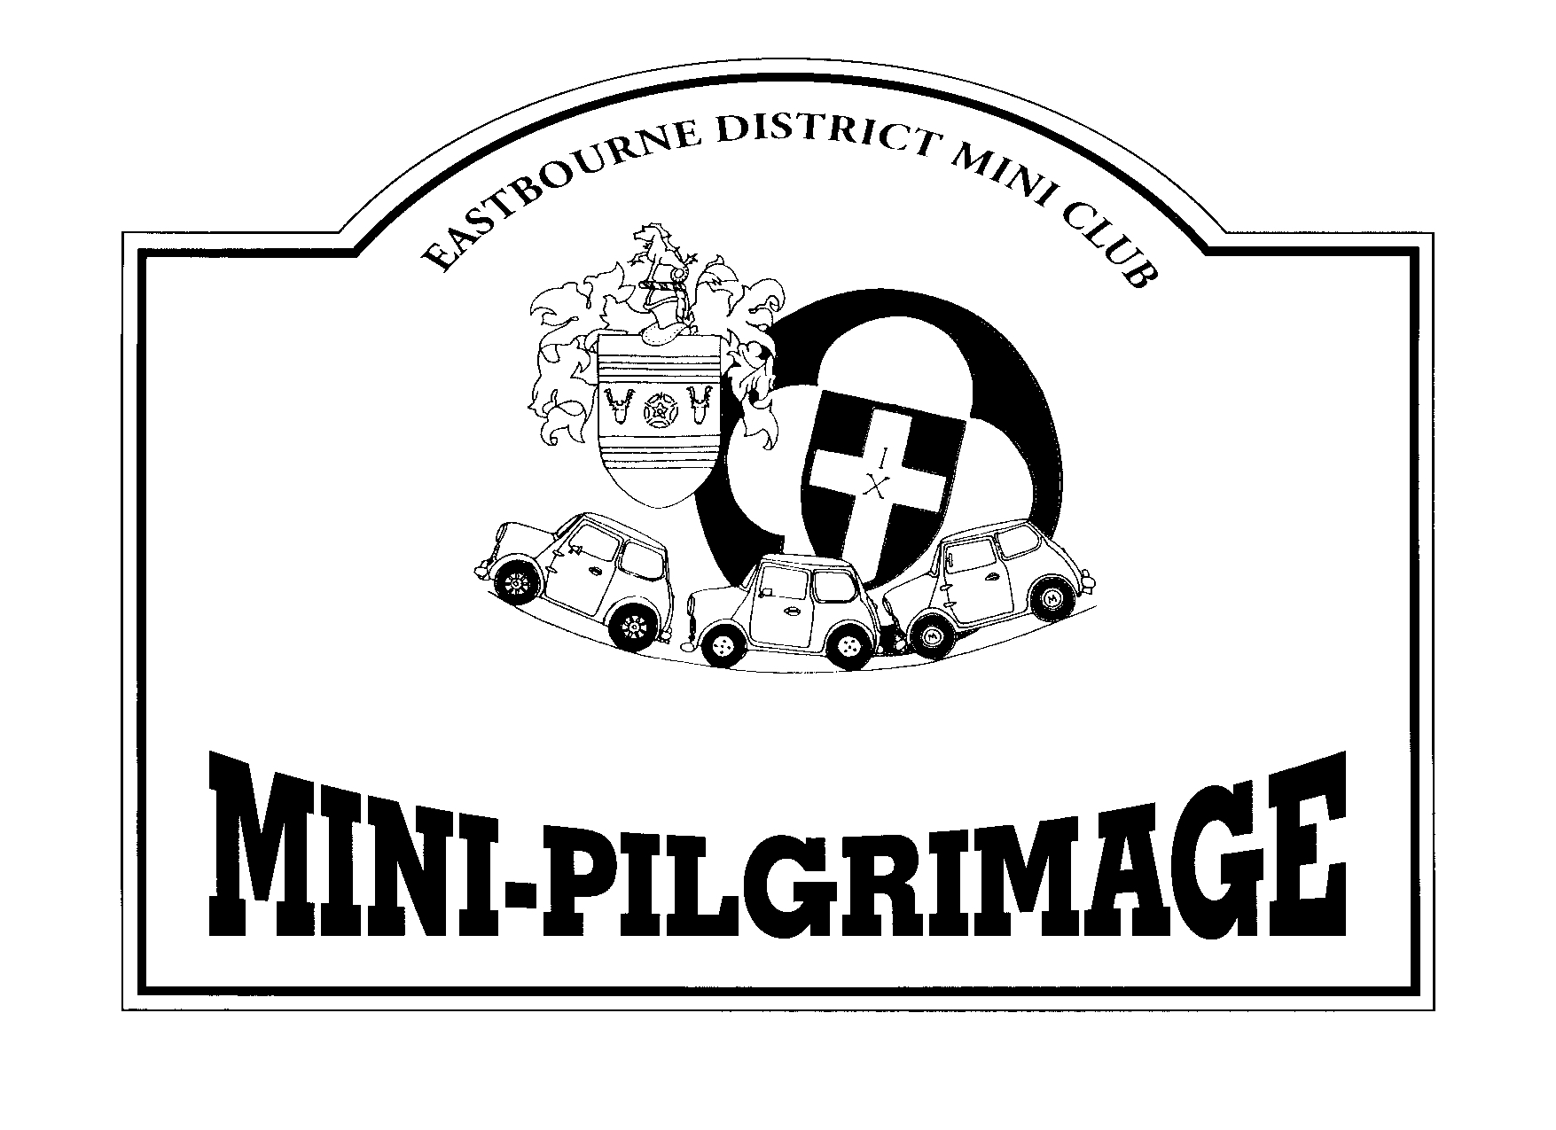

This year is the 5th Pilgrimage for EDMC, on Sunday 27th June – so there is still time to book your place!

Remember: In order to get your Early Bird Discount of 10%, make sure you hand you entry form in before the 30th April!
Also, it is advised to pre-book before the event to ensure you get your 2010 run plaque & avoid disappointment if we run out on the day. You can still arrive & pay on the day.

Entry forms are available at the club meetings or download them from the Pilgrimage pages on the main website www.edmc.co.uk . Cost is a mere £10, of which just less than 50% goes towards the charity.

Ideas & Prizes

We are looking for some ideas & volunteers to help organize some fundraising activities. Already there are some events going on including the Prom Runs organized by Lisa, which makes a good amount for the charity, (see the forum for more details on current events). All ideas are welcome.
Also, we are slowly but surely getting some raffle prizes together for the main run’s raffle. If you have any of those bits & bobs or unwanted Christmas gifts still lying around, then please donate (big or small) to make the raffle worth while!

Pilgrimage Web Pages


As some may have seen already, the Pilgrimage page on the main EDMC website has some additional links, including; up & coming News flashes and a Sponsors link page. All the flyers, forms & related documents can also be downloaded from here. If you experience any problems with downloading, then feel free to contact a committee member or any of the Pilgrimage team.

Uckfield Picture House Charity Cinema showing confirmed to go ahead in July!

We have had confirmation from the UckfieldPicture House to do a charity cinema showing as part of Uckfield Festival in July to raise funds & awareness of the CWCF & EDMC.
Date & film still need to be confirmed, but will potentially be between 9th & 19th of July. Proceeds raised will go towards our chosen charity, & there will be fancy dress with prizes on the day!
More details to come, but we need some ideas for a family viewing film - preferably that is well know, & can involve fancy dress – even potential ‘sing along stuff’ if we want to stretch that far!
Failing that, please make any suggestions that you feel would be popular enough to fill the cinema!
Original suggestion was Grease - but apparently the Lions Club did this last year, so we need to come up with something else preferably.
Any suggestions please post them on the forum or contact any committee member or Pilgrimage team.

Josie – Pilgrimage Chair
01825 733890

