
We welcome sunshine!
* EDMC Newsletter *
May ‘07
Issue # 14

Some down, so many to go! The Mini season is now in full swing & it’s getting hard to decide where to go. Whatever the event, EDMC will do their best to attend if there’s interest, So please give your suggestions & book early! Visit the EDMC website / forum, e-mail the Committee or catch us at the next club meeting. Enjoy the beginning of Summer…I know I will! Regards, Josie.
‘The Best of 2006’
With reference to last month’s Newsletter, I am still looking for your favourite photos from 2006. We have a few in the pile now but still need more please! Send your suggestions by e-mailing edmcnewsletter@fsmail.net, or see me at a Club meet or event. If you know of a specific photo you’ve seen, but don’t have a copy just let me know & I’ll try track it down.
(NB: Submitted photos must have been taken by an EDMC member or involve EDMC as the main subject.)
Cuckoo Fair - Laughton
This is a fun, family country event held in Laughton, near Ringmer. Apologies on this one though - we have missed the deadline for exhibitors to book in, so we cannot have a club stand & exhibit our cars to the public. However, we can still go as a club ‘mob handed’ on the day, but will have to park with the general public.
Adults £7.00 Children £ £3.00 under 5's free.
For more information visit www.heritagefield.co.uk or chat to our Events Co-ordinator, Dave
The Cuckoo Fare also has a Sister namely ‘The Laughton show’, which is held on September 8th & 9th. Camping is available, as a club participating in the event; as is the entertainment provided by the organisers…however, I’m sure EDMC can also provide their own!
Mini Pilgrimage
It’s not too late to hand in your forms for this years’ Mini Pilgrimage run, to be held on Sunday, 24th June. Monies raised this year will be going to The South Downs Community School, Eastbourne. The start will take place at the South Downs school & end at the Kent & Canterbury hospital. Forms & more information is available on the main EDMC website, at the club meeting or contact Rob at edmctreasurer@fsmail.net or henrob6166@aol.com for more information. The school are keen to get the kids involved & even want to do a project on Minis! There is no minimum for raising money, but every penny counts!

Minis on the ‘rec - Brighton
Once again our neighbouring Club are putting on another show down at Shoreham on the 7th & 8th July for a good family day out.
EDMC will be making an appearance to support BMOC in their fundraising event for the local charity, the Chestnut Tree Children’s Hospice.
This summer show will be held in Shoreham on the Adur recreation ground.
It promises to be a fantastic fun-filled event with many great prizes to be won, competitions to enter, entertainment to enjoy, trade stands, the odd auto-jumble to browse & much more. For more information about the event, visit www.brightonminiclub.co.uk, or to find out more about the charity www.chestnut-tree-house.org.uk
Change in Committee
Sadly, Neil has decided to stand down from the committee as Web Editor. As Simon has been working on the main website in Neil’s absence over the past year, he has now stepped up to head the title. All enquiries & items for the website, please e-mail Simon (or co-web editor Stephen) at edmcwebeditor@fsmail.net

Riviera Run ’07 –
a Mini Adventure!
Wakey wakey, rise & shine! Not the best words to be using at 3am on Friday morning – except there was a good reason for it! The EDMC early risers for the annual Riviera Run to Cornwall, congregated on the A27 to set off at 4:30 for the 300mile trip to Newquay.
With the exception of Rachel’s dodgy lights, all was well until our first hurdle…Shoreham tunnel became a nice spot for a clubby estate to empty its tank! A short tow journey with Bean Machine escort, followed by the siphoning of fuel (although Shawn accidentally drank some!) the Clubby sustained enough to get to the next station for a top up! We caught up with the rest of the gang at Rownhams Services where we met Sarah & Tom. Quick set off again to get a good start in front of the early traffic, then breakie stop at Bridport, followed by a long queue at some road works, finally ending up down a long winding road right to the camp site door; at which point the sun was out & the breeze was crisp off the Cornish shore! (& even Manky survived the journey down with no hic-ups!)
Ahh… Newquay! I couldn’t help thinking that it was a year since we were all here last! Base camp was quickly set up in a small corner of the site (suggested by Shawn & Gemma), which was flat, away from the main ‘noise’ & even better…only meter’s away from the toilets & showers! (except from discovering the outside light & nesting trees for pigeons above!)
Even before all tents were up, the beers were opened & the group chilled out after a long journey. A nice seaside meal at the local pub was welcomed & then back at camp, it wasn’t long before Alan became the evening’s entertainment, with Simon’s nervous disposition at hand (drink does tend to make one more ‘jumpy’ than usual)… 3 times!
Saturday morning was welcomed by breakfast bangers & bacon sarnies, & after the heart-attack meal, most of the group took a leisurely walk into Newquay town along the ridge of the cliffs. A few pasties & Cornish ice creams later, it was time to head back to camp. Some took the bus but 5 of us risked being washed out to sea by walking across the beaches whilst the tide was out.
Arriving some time later back at camp, Simon, Paul, Alan & some others cruised down to the Auto test area to show what the minis could do. (videos will be available soon on the website) The Bean Machine discovered it can go sideways, & Paul’s discovered that Simon needs more supervision when driving his car! As a result of multiple runs, the Cooper began to misfire, & inevitably was pushed to camp & out came the toolbox! A change of coil did a fix but the bewilderment of looks from on lookers when it continued to run even when the plug was out…gave me the impression it wasn’t quite right!
In the mean time, a shopping trip was in order for the evening BBQ feast. With myself, Rachel & Sophie co-ordinating, Dave did the ‘manly’ thing of pushing the trolley!
Back at camp, BBQ feeding commenced & more alcohol consumed (including Sophie’s Pimms…yum!) as well as a surprise Birthday cake for Paul. All fed & watered, we headed down to the campsite’s club house to see our long awaited blunt Cornish comedian with his mickey taking songs & favourite phrases! Prior to that, EDMC entered the quiz & surprisingly won! Well done guys & gals! £10 drinks voucher & a place in the finals the next night. With lots of drinking & dancing, the time had come to grab a taxi/bus (Alan singing ‘The wheels on the bus’ included)& head for the main town to my even more long awaited Walkabout club!
I believe everyone enjoyed themselves; however, the ‘Member of the Evening Award’ must go to Alexandra – the dark horse, who really came out of her shell with her straight vodkas & dancing moves! Paul’s love of Techno ensured his lively actions & thanks to Tony, who deterred men away by telling them I was a lesbian!
Anyway, sometime later (no idea when) it was time to leave, with a quick Kebab stop on the way & the last bus home polished off a good night out, (although further drinking continued until early hours!)
The next morning, surprisingly with no early wake up call from Jim, was chilled out once more as people recovered from the night before. The main show was open to all first thing, & apart from the usual china bling, the traders were varied & the concours cars where glistening in the sunshine.
The Cornish Mini Club put on an afternoon cruise for all to take part in, but something in the air turned, as Jim’s brake cylinder decided to leak & Shawn’s ‘exhaust removal’ meant that more tool boxes were out & well used. With all repaired, we went for the run at our own pace, but as the weather turned & recurrences from the night before surfaced, the un-thinkable happened.
And he was doing so well up until then!
Manky had problems; water pump was diagnosed so we all headed back to camp in the rain, leaving Manky in a near by petrol station (see “Manky’s Midnight Mechanics”)
As the wind picked up, all hands were on deck to pull down the gazebos before they blew away. As Manky was recovered back to camp by Jim’s nephew, the remainder tucked into fish & chips & staggered down to the campsite club house once more for the finals of the quiz. Daz had to go solo for the head to head challenge but despite efforts of blatant cheating from EDMC, the other guy won, but Daz walked away with another £10 drinks voucher. Well done Daz!
More drinking finished the night off & while most of us slept, boozed up & crazy mechanics worked through the night for a head start on tomorrow’s repairs.
Sunday morning was quick & easy, as all tents were packed & minis rearing to go within a few hours. Karen & Gabs said their goodbyes & headed off for a head start, whilst the rest of us had breakfast at the local café (which I still regret having – not after a night out & before a long car journey anyway!)
Even though the weekend had ended, the journey home was still part of the mini adventure: with plenty of stops for quick repairs, oil top ups, traffic jams & my cracked windscreen!
Although we all wanted to just get home in the dry & to warm beds, as people started to peal off from the group in their separate directions, I had a sudden sense of realisation, & sadness - that the weekend was over – but it was filled with plenty of laughs with a great bunch of people that I am proud to know & be a part of.
Thank you to everyone!
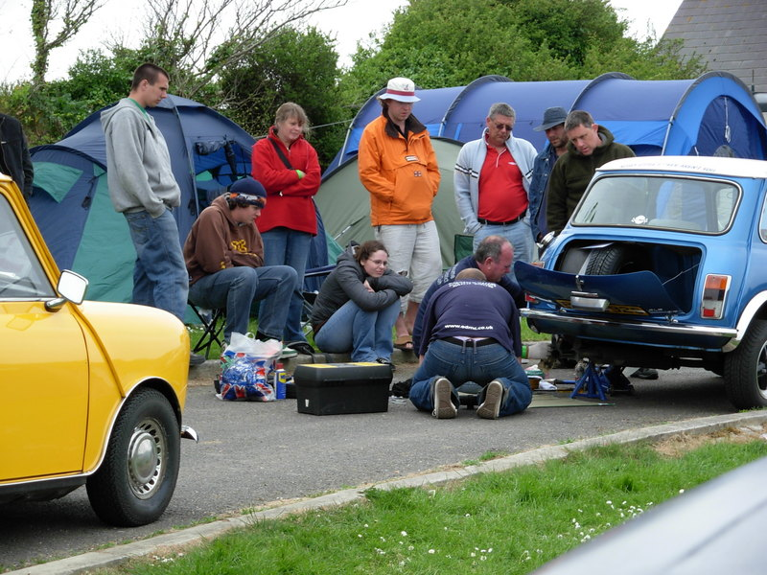

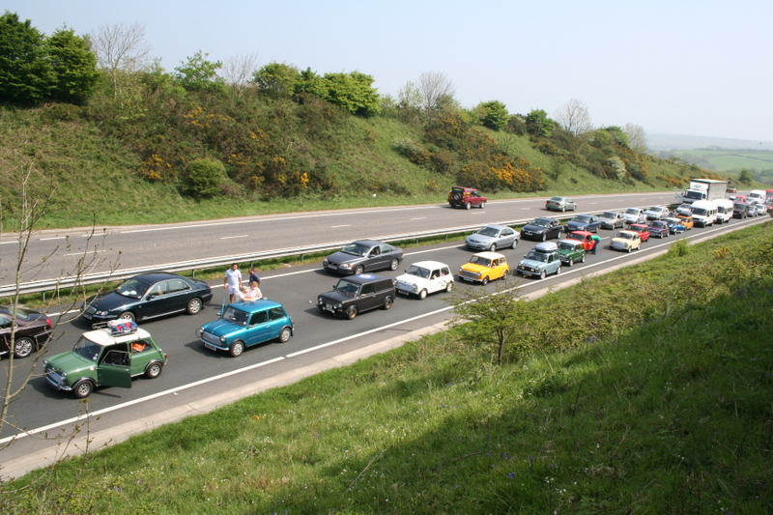

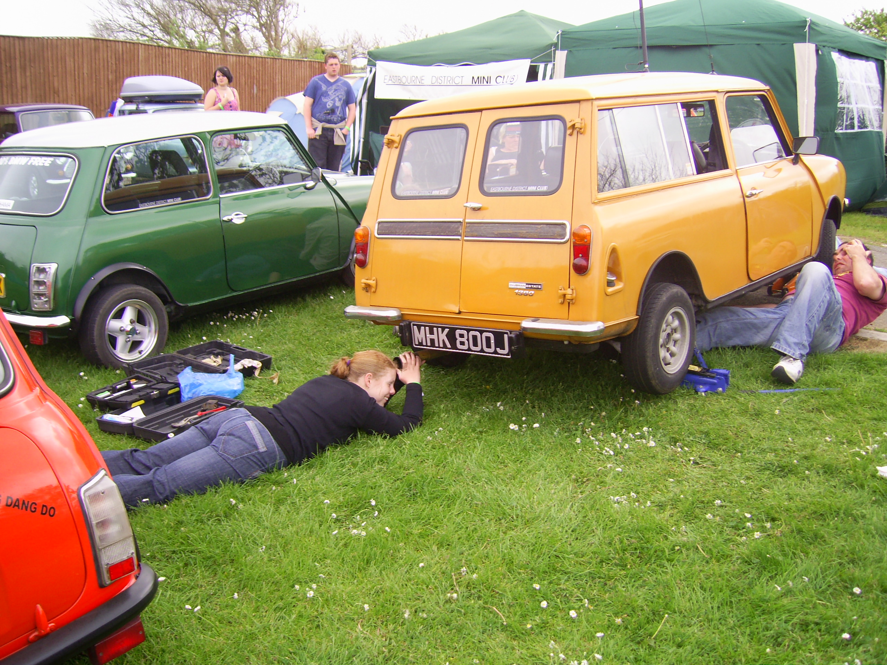

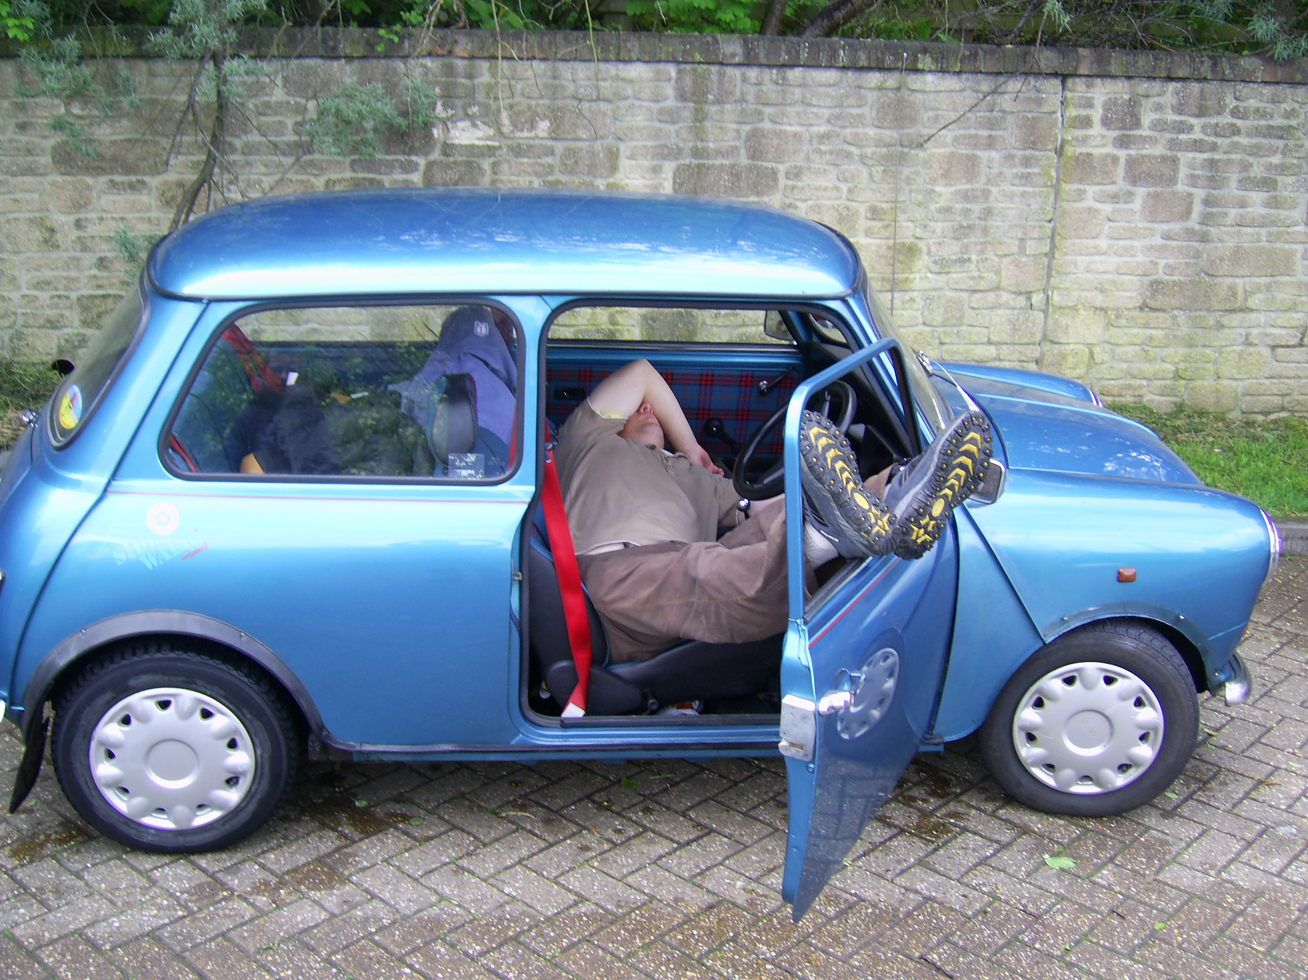
Manky’s Midnight Mechanics
On the way home from the Cornish Mini Clubs’ Sunday Cruise, Manky decided to have a tantrum & throw out all his water in a cloud of steam. We recovered him the few miles distance back to camp for someone to then diagnose the water pump. Paul phoned a mate & organised a replacement pump for Monday morning, which meant we would be leaving a lot later than anticipated to go home!
A few of us went back down the Treverlgue Club that Sunday night & had a few beers. We got kicked out of there at gone midnight - nearer 1am I should think. The EDMC camp was quiet: it was dark, wet & blustery that night. The others went to bed leaving me, Paul & Daz. At the time, we thought it a good idea to take Manky's water pump off there & then to give us a head start in repairing it the next day. Well, a lot of laughing & mucking about ensued even more beer was drunk & eventually - by torchlight - we got the pump off, only to find it was the bypass hose…great! Who diagnosed the pump then?
The bypass hose was good news though. Luckily, Daz had the correct piece of reinforced hose in Manky, so we cut it to length, re-sealed the water pump gasket with Super Jet Aircraft sealer (cheers Paul) & put it back together finishing at 3.30am!
Early morning, I was up with the lark, got Daz up & we had Manky up & running, then road tested even before some campers had risen from their pits! All was ok - no leaks. Manky got home with no problems, which is more than I could say for myself as I was very tied being hung over, I had nearly 3 hours sleep & was not keen on driving 300 miles - hence the pictures of me asleep with my feet out of the car window!
It was worth it though. We wanted to get everyone home early & that’s what we did. Cheers to Paul & Daz for helping… bloody idiots!
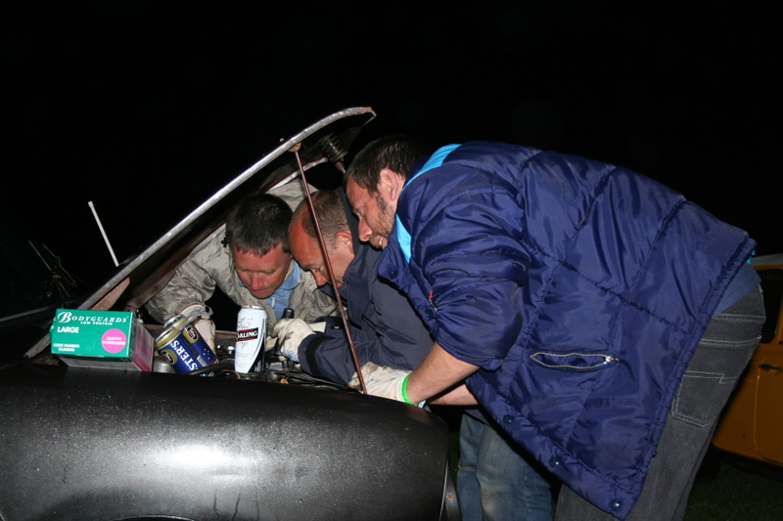
(an account by Dave)

