The Fun’s Just Got Started…
* EDMC Newsletter *
Summer is coming upon us; almost every weekend is being booked up with good old-fashioned Mini fun! So much to say…so little paper to print on! Hope you enjoy another issue…must be going ok so far as I’ve not had the sack yet!! ;-)
Regards, Josie.
London 2 Brighton: Not long now!
A great event to look forward to on the 21st of May! Although numbers are unsure at this time, some people will be camping & some will drive up on the morning. Times are yet to be discussed, however keep your ears & eyes open!
As well as the club stand (to be decorated to suit this year’s theme of Harry Potter!) & not forgetting the soap box challenge event for 4 of our members, EDMC have now also entered into the ‘Pit stop challenge’ where our team have to drive a BMW Mini Cooper S into the enclosure, jack up one side, swap rear & front wheels, and then do the same the other side, then reverse out. Daz, Paul, Dave & Simon are taking up the challenge with Bean Machine in reserve! Even more reason to hang around & support the club; good luck Guys!

Auto Test Success!
Steve’s Auto test turned out great when a good 20 odd minis arrived to help raise money for the NCH & ‘support4pseudo’. Just over £100 was raised & all in all some top drivers took part. Results for the day are still to be published but congratulations to Sam, Oli & Gaz for their winning runs, & Karina for her faultless run, winning best lady! No major damage was taken on the cars…. well…. there was ‘Mingie2’s bumper incident, Tony’s low profile fairing…& I could list a few items on my little ‘Ugly Duckling’ Mayfair!
If you would like to receive copies of this newsletter; past or present, through a preferred contact (i.e. e-mail or post), please contact me on the e-mail address below or catch me at the club meeting to give me your address. Otherwise, newsletters can be found on the EDMC website.

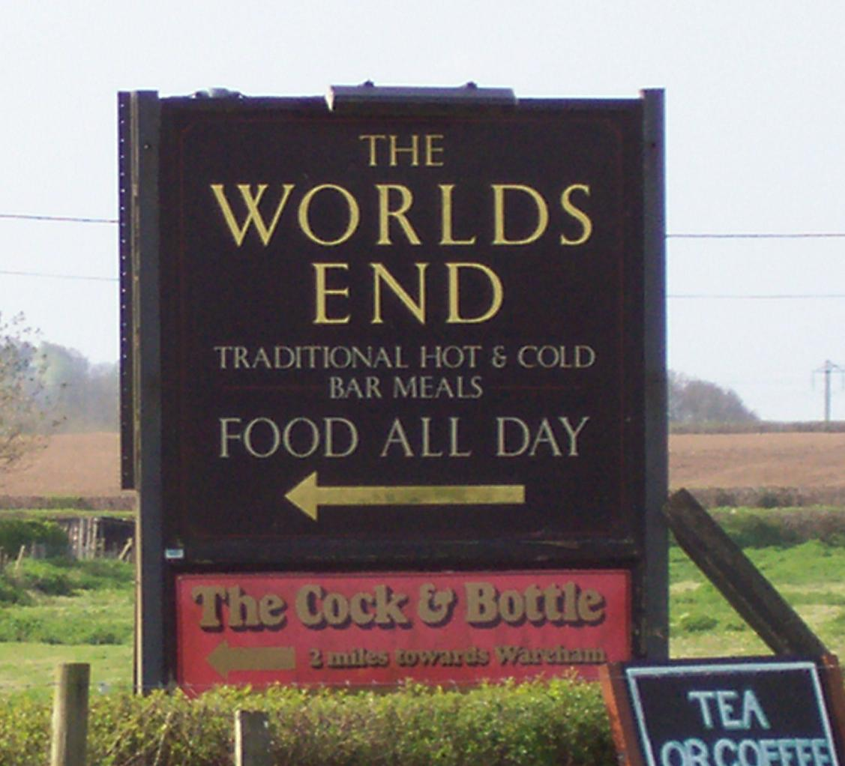
Rosie’s Charity Day: 3rd June
Highlighted Event
As some may know, Rachell’s son’s girlfriend Rosie is arranging a charity day at the Rugby Club, Hampden Park, in Eastbourne on the 3rd June. This is to raise awareness & funds for her charity. Rachell would like EDMC members to lend their support too and come along, on mass, & show off our darling little cars!
The event will involve a large raffle, live music, craft stalls and loads of other family stuff, so a great day for all of the family!
If anyone is interested in taking part, please let Rachell know, as she will need to know how much space we are going to need.
The plan is to meet at the British Queen & take a cruise around the area, ending at the rugby club, so we all can arrive together. So please lend your support & have a great day out at the same time!
For more information about Rosie and her illness please visit www.support4pseudo.co.uk.
28th May, Sussex Cruz
Simon & I are planning another Sussex Cruz including a BBQ lunch & games! This is open to minis outside EDMC too & will be taking place on the 28th May (Sunday after L2B) so not far away! It is a planned day to help raise funds towards the EDMC Mini Pilgrimage.
The cruz will take you along some of our favourite routes around the northern parts of the Sussex countryside. The day will begin from the ‘Nutley Arms’ car park in Nutley, then after a morning’s drive round some interesting routes we’ll park up at our house for a lunchtime BBQ, including paddling pool for kids (and adults if you wish), Scalectrix track racing, a couple of small competitions with prizes, (including ‘how many mini’s can we fit on our drive!’) & a few laughs!
For the whole day including the BBQ food & drinks is £5 a head, & £3 for children (under 5s free) Pic-nickers are welcome too but a small donation is appreciated for taking part.

Magnificent Motors:
An Account of the weekend

While half of EDMC went to Newquay for the Rivera Run, the other half stayed at home and attended Eastbourne’s classic car show Magnificent Motors. Apparently there was approx 500 vehicles on display over the 2day event ranging from motorcycles to…well…minis. We cavalcaded down the seafront as the heavens decided to open up but this was short-lived and by the time we had set up the sun was breaking through the clouds. We shared a pitch with Sussex Mini Club and Screwball Mini Club, and as usual SMC had a good range of minis on show while SBMC had a large variety of 1 Mini City.
After having a wander round we came back to find flyers for SBMC on all our minis, so we decided that we would keep Robs daughter amused by making paper aeroplanes, frogs, and swans out of them. On my planes maiden voyage it flew like no other paper aeroplane and landed on the back of SBMC chairman’s wife who just happened to be bending down at the time. At this point everyone was wetting themselves laughing and the area was vacated. Meanwhile Bill had gone missing, but was soon found by the bar-bequest chatting away to a fellow mini nut.
On the Monday I turned up early to see if anybody else was there and ended up helping SMC rescue their marquee after a flimsy gazebo came crashing down the western lawns straight through it, bending the tubes and ripping a hole in the roof. Decided it was too wet and went back to Steve Medhurst house for brekkie.
Went back about 12 and found that 4 of EDMC had turned up.
The star of the show (apart from mingie2) had to be the V-Tec & K-series conversions which grabbed a lot of attention from the 30,000 or so people who flocked to Eastbourne Seafront over the 2-day event.
All in all a good weekend shame the sun wasn’t out as much as the previous year.
Darren Brown ‘Aka The Boss’

Events coming soon…(plus organisers)
- 21st May – 21st Annual running of London to Brighton. (Daz)
- 28th May – Charity Cruz & BBQ, (Si & Josie)
- 2nd to 4th June – International Mini Meet, Poland
- 3rd June – Rosie’s Charity Day, Hampden Park, Eastbourne (Rachell)
- 11th June – National Mini Cooper Day, Hampshire (Shawn)
- 17th to 18th June – Mini Racing festival, Leicestershire
- 18th June – Eastbourne classic car show (?)
- 25th June – EDMC mini Pilgrimage. (Rob)

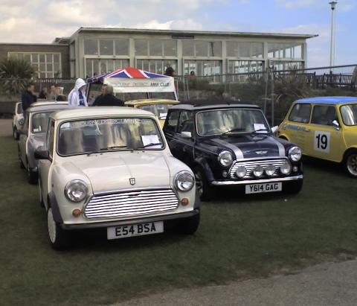

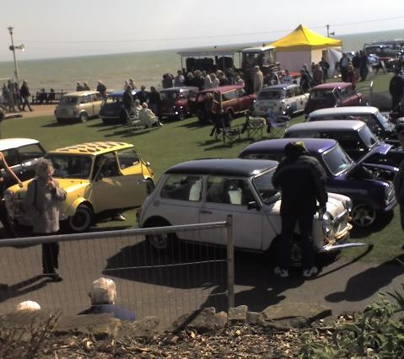

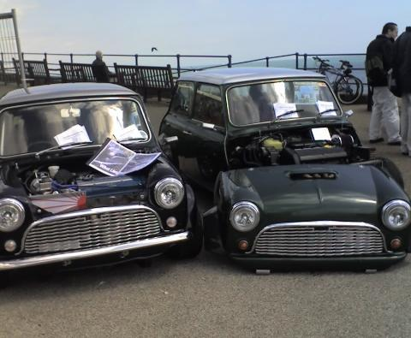
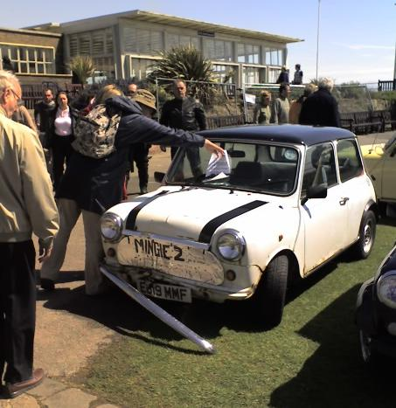

Riviera Run, Newquay:
An Account by Josie

From leaving Sussex at 6am on Friday 28th, to the return home on Monday, the Riviera Run was a fantastic weekend in the sun for the 14 EDMC members & 7 cars! After a long 9hr drive there, including a few stops to top up a very thirsty clubman, we arrived at a typical holiday campsite. For some, a trip into Newquay for dinner was a relieving start to the holiday! The Saturday consisted of an exploration of mini spotting around the site then a ‘walk’ into Newquay for a good look round, appointing Dave as our tourist guide (I say ‘walk’ generously!) Although the weather wasn’t your typical sun & surf it was certainly good to us. After a feast of Cornish pasties & ice-cream (I quote: “you want chocolate nuts?!”) & long walks round the beach before the tide pulled us in (Jim + co. & Tony exception, who opted for the bus) we returned to the site in time to see the first cars in from the actual run. Although there weren’t lots of trade stalls, there was plenty around selling the ‘Bling’ to keep everyone happy. A few bargains were to be sort after!
After a trip to the shops, we managed to scrape together a BBQ with drink before the sun went down, then trundled down to the campsite clubhouse to be entertained by bingo, a quiz (which we could have won if we’d entered!) & a rather blunt Cornish comedian with his favorite catch phrase (not to be published here)! Whilst everyone trundled back to the tents at about midnight, Dave, Simon & I (along with Simon’s reluctance of me going with them) were driven into Newquay (thanks Jim) preparing for a long night of surf clubs! An Auzzie bar called ‘The Walkabout’ made the grade & successfully revived my love for Queen music & got Dave & Si to pull out their dance moves! The return back to camp at 3:30am certainly wasn’t quiet! I think everyone knew who EDMC were!
Sunday came round with the new club alarm clock called ‘P**s in a bucket’ trick, and more browsing round the trade stalls & show cars that were crammed into the car park; showing off a lovely Paul Smith & some impressive engine builds in well presented classics. The afternoon consisted of a good 70mile odd cruise by the Cornwall mini club around the Cornish countryside including water splashes and that 33% slope that I don’t think anyone would forget in a hurry! After a tiring day, it ended in fish ‘n’ chips & a bucket of rain that continued through the night.
Monday, although wet underfoot, brought sunshine as we reluctantly packed the tents to head home. Another country route was taken out of the Cornish countryside to join back on the main road to head for home. As always, the journey was part of the holiday & so a few stops here & there for the thirsty clubman & hungry members didn’t go amiss. Jim’s thirst for racing some BMWs also gave some entertainment, although the fan belt snapped when he was almost home! Simon & I pealed off half way as we were continuing the holiday else where, but could not help feeling sad to see everyone go! Everyone returned home between 8-10pm, all in one piece & tired of driving!
All in all a great fun weekend enjoyed by all, and what a great bunch of people to spend it with! Thank you! …Here’s to 2007!!
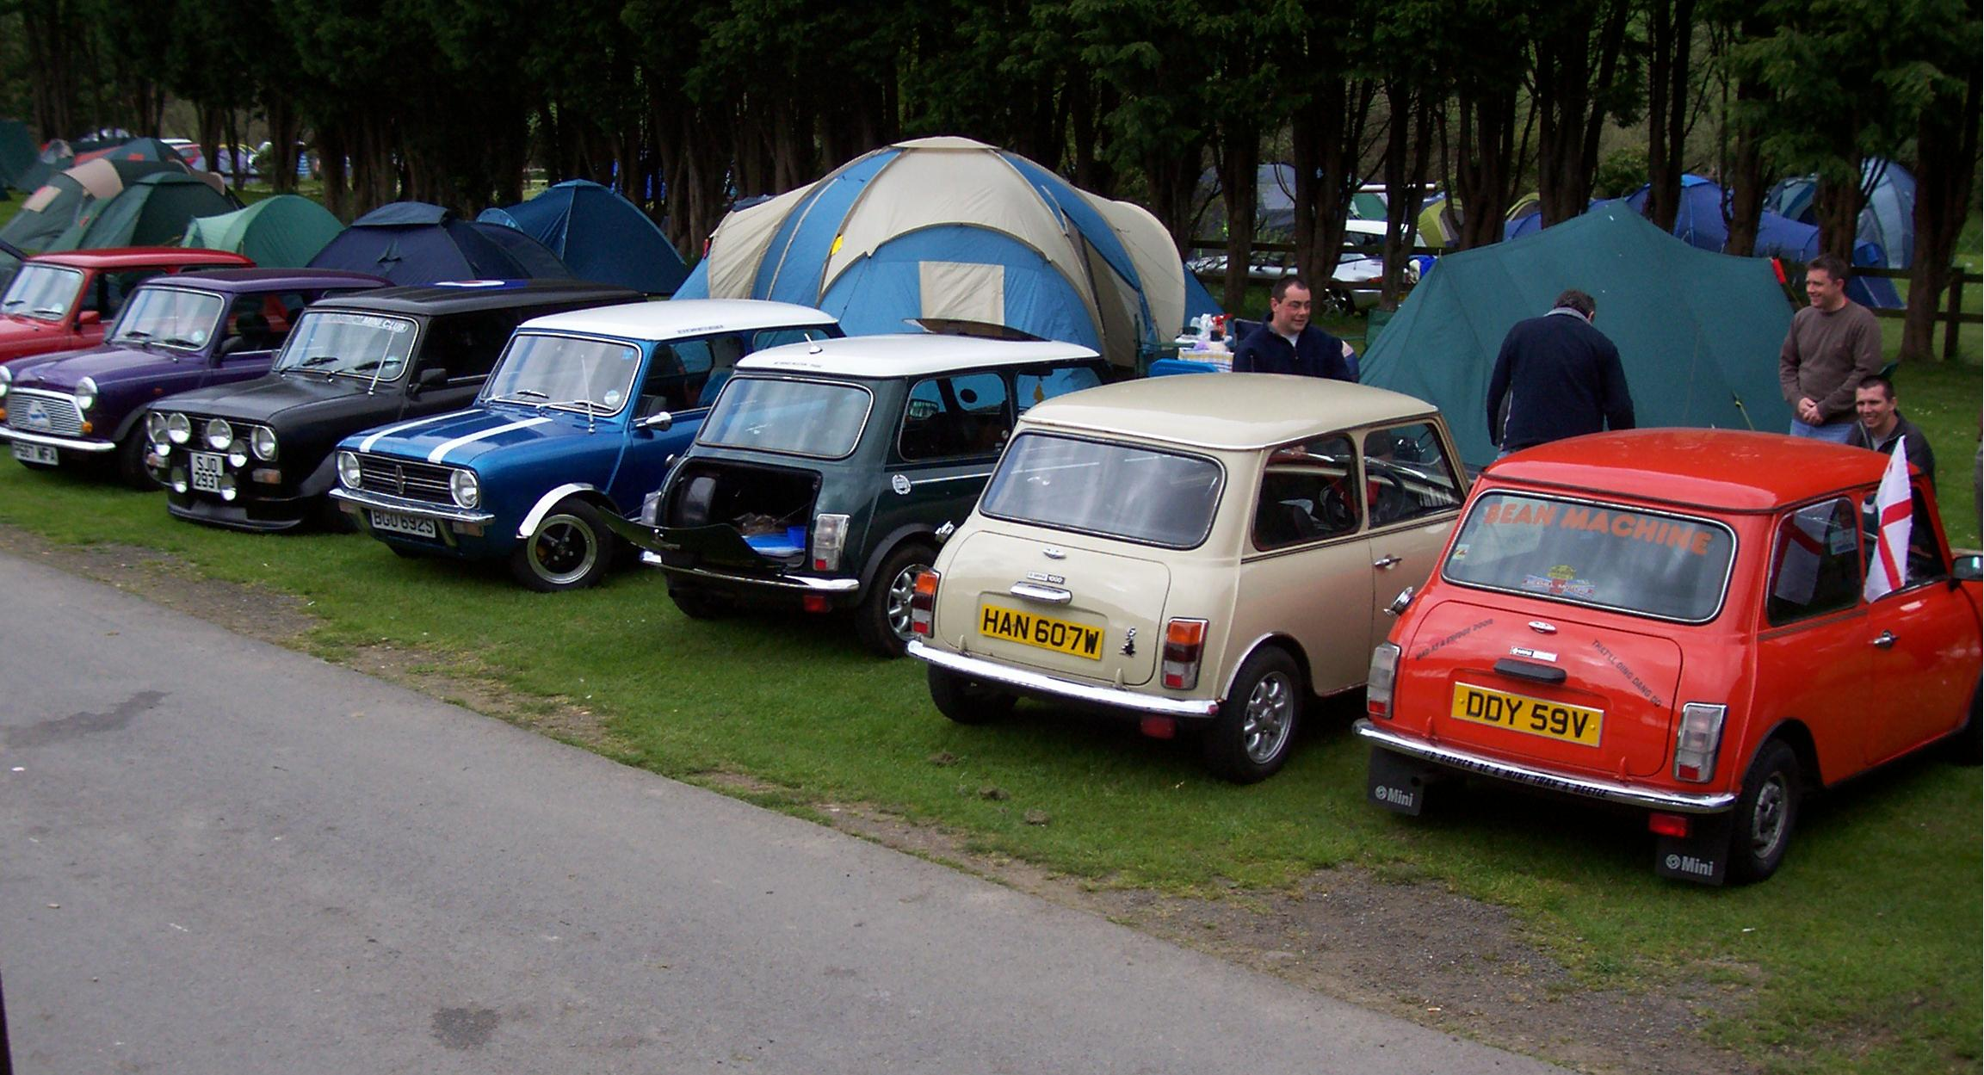

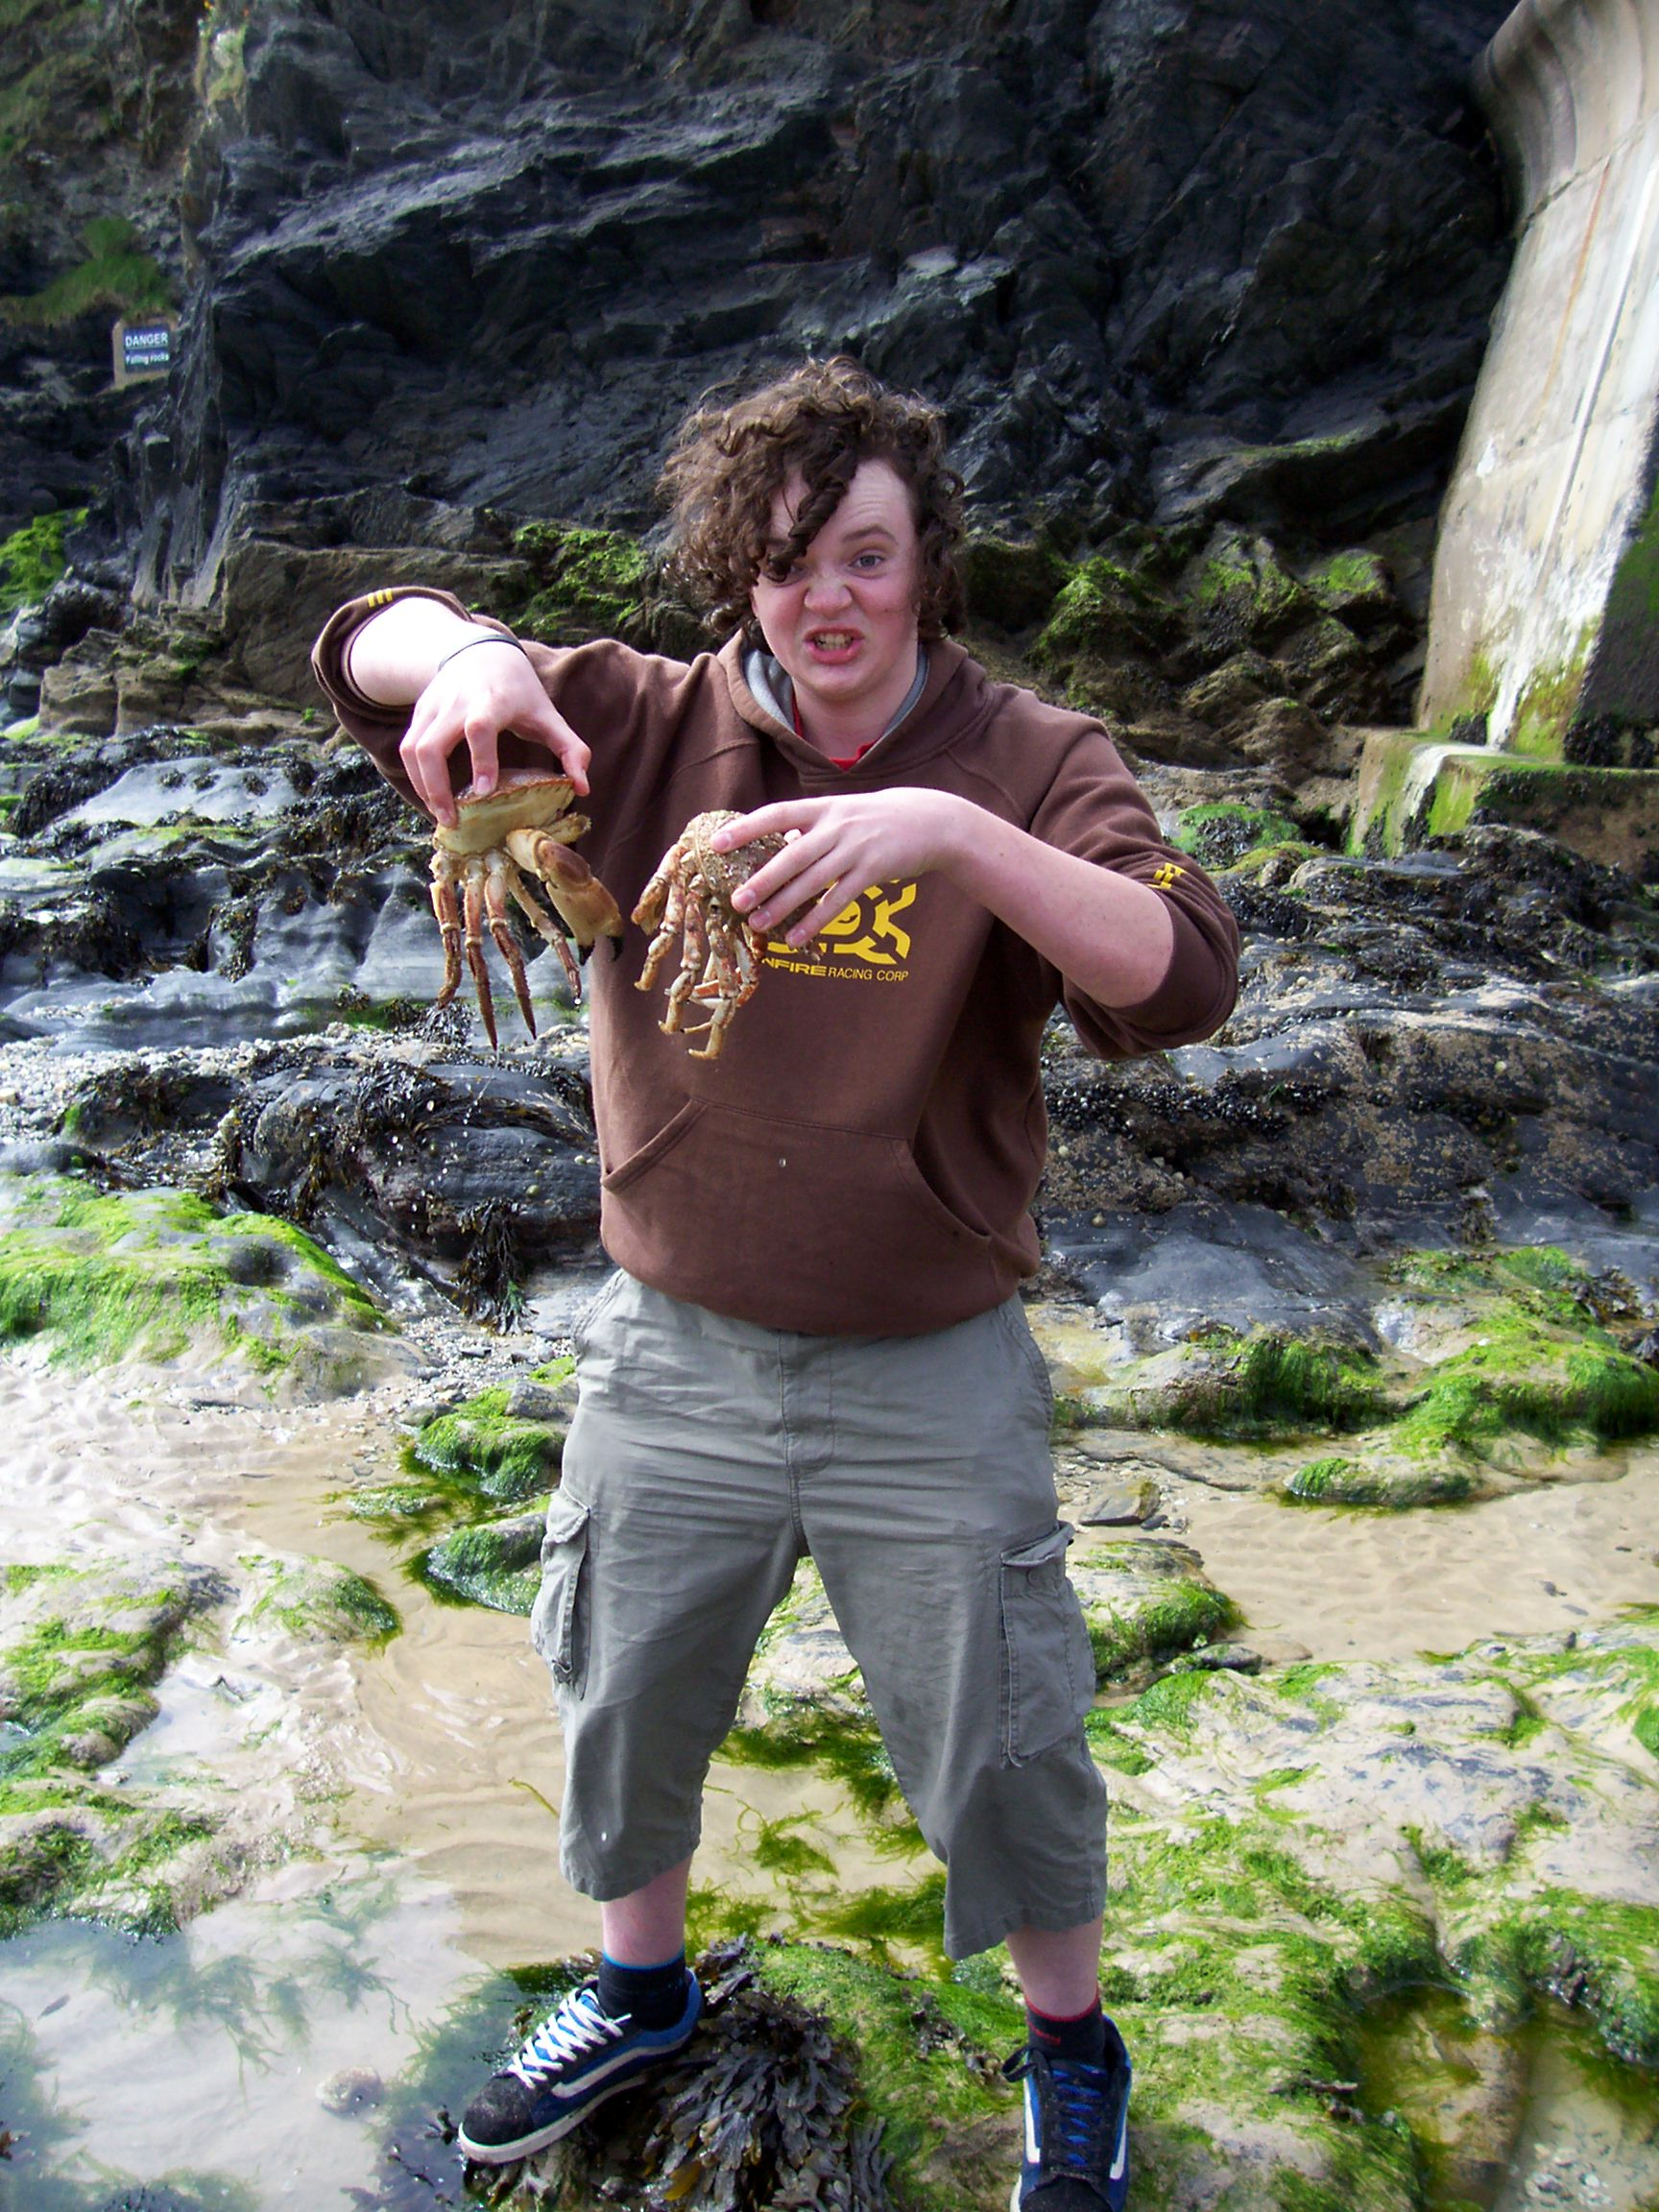
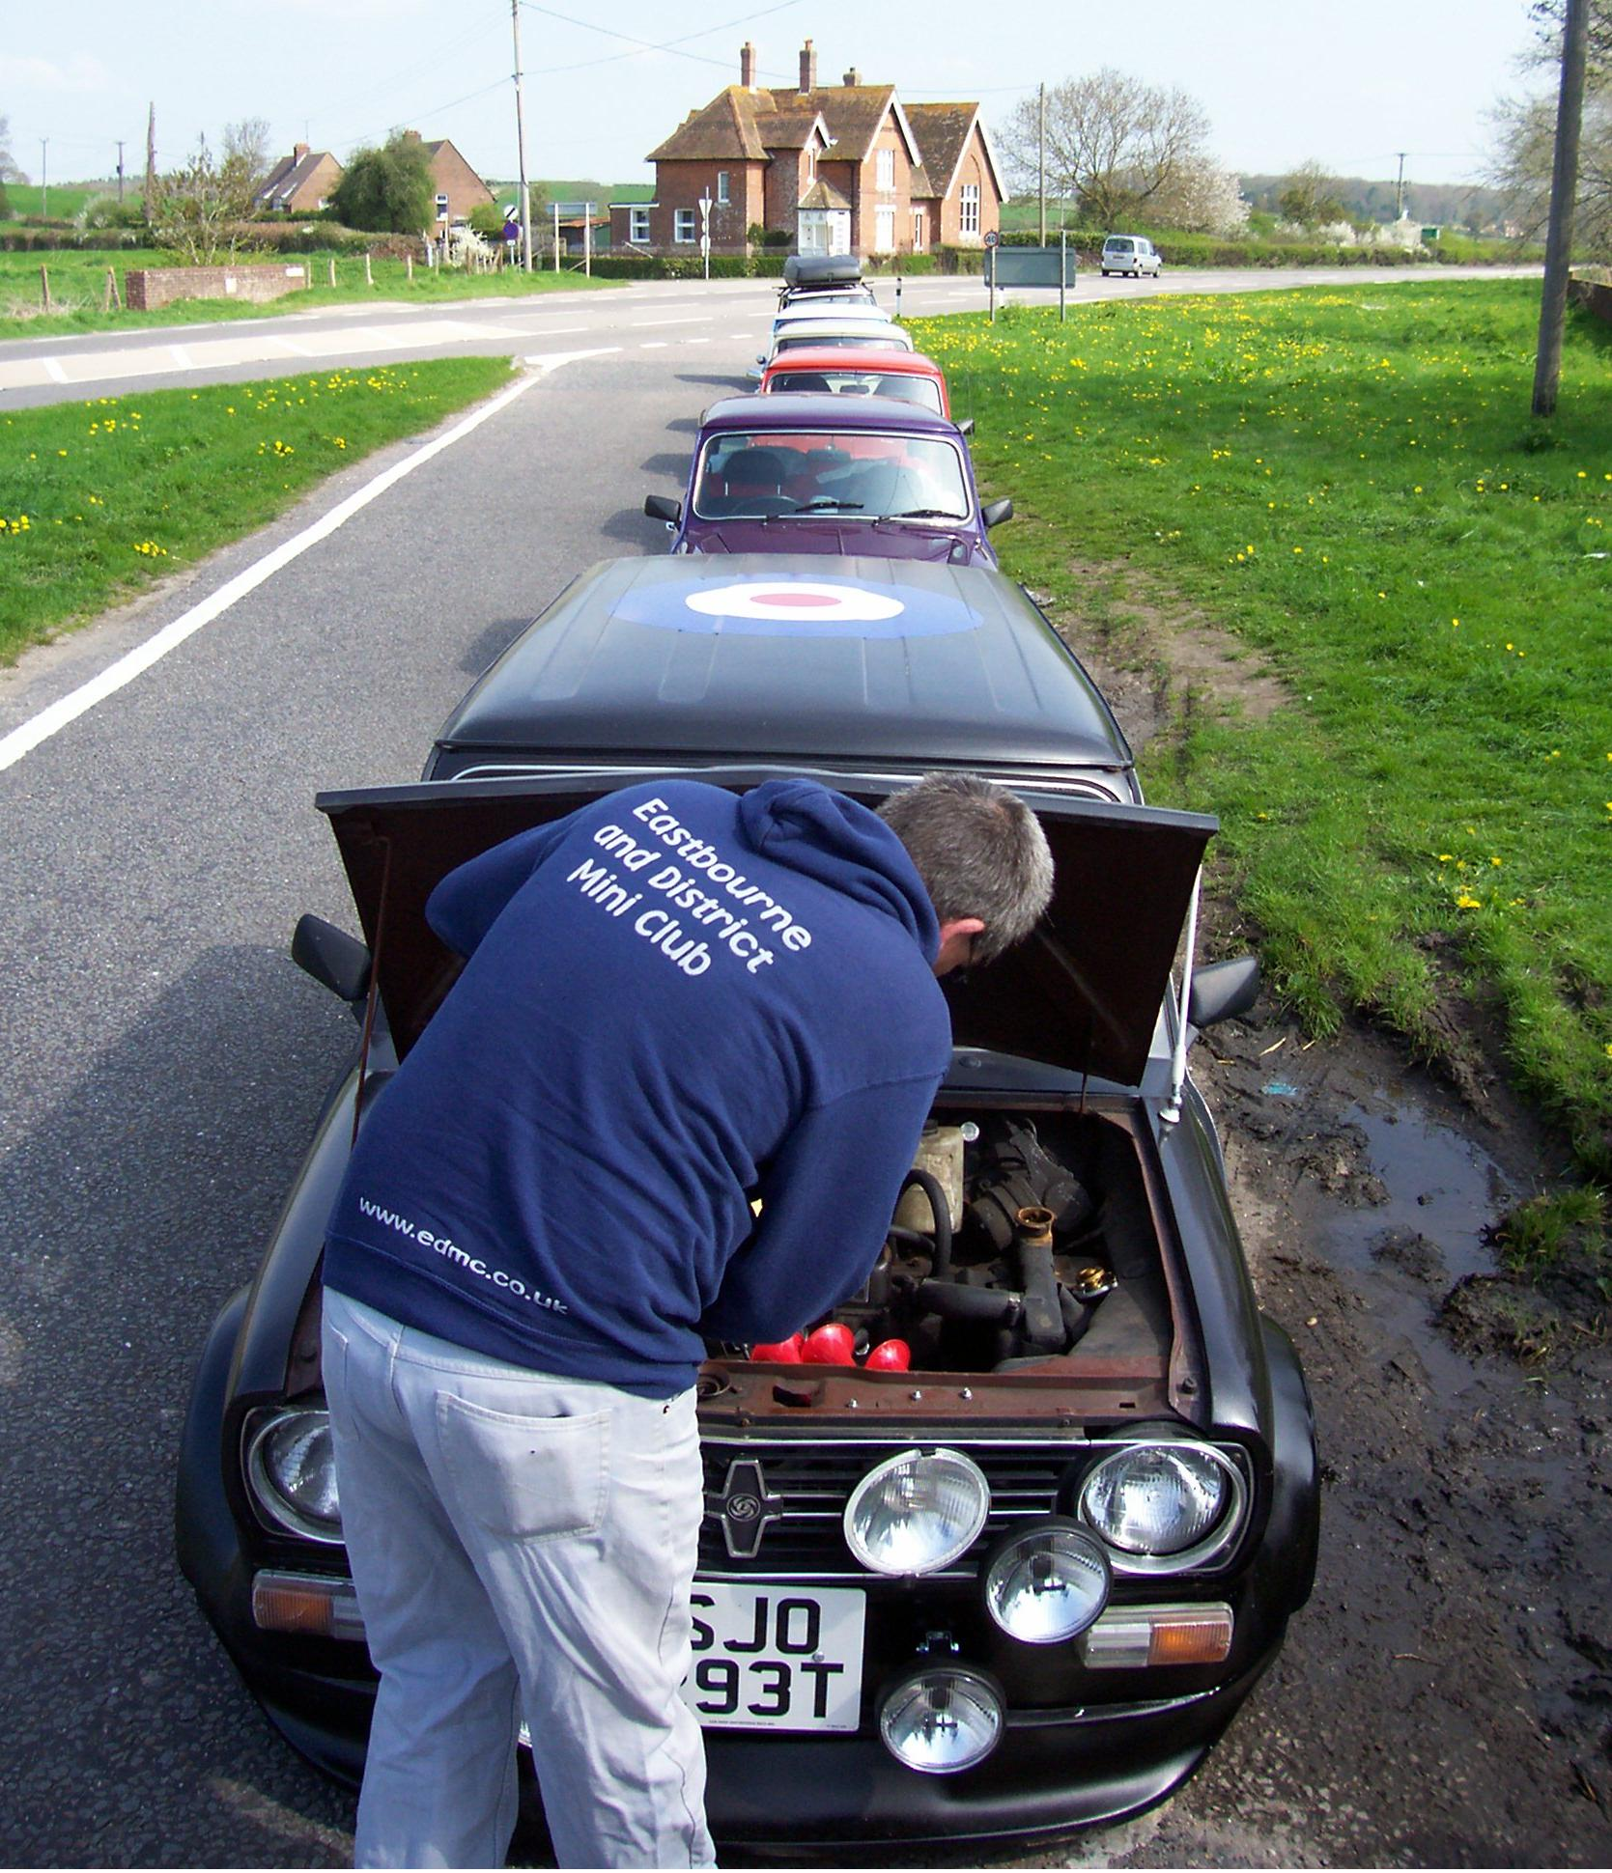
More photos & video for viewing soon…keep an eye on the forum for details!

