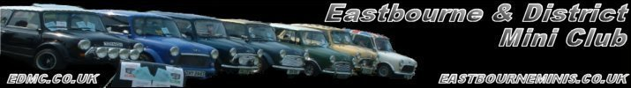
Spring clearouts &
* EDMC Newsletter *
March/April ‘07
Issue # 13
April showers!

So much to do, so little time! With a fresh start to the year – including new house & new job – all of a sudden we’re having to find time to polish up the Minis ready for the start of the season! There’s lots going on this year & hopefully if one show isn’t quite your cup of tea, then there’s another around the corner that will be! Within EDMC, we try to keep you informed about them all – whether locally, nationally or internationally. But remember, if there’s something we haven’t mentioned yet, let us know, & we’ll spread the word! Regards, Josie.
New Club Meet Venue!
After numerous discussions for the past couple of months & a vote held at last months club meet, a decision has been made to move the venue to Langney Sports Centre. Among many areas of concern was the location & parking at The Pubb, of which Langney boasts a large open car park. We also have the benefit of a private bar section, WCs & side entrance. The first meeting at the new venue will be held on April 2nd.
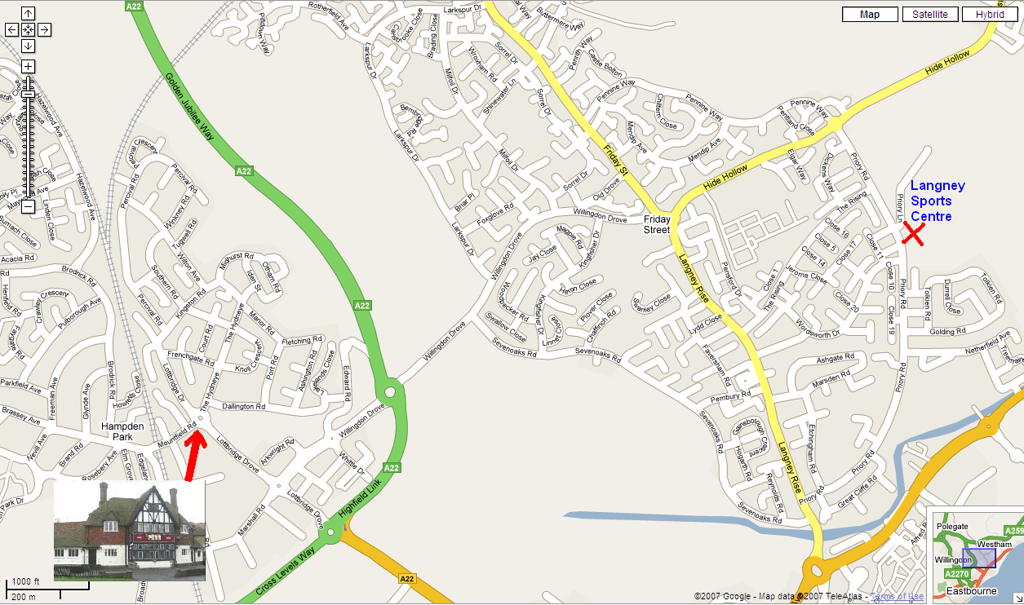

What’s your Favourite?
After such a great club year in 2006, I have been trolling through the photos & rekindling the memories –the good & the embarrassing! Which made me think… ‘What is the best picture that would sum up an event, or even the whole year?!’ But I cant be the judge of that, so I thought I’d put it to the people who were also there: YOU!
For the next few months I would like to hear of & see YOUR favourite pictures from ’06. The idea is assemble a selection of the top 10. Then they’ll be voted on by Club members as the ‘Top EDMC Pic of the Year’!
Please submit suggestions by e-mailing edmcnewsletter@fsmail.net, or see me at a Club meet or event. If you know of a specific photo you’ve seen, but don’t have a copy just let me know & I’ll try track it down.
(NB: Submitted photos must have been taken by an EDMC member or involve EDMC as the main subject.) I look forward to the response!

Mag Motors, Eastbourne
Held on the first Bank holiday in May, this local event is a must for those members who aren’t venturing South West to Cornwall. For event details & programs see www.magnificentmotors.co.uk
Entry applications need to be in by 12th April. A form has been filled out but as our Events Co-ordinator will be in Newquay that weekend, a volunteer is required as a point of call for the event organisers. Please speak to Dave ASAP if you would like to volunteer.
Riviera Run – Important Info
Attentions all those who are packing their cases for the Rivera Run to Newquay:
MEETING TIME - 4.15am LEAVING TIME - 4.30am
Meeting place will be in the Newmarket layby on the A27 at Lewes – Same as last year. (& same as Brooklands this year)
Dave anticipates with the earlier leaving time we will arrive in Newquay during the morning, allowing us more time to camp up & wander into town at leisure. The road works are still active at the Newquay end though, but should have finished by now (however, in one direction the traffic will be using the new road, easing congestion.) A quick recky of the area by Dave will give more information before the May weekend.

Brooklands Mini Show
Account of the day
Being the first show of the year for the Club, it proved yet again to live up to our expectations for another year running. The setting of the period racing track, preserved Concord & some amazing historic race cars set the atmosphere.
We congregated for a sensible 08:30 start outside Lewes & gathered 18 Minis to convoy up the M23, round the M25 into Byfleet. Only a couple of cars failed to get to the show; bad luck to Neil with a clutch problem.
The drive up went well, a couple of the smaller engined cars just about tagged on the back. With the use of the handheld radios we all managed to keep together. Expecting a good spaced club stand on arrival, we were a bit disappointed with a space fit for only seven cars. Apologies for asking Dez to park up in the general parking (Dez managed to squeeze in anyway), during the day his car was in the last three for ‘car of the show’!
Rachel & Tony’s new photo display board went down a storm; it got a lot of interest from the public. Toby & Steve had spent a fair few evenings cutting vinyl for the black EDMC signs, which really stood out from the other club banners, (but then left them behind LOL) Cheers for the contribution everyone! Lets hope we get in the magazines with all that effort!
On another note, I think we are all getting disappointed with traders: non-genuine ‘genuine’, china bling chrome & inflated prices on basic essentials set the tone. Thankfully a few clubs had a bit of auto jumble to help out.
The ‘Test Hill’ drew in the crowd just after lunch. Back in the 1920’s it was used to test brakes, clutches & ended up been a hill sprint challenge. The fastest ever car to fly up the short hill travelled 40feet clear of the ground when it reached the top!!! And that was set before 1940!! I made my attempt; 1st gear to the red line, but it didn’t impress Jim, Dave, Ricky & the usual hecklers! A whole mix of cars charged up the hill, from an Austin Woody to a Honda clubman. Most looked faster than my attempt ☹
Unlike last year the weather held out for us to drive home. Most of us gathered to convoy back. A few lessons have been learnt about keeping 15cars together earlier that day… travelling at 50mph as the lead car on the M25 did the job. Rob & family in his 850 got bored of plodding behind my MPI & took the lead. That freed up Josie & I to do some camera work, along with Rachel & Tony with ‘Camera #2’. ‘Video coming soon to a Club Gallery near you!’
Everyone got back to Sussex safely. As far as I know, we had no difficulties with the exception of Dave’s SideWalk been short of 3 litres of oil at the start. If its not petrol, its oil! All in all, a good local show for the club & I’m sure we’ll be going back next year!
(Report by Simon – AKA ‘Mininutter’)

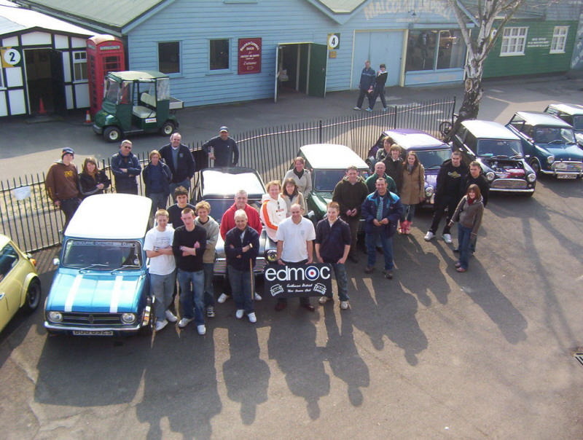
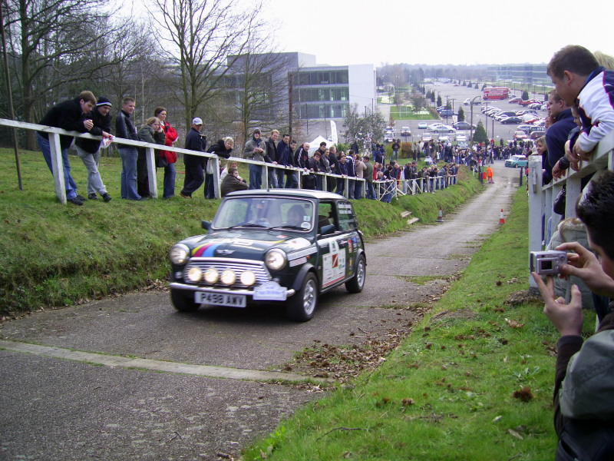

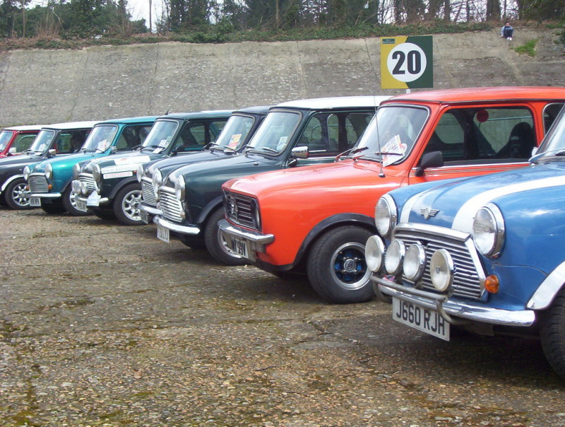

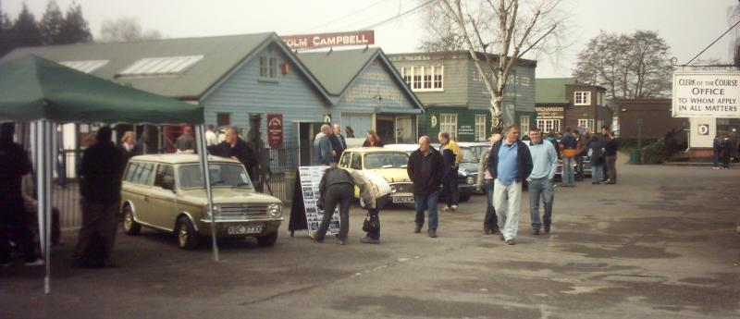
Classic Cars – Classic Stories!
On Saturday 31st March, some EDMC members attended an open day held by ‘Classic Cars of Kent Ltd’ at their new workshop situated in High Hurstwood, near Crowborough. The morning consisted of complimentary tea, coffee & bacon sarnie as many Minis from local clubs parked up in tight formation inside the company’s paddock. A mooch around the gathered Minis was followed by an interesting walk round the workshop inside: decked out with interesting Classics from MG Midgets to the Cooper Silver Bullet, all with their own historic tails.
Later, guest mini celebrity John Rhodes (otherwise known as ‘Smoking John Rhodes’) gave a short presentation; telling of stories of the highs, lows, thrills & spills of his motoring career – with a good sense of humour too!
More mooching of cars & one-on-one chats with John followed, before cars started to roll up for a quick turn on the workshops’ Rolling Road. Toby with his 16v ‘K’ series stepped up to the challenge as the only one from EDMC. With bewildering looks from the mechanics, trying to work out how it all works, I’m not surprised that Toby was worried himself if they could manage it! But as expected, it came out tops becoming a ‘winner’ of the day producing 145bhp – only 5 less than Geralds results last December. A good comparison I believe.
Talking of ‘winners’, EDMC did win something for the first time! A quiz was set for those who dared about the history of the Mini. With the help of Dave & others, Daz gave 15/20 correct answers, winning EDMC a John Rhodes signed bottle of Champaign! Well done!
For those who are wondering, John Rhodes was the ‘Daddy’ in British Touring Car Racing in the 60's, helping to put Cooper in the touring car limelight. If you have seen a old picture of a touring car Mini going round a corner with smoke billowing off the tyres its quite likely that was ‘smoking’ John Rhodes at the wheel!
For more information about Classic Cars of Kent Ltd, visit www.classiccarsofkent.co.uk
“If you would like to tell your story of a mini event or want to add your views on anything, please send your subject & write up to the contact details on the bottom of the page – Thanks”

