
* EDMC Newsletter *
June ‘08
Issue # 22

Bumper Issue!
Wow! What a year so far! 6 months in & we’re filled to the brim of events & shows. This months’ news is a bumper issue with lots of stories & photos from the past month or so.
If you have any other articles, events or anything else you want to advertise to the club, please e-mail or catch me at a club meet. The more the merrier! It’s your club & your news – spread it about! ☺ Regards Josie

Beaulie Cooper Day 8th June
Alan (aka Bean Machine) is planning a road trip down to the Mini Cooper Day at Beaulieu for the 7th- 8th June for those who want to make a weekend of it. Alternatively, you can travel down on the Sunday instead. Either way, a club stand with 15 places has been booked, & from the feedback from members in previous years, this event is a classic! If you wish to attend, please contact Daz or leave a message on the forum, where more details can be found.

Eastbourne Motor Show
Eastbourne Motor Show is held on at Hampden Park/College field on the 12/13th July. This is a free event to those on the club stand - if you would like to attend please speak to Daz at the club meeting or via the website. We have space for approx. 15 cars & space will be allocated on a first come first served basis (though you need to be a paid up member to be covered by insurance). Please note that you will need to be at the site by 9am & will not be able to remove your mini until approx 5.15pm. For more information & updates, please see the EDMC forum, or speak to a committee member.

Mini’s on the Wreck reminder
Just a quick one to remind you of Brighton Mini Club’s event on Sunday 13th July (with camping overnight on the Saturday) at the Adur Recreation Ground, Brighton Road, Shoreham-By-Sea. Show kicks off on Sunday 10am-4pm. Please see previous EDMC Newsletter (issue 21) or the forum for further details.

Go-Kart Tournament
Stephen is gathering names of those interested in another karting session down at filching manor as the last event was well received.
So far, it would cost roughly £30 entry; this will get you a lot of track time. Last time we had a practice session, 4 races, a semi final & then a final. The karts are all rigged up to give you lap times & qualifying positions, points. It promises to be great fun for all! Also there are normally trophies for the top 3 in each final. Usually, this would cost around £45-50, so the special price of £30 is a good deal. 20 people would be ideal, so if you are interested & want to find out more, please speak to Stephen at the club meetings, or check out the forum thread under ‘Events’. Thanks.
Basic Training Session –
2nd June No.1&2
June’s Club meeting will be a bit of a double whammy as unfortunately last months basic training was cancelled. This session is named ‘Survival Crash Course’; which will include jump/bump starting & changing wheels. Held outside weather permitting.
A hand out of “Tools, equipment & suggested literature” will also be issued.
- Recommended emergency kit for the car
- Tyre changing (including where recommended jack points are!)
- Jump/bump starting
- If it wont start in the morning – check points
- Lights not working – check points

Session number 3 will be discussed at the June meeting.
For more details on each session, please see forum link, or speak to Josie (or another committee member).
Mag Motors Report
“This years magnificent motors went very well. Apparently, there were a lot more classic cars than previous years. The French market was very nice, with lovely food & other items for sale, as was the beer trailer!! The weather was great & so was the company, its was really nice meeting everyone! We were welcomed in with Sussex minis on the wish tower slope & the Italian job marquee in the main arena (thanks for the hotdogs ken!) The place was packed, especially on Sunday when even more cars turned up. I had a lot of club enquiries so hopefully new members! I think 'Humbug' was the only one to play up, he decided he didn't want to leave Saturday & caused a crowd of spectators to appear, one way of getting attention drawn to yourself I suppose! But thanks to Pete & his son Chris I managed to get home! Thankfully with my partner Chris working till midnight to find the problems & early next morning to do a temporary fix job, I was able to attend Sunday, with a bottle catching the overflowing fuel, (which was leaking whenever idol) & the battery from my Honda! More of us minis turned up for Sunday & the cavalcade was, I thought particularly good with the extra cars so all in all a great weekend & hopefully we will have an even better one next year!”
Account by Nicky (& Humbug!)
Crazy Creations UK

Crazy Creations UK founder, Colin Baxter, makes model Minis & other cars, & is hoping to make a living out of selling them. He's been working on his models since 2000 & has now have launched his own company. At this stage the company is still new & he's struggling to make it a success.

We genuinely want to gather opinions from other car enthusiasts to try and help kick-start Colin’s company. So if you are interested please visit the website www.crazycreationsuk.com. Colin would appreciate your feedback, comments, & suggestions as to which models would appeal to you. We hope to build relationships with car clubs like yours in order to put the right cars in our catalogue & reach the right customers.

Please do not hesitate to contact us at sales@crazycreationsuk.com to discuss any aspects of the company or the cars.

Thank you for your interest. We look forward to your feedback.

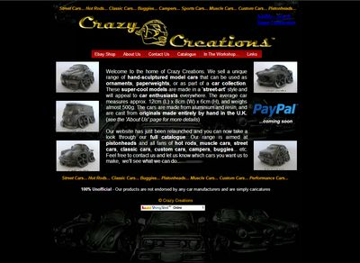

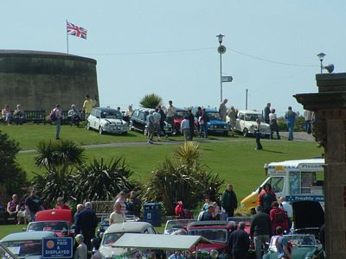

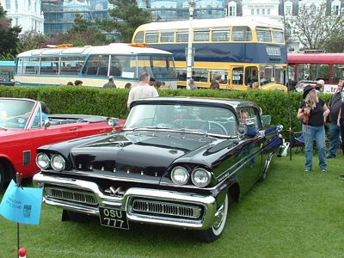

Riviera Run Report
What a blast!
Another early morning start – arrived at the meet point to find Daz, Lisa, Matt & family - including the re-born Manky, ready & rearing to go! 4.30 came & went, & we wondered if we had the right day or not! Suddenly, the rest of the rabble arrived; some wide-awake & others still half asleep, but all raring to go for the long drive to Cornwall.
Along the way, approaching the Shoreham tunnel, I noticed Manky’s exhaust had dropped & was making a lovely display of sparks in the darkness of the early morning. I wanted to point this out, but didn’t realise the cop car following the group as well, & as Manky pulled over – so did they! Further down at Shawn’s memorable layby from last year, the rest of us gathered to await the news.
The go-ahead was given to set off again, with a smooth run down to Rownhams to meet up with Sarah & Tom. A quick stop & catch up on the progress of the Manky party not far behind, we continued on – with no road works or further delays all the way down, allowing us to arrive on site by 11:45 – set up & beer open! With arriving earlier than we have done in previous years, most wondered what to do to pass the time. This led to the new sport of watching ‘tent man’ try to erect a tent that’s meant to take only a few minutes. About 2 hours later, the party was spoiled when ‘Tent Man’ disappeared in an angry fluster, to then return a few hours later with a new tent!
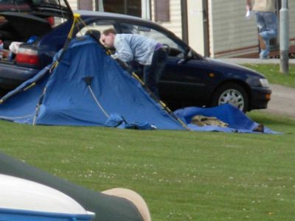
As the evening drew in, some settled in camp with takeaway, whilst others made the trip to the Mermaid pub for dinner. Full stomachs later - the walk back seemed faster (for some reason) in order to walk off a hefty meal. Many drinks later, most people had gone for some shut eye, whilst others waited up for the arrival of new members Gareth & Gemma – arriving around midnight & requiring help with tentage!
[See ‘Midnight Tent Squad’]
The next morning (after a windy & slightly wet night) was greeted by the smell of bacon rolls, tea & coffee. Some attempted the freezing cold showers on site before the staff decided to switch on the hot water! The lazy morning continued until some decided to go for the long walk towards Newquay via the beach path… only to discover that the tide was not out far enough to make it all the way round. Much to Jim’s dismay & complaining, the walk back round to the steep steps was tiring, though as the sun came out with blue skies, it turned out to be the sort of Cornwall weather we hoped for. The traditional Cornish pasty & ice creams in the town, along with random window-shopping, made the afternoon pass quickly & soon enough it was time to head back to camp.
Later, some went to try out the auto-test on the grass – Gareth’s 2nd attempt giving him his best of 42.3 seconds, & Alan’s best of 49 seconds!

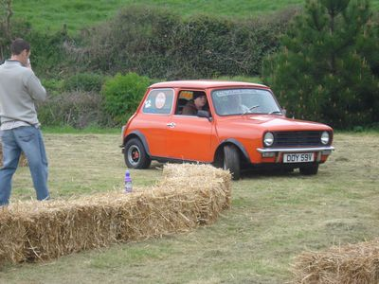

With the scrapping of the other tradition – the BBQ – it was decided to order a Chinese takeaway for those who wanted it. Naively, I offered to make the call… which is something I doubt I will ever do again – especially when Jim is involved somewhere along the line! To cut a long story short, my conversation with the Chinese lady at the takeaway place involved spelling out names & numbers, as well as trying to describe where to deliver. Not having much luck we decided to go pick it up instead – well, Dean did…. Sorry…. ‘D’ ‘E’ ‘A’ ‘N’. !
Either 16 minutes or 60 minutes later (as we didn’t know which one was agreed!) I had a phone call from a rather angry Chinese man who I couldn’t understand one bit! Turns out 3 minutes later (& after sending Dean & Alan running for the car thinking our food was about to get binned, & being told I’ve insulted his wife), the Chinese man couldn’t carry on any longer & so turned into Jim… however, I didn’t call him Jim at the time, as you can imagine!
Later, when the food did arrive safe & sound, with no angry Chinese people & my nerves finally calmed down, the evening continued with food & drink, then a trip down to the campsite club house for the quiz & entertainment. With Daz & Alan at the helm for the quiz (as if they would ever cheat) a tie breaker with another club was needed... oh dear Daz! Now, how many European counties can you name? & I’m afraid Jamaica isn’t one of them! Fair to him though, the other guy didn’t have a clue either, & unfortunately he guessed right before Daz had the opportunity. The rest of the night continued with drink & some silly dances, until the late walk back to camp (waking everyone along the way) & much needed sleep.
The next day came quickly, & stories of the night before started to unravel, & a scene of crazy painting was discovered around Dean’s tent (naturally, everyone blamed Alan… but it wasn’t him for once!). More bacon sarnies were consumed before heading for the show to take a look around (in the rain mind you!) The usual stands & cars were there, but included some newbies on the concours line.
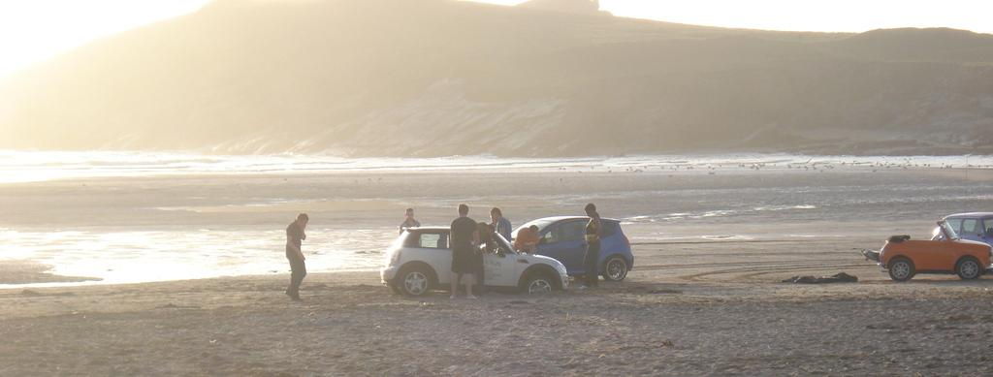
Later, instead of doing the usual Cornish mini run, we went on our own route around some great country roads & rediscovered the famous tin mine from two years back. Unfortunately, Daz & Roger didn’t quite get there due to brake failure, so had to head back to camp. With Dean’s Bini safely through the tight barriers of the tin mine, the route took us to the Cornish Cider Farm for a rest, taster testing & purchase of … well… cider! A short trip down the road to have original Callestick ice cream finished off the tour of Cornish countryside. Arriving back at camp to find Daz fast asleep, people dispersed to sort out dinner – mean while, Gareth & Gemma went to down to the beach, where many minis were doing their own sandy auto-test. Sadly though, the Bini got the most laughs, as it became ‘stuck’ to say the least!

After food, everyone settled into another night of antics & drink, (including another attempt at the quiz) laughter & the senseless giggling from certain people.
The next morning of packing up was unrushed & not too many hangovers to contend with. With all raring to go by 10am, a quick breakfast on camp set us up for the long journey back. Although many stops along the way to tend to people & mini needs alike, everyone arrived back home safely. And I can safely say that Riviera ’08 was another fantastic weekend of mini antics, fun & games, enjoyed by all! Thank you to everyone for making it what it is!

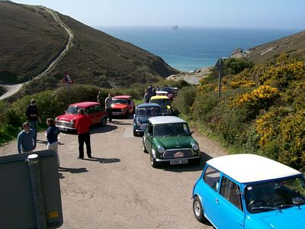

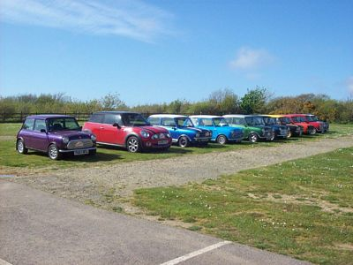

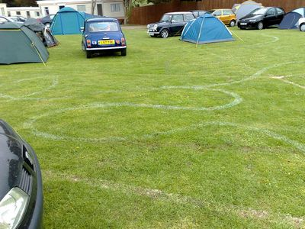
Midnight ‘Tent’ Squad
As everyone settled down for the night, Jim, Daz & Dave stayed up for the late arrival of Gareth & Gemma. For a while they stood in the dark, listening to the sounds of the night – though mainly the snoring from near by tents! Throughout the late evening, Gareth had been texting Jim with progressive whereabouts. Just gone 11pm, the message was they’d just left the A30 – great, now just need to count down the minutes & try work out where they are all the way to the site… well… try to work it out! They seemed to take ages to get there! Finally, the call came – they were on site! Now the midnight team just needed to guide the weary travellers to club site. They could hear a mini & see lights but even when directed by phone, they seemed to have been round the whole site before finally making it up the hill.
Midnight struck. There was still need to set up the tent for the night. Night – relating to dark – so attempting to erect the tent, which has colour coded poles, was nothing less than a mission for our old midnight bodge squad. With the addition of holding it down as the wind picked up, torchlight the only saviour, the team described it as ‘a bit like assembling an MFI chest of draws without the instructions!’ (as if you would read the instructions anyway guysy!) However, Gareth knew what he was doing, & in the muddle through torchlight, the outer & inner was assembled! Well-done team! Leaving Gareth & Gemma to settle in, the others headed for their own tents - by that point Jim in particular had been up since about 2am, & had almost made it 24hrs awake. For Daz & Dave though, the ‘Mid-night Squad’ was tradition. The tent withstood the night, so was deemed a success! General comments – the squad prefer tent fixing, than repairing Manky at Midnight any day!!!
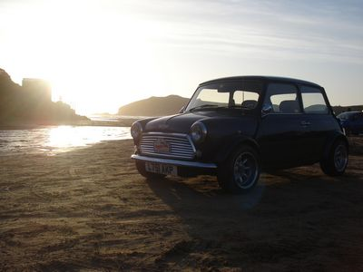
London to Brighton Report
Antics at Crystal Palace – it was all a bit of a blur!
“As the rest of the troops set off from Jim’s, Simon & myself were still preparing to come up. As we arrived at Crystal Palace, the troop had already set up camp. Dean & his Extra Big Bini had gone to find a gazebo to make HQ for the night & was successful. So the Gazebo was erected & it was time for the fun to begin. We set to work getting the gas cooker started while everyone else was waiting for their BBQ’s to fire up. After we had eaten it was time now to begin the heavy drinking!
Alistair made his introductions & joined the drinking. It was now 7.30pm & it was suggested that we put our cars in line. And oh yes we made the first line! As we now had no worries it seemed like things could only get worse. Simon left us & went to join the Brighton Mini Club! “Traitor!” were the cries from the club, so the ‘underage drinkers’ took it upon themselves to go & bring him back! Well… it didn’t quite go to plan as beer started flying! And then bang - we heard those worrying “Man Down, Man Down” calls. It was Alan - he had been hit hard! That was the end of it - we had to get Brighton hard & fast. We saw our perfect target: their Banner (or as they liked to call it “parabola” whatever that may be!)
As Alan & Myself took off with it & made our way down to ‘The Mr Bean & Phone box’ mini for that Famous photo. We then proceeded to hold on to the Banner for probably another half hour before I ran out of energy & had to submit. This sequence of events set the standards for the rest of the night, as it seemed after a short break another banner had made its way from its rightful stand to a BMW Clubman!
In all this excitement I forgot to mention that whilst Simon was over with the Brighton stand, Alan duck taped his duvet round his bed! Not so wise now Alan? After this most of camp hit the sack to be in a good state for the morning while Simon kept burning the midnight oil. I believe he finally made it to bed at around 3am, to find his bed in a taped up state - Oh dear Alan. He suffered hard for his earlier actions with the loss of armpit hair & some eyebrow!
4.45 came round & a certain car alarm went off. The Troops were up & everyone (bar Alan, Ant & Simon) started breakfast. Again, what a success the gas cooker was! 30 minutes later once the sleepy occupants had decided they could no longer bear that wafting smell of bacon, & with a few encouraging words they were up. Still only 5.30am we had a long wait on our hands….
I think a well-enjoyed night by all!”
Account by Tristan (Maverick)

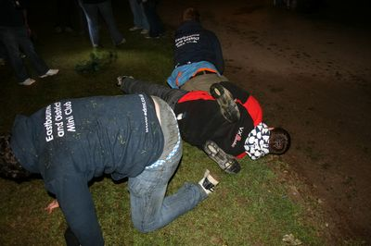
Drunken antics!
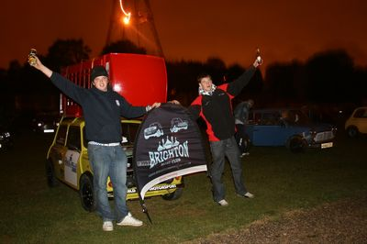

_______________________________________________

“We left home at about 1pm Saturday straight to the nearest petrol station to fill up, then over to Jims for 2pm; remembering to park the car down the road so people don’t realise Jim knows someone with a Bini!!! After we all had a chat, the convoy of 4 minis & a Bini went up the A21 to meet a few more people then off to ‘John Cross’ to pick up Gareth & Gemma.
8 minis strong we meet Alastair (liirge) with his Moke at the services just out side Tunbridge Wells, then headed up to Crystal Palace. A few of us lost each other on the way up in traffic but we all got there fine. The weather – well, was damp but at least it was not raining!
As soon as we all set up camp, the drink came out & it never stopped. A few of us popped down the road to get some more drink, food, & a gazebo!!! Up that went & out came the BBQ’s.
Halfway through making dinner we notice a few people lining up so we jumped in our cars & started to line up all by 7:30pm.
The evening was so funny once people had a few drinks; Alan & few others went to play on the bouncy castles, while others finished off the food.
Late in the evening when a few people had a few too many, Alan & Tristan ran over to the Brighton club camp where Simon was & jumped him - they were all on the floor, beer everywhere & everyone laughing! Then they stole the Brighton Club’s flag & went running round the site getting photos of it out side different cars until Brighton came running after them.
We were all woken up at 5am by some wally setting their sports pack alarm off. Thank you!!! So we all got up, cleaned up the many many bottles & made breakfast. Afterwards we put down the tents & watched the minis coming in until it was time to go. The line started to move but Alan’s car would not, so it was push down to one side & half an hour later he was on his way!
Once we got to Purley round-about we meet up with Simon & took the back route up & down country lands through housing estates & then ended back on to the M23.
Once we got to Brighton, we were put up the other end of the show so we had a nice big walk to do - lucky it was not raining though! On the way down, we looked through the stands & then meet up at the EDMC club stand - which should of won. It looked really good & a lot of heads had been put together to get it right. Well done!
At about 5pm we jumped onto the tram & got a lift down to the marina end to collect the car; better than walking!
It was a brilliant weekend, first time in 6 years I have joined in & done the run… & had a mini to do it in.” Account by Dean.

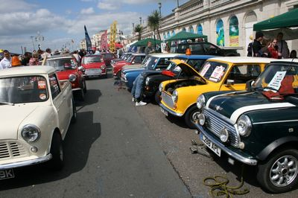
A well planned & created stand – well done team!

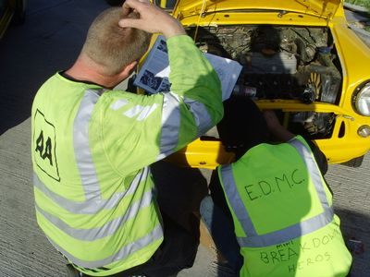
Alan assists the AA man after a break down on the way back home!
______________________________________________

A not so early meet up at 7:15 on the A27, (thanks to Tony for the lift), the stand goers started to arrive, initially to find Neil & Hayley already waiting in the lay-by… well, Neil anyway, as Hayley wasn’t allowed out of the car until Brighton due to the door latch playing up! Before I knew it, everyone was ready & rearing to head for Brighton.
The organisation this year was much more precise than last, as the event staff knew where we were going for once. Tightly packed up at the pier end of the Maderia Drive, we were quick to start the set-up and get our overalls on. Everyone did a great job creating the theme of EDMC Breakdown & Recovery – every mini owners Hero! Neil’ pickup come tow truck, Pauls’ on tow breakdown, Dez & Tony’s fake legs & arms (Bert & Ernie) a& Shawn, Jim & Alexandra’s minis in mid-repairs.
With the recruiter stand set up to promote the club & Pilgrimage, & most members sporting their overalls, we were convinced we were on the winning path for best club stand!
Which was more to say than for our poor go-cart! Made in proper ‘Scrapheap Challenge’ style (or otherwise known as the ‘Cornell Garage Challenge’), the proposed pick-up style cart had a life expectancy of 25minutes; 15 for trial time & 2 runs on the day (max.)! Surprisingly, it out lived its expectancy & survived longer than even its competitors. But not enough to win the race sadly.

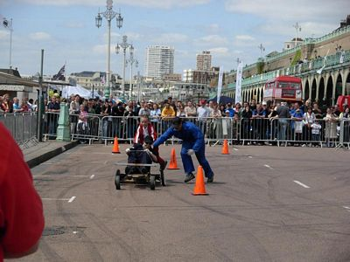

With bruises & war wounds, the carters (Daz, Carl & myself) slowly made the long way back to the stand, where more EDMC members had gathered, showing off their bargains & telling stories of the night before… poor Alan!
With the kettle on the go most of the time, we were really getting into the mechanics’ garage mood!
As the day went on, all we could think of was the potential of a prize. With thinking the only competition was Brighton Club (with their theme of the life boat rescue crew) we waited potentially for the results… only to find no mention at all for our efforts.
Well – enough said.
The packing up was as quick as the set up that morning, & soon enough we were all on our way; tired but thoroughly enjoyed the day.
Many thanks to all those who helped & took part in the stand – all our efforts will not be wasted… especially when our photos keep appearing in the papers, magazines & in next year’s L2B programme! ☺
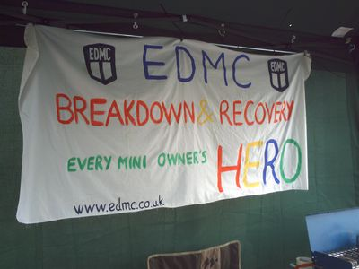

IMM Report
With the International Mini Meet (IMM) coming to Birmingham in 2009, this was our last opportunity to get to an IMM on the continent until 2010. Just been the other side Amsterdam in Holland, the mileage was on par for a drive to Newquay. So a plan was hatched, IMM or bust....
The plan consisted of four cars. Sadly Paul discovered excessive rot in his Cooper's shell a week before departure. So all efforts were thrown into his mainstream. Welding stig was dragged in to finish a boot floor repair. Paul got it through the MOT mid afternoon the day before the sailing.... Emotional is an understatement for Paul's condition!
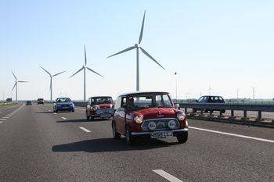
That evening Martin and Eric made a bee line to Dover to chill at a B&B, sadly the fuel pump died when pulling away, the usual method of bashing the electric SU pump with a hammer failed. At gone 9 o'clock, Martin loaded up his VW Golf and headed off to the B&B with Eric. Both a little disappointed.

Our problems emerged as we checked onto the ferry Friday morning... I'd booked the ferry for the next weekend! Lucky the young lady at the booth was not offended by our charms and sorted out the tickets. Paul discovered his fan belt was loose and Neil attended to Si's faulty brake switch. Eric and Martin joined us, fresh from the B&B. Their Golf soon acquired additional baggage from my Mini.

It was a beautiful crossing over to Dunkerque; we congregated for Paul's Birthday fry-up. He donned the birthday hat and was serenaded with an all to familiar birthday song from us. Loving the sailor pose.

We came off the ferry and headed East for Lelystad, Holland. Busy roads, but the weather was great. Neil and I drove the entire route will all the windows down it was that nice. France turned into Belgium, Belgium blended into Holland. We hit a little slow traffic when the scary moment occurred. To my horror I saw both sides of Si's car in the rear view mirror. Si was dubbed 'Captain Brown'. Thankfully laughed about.

By 3 o'clock we approached our destination, poor Neil had been forced into navigating the route and did well too. We'd arrived to a 1-mile queue of mini's... Kay and Karen from the Miniworld where a few cars ahead and so we said hello, Neil corrupted Sophie into pulling wheel spins off the mark in Paul's mainstream.

Into the venue we went, and what a venue! Lelystad is a vehicle test centre and the IMM event was setup in the middle of the oval track, banked corners at either end. The pitch went up and soon after a couple of cars where despatched to find beer and pizza. Paul and I found a little square with some bars and restaurants; pizza was scoured from the Italian. I lead the way out, along a cycle way to the local’s surprise. We did a little walk around the IMM cars but by midnight we had all retired.

Saturday, a beautiful blue sky and warm morning got the ball rolling. I got breakfast going. The event was really something, a good turnout of traders and plenty of really interesting auto jumble from the Innocenti minis. Oh and Moke heaven! Lots of really novel stuff not seen in the UK, along with the prices. Everything was a lot more expensive due to shipping out of the UK. Near all of the cars are in great shape, not many rotters could be found! I think I only saw five broken down cars over the weekend. Some of the customisation was amazing. A low loader mini with a AA van on the back to a very slick V8 installation in the back of a pickup.
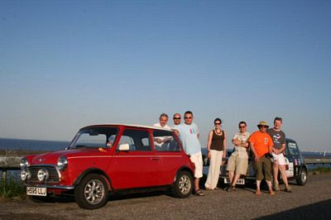
By the afternoon I was dying to get on the sprint. Si came as a passenger but a quarter mile in 19 second was unacceptable, Si was quickly out along with the spare wheel and anything else removable 18.8sec... so I duck taped up the seams and got 18.59. I convinced Si to do a blast down the sprint, not sure of the time. Paul turned up and clocked 18.4 on his second run, different gearing I say. Lol

The Saturday evening meal was provided in the event ticket. We went for an evening drive out onto a 20 mile plus course way over the sea for a few pictures. A little later we ended up at the same bar as the night before in a pleasant square. The heat of the day still radiated from the ground until past nine. A mix of beer and wine washed away a banter filled fine evening with great company.
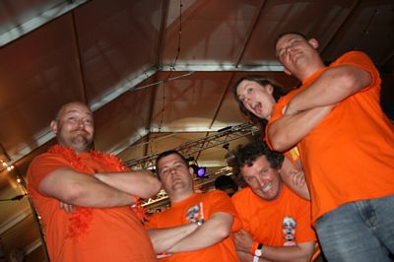
On return to the IMM venue the sun was heading down, we polished off some more bevies and made our way to the live act in the main tent/dinning hall. The 'orange' themed evening resulted into major booze up, Martin being acknowledged as been a legend. Neil put Martin to bed and we continued to party for at least an hour or two. We returned to our pitch to find Martin sleeping in the long grass way away from the bed he was left in. Neil confirmed his vitals were is good order and proceeded to document the event with photos.
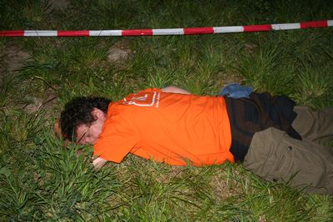
Sunday, a beautiful blue sky and hot morning was not welcomed by our group of hung over travellers. Breakfast in a bag was supplied with our entrance ticket. The first order of the day was to get our cars into the World Record attempt for the longest convoy of same make cars, Bimi's and all. I just about got my body working to get in there, Neil and Si got some enthusiasm later. Paul took Sophie to the train station as she had to be home that night, he managed to cut in with me. 896 mini is quite a sight! About eleven o'clock the cars where fed off, over the two hours we went out about three miles and back again. The back again was the interesting bit, watching the other cars go the opposite way, mini after mini after mini!

Martin was still suffering, so we left him behind for lunch at Burger king. Eric tried to order a doughnut, the poor Dutch girl had trouble with Eric's accent. So he descried it as 'like an onion ring, but made of cake' to our delight.
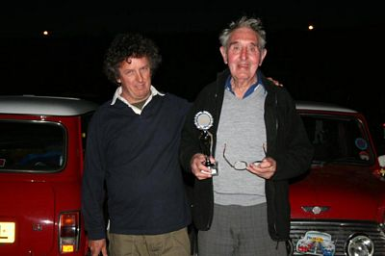
The relaxing afternoon led to some preventative maintenance of Paul's near side hub bearing. We shopped around and managed to find one for 30 Euros rather than the going rate of 45. It was replaced in under thirty minutes with the gun of fun and Neil's pessimistic supervision. We all went for some drinks and food and the same square visited over the last two evening. By the time we where back, it had gone ten. We missed the handing over of the key to Birmingham Mini Club and the awards. Jo Holland sprung us with an award he had collected.... for Eric as the oldest percipient.

Monday. We packed camp very quickly and went for some photos of the banked corners. Being a public holiday the roads were bliss. Neil plotted a route up to the coast on the 'B' roads and crossed into France to the Ferry in perfect time and a relaxed pace.
Truly a mark above any show I've been to and only beaten by the Italian Job for me. The international crowd is really something, friendly and fun. Mix that with our EDMC crowd and it only adds up to some great times. Roll on IMM 2008 in Birmingham and 2009 in Bavaria, Germany! Account by Simon [Mininutter]
Many thanks to all those who put their write-ups & photos to this month’s newsletter! It is very much appreciated & I hope that everyone has enjoyed reading it!

Kind Regards
Josie - Editor

Pilgrimage Page – 29th June – Beachy Head to Canterbury

Dear EDMC Member
The Pilgrimage is now only a few short weeks away. The entry fee is a mere £10 per car. BBQ lunch will be at the Palm Tree Inn where you can buy burgers or hotdogs for just a couple of pounds.
This year we are delighted to have a special guest, Derek Ware from the original Italian Job, who will wave us off at the start at Beachy Head! Derek is looking forward to the day & is more than happy to chat to members, sign autographs & pose for photos. We also have a large picture taken from the film that Derek will sign for us to raffle at the end of the day.
Our nominated charity this year is the Lee Spark NF Foundation who help sufferers of Necrotising Fasciitis, which is a flesh eating illness caused by streptococcal infection. There is no minimum amount that you need to raise, but any donation will be gratefully accepted!
To help raise funds for this event, we are attending the car boot sale at Cophall Farm, Polegate on Sunday, 1 June. If you cannot make it that day, but would like to donate items for the sale, (they do not have to be mini or car related,) please contact Darren or Rachel, who will arrange collection.
This is our big annual club event & we are hoping to make 2008 the best yet, but in order to do that - & attract other clubs for future years - we need your support! Entry forms are available from the main website www.edmc.co.uk or pick one up at the meeting on 2nd June.
We are also hoping to arrange coverage of the day by one of the mini magazines. This will be an excellent opportunity for us to spread our name on the mini scene & show others how we have fun & raise money for a good cause at the same time. So, please give this event your full support & I look forward to seeing you on the day!
Rachel
[EDMC Secretary & Pilgrimage Co-ordinator]

Prom night approaching

26th June is fast approaching & at least 10 bookings have been made. Lisa is planning a route to collect all the party-goers. Please contact Lisa to confirm that you are able to attend. We are expecting to meet up at approx 5.30pm for some pick-ups outside of the Eastbourne area, to then re-group for the remainder of the route. If you can make the early 5.30 start, let Lisa know. Otherwise there will be a later meet point arranged. Keep an eye on the forum for more details or speak to a committee member.

Co-op Charity day

On Saturday, 14 June the Co-op in Framfield Way, Eastbourne will be holding a charity fun day to raise money for the Lee Spark NF Foundation.

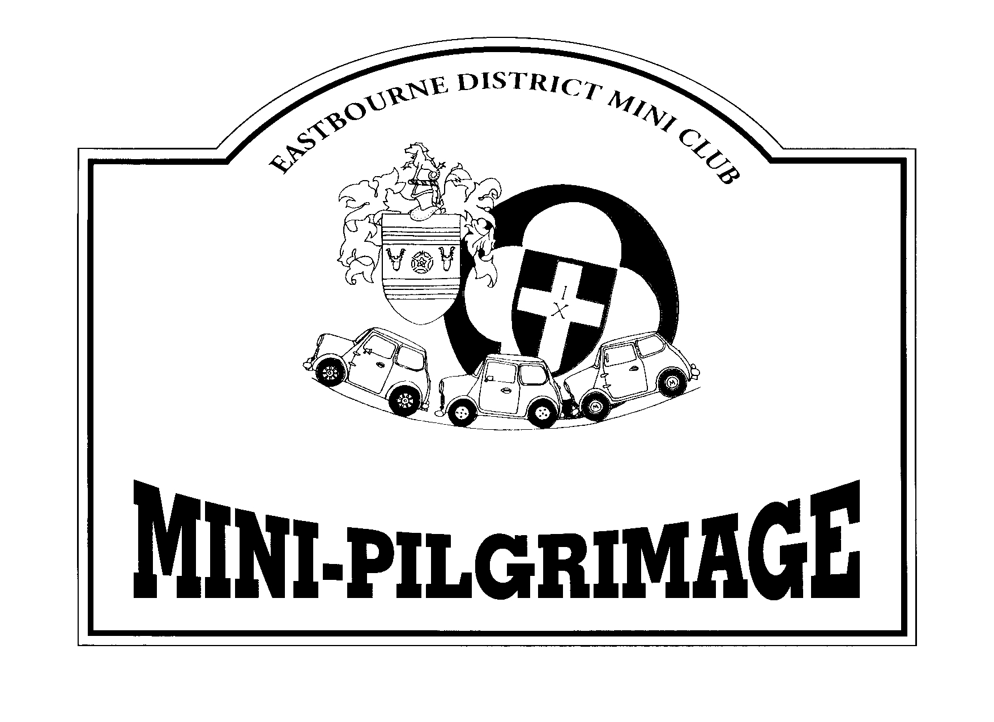
The fun starts at 10am with Rachel being locked into the stocks for people to throw wet sponges at her, (a great opportunity for some), hopefully followed by several staff members and maybe the odd customer or two!

As well as some live music, there will be a raffle, guess the name of the teddy bear, two 11ft giants, tombola, face painting, refreshments and much, much more!!!

If you are in the Eastbourne area that day, please come along, join in the fun and give your support. Thank you.

