
No time to waffle!
* EDMC Newsletter *
June ‘07
Issue # 15

This month’s message is short but sweet; purely because summers’ here! I don’t know about you, but I’ve got a mini to clean & then take it for a drive round those winding country roads, end up at a pub with a cold beer, chill out & chat ‘til the sun sets! So in that case – I hope to see you there! Regards, Josie.
‘The Best of 2006’
I’m still looking for photos to be put forward for our ‘Best of 2006’ picture votes. Please pass on any entries at the club meetings or e-mail me at the address on the bottom of the page.
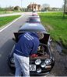
Here are a couple off entries so far!
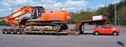

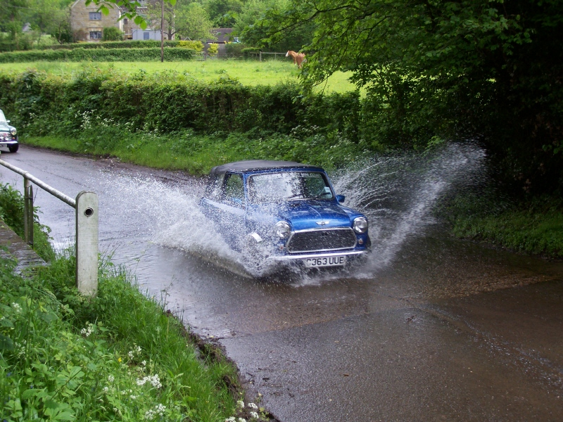
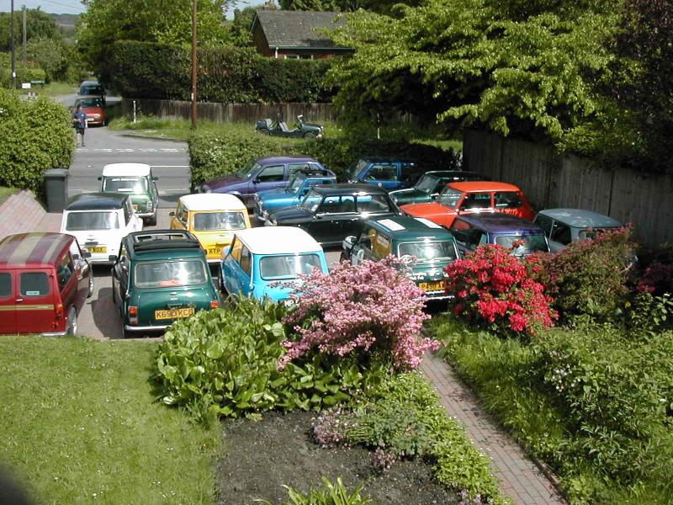

Mag motors Photos
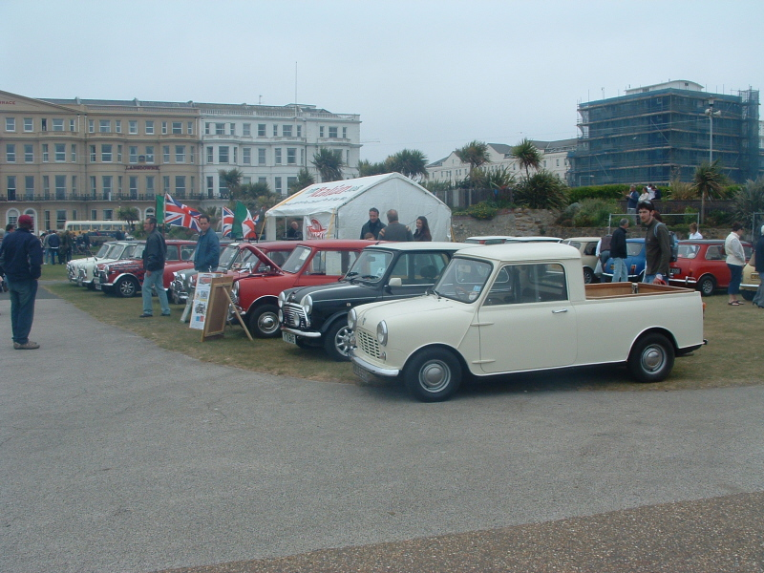
Here are just a couple of photos taken from last months’ event held in Eastbourne.

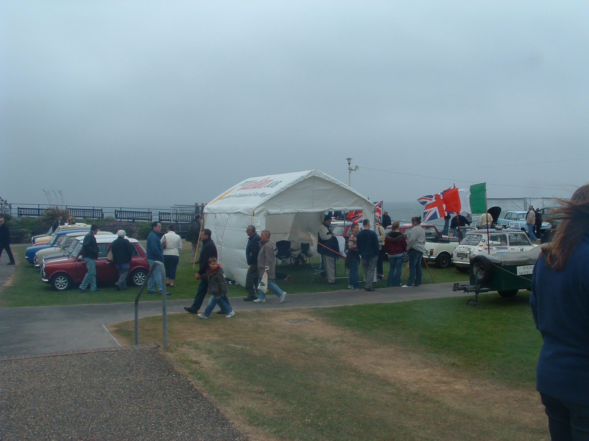

Stephen’s Cruise
In Stephens’ own words, “Feel I’ve been a bit lazy recently so thought I should organise something!” Planed to be a local cruise set for either a Monday or Tuesday evening, but there’s talk of even making it a Sunday event with a pub meal at the end of it! All he asks is for £2 entry to go towards the EDMC mini Pilgrimage. As it will be similar to one from about 2 years ago, I promise it won’t be one to miss! Keep an eye on the forum or e-mails for more information

London to Brighton Run ’07
Account of the day
3.00am & the alarm clock sounds. Having managed to grab a precious few hour’s sleep I bounced out of bed full of excitement in anticipation of the day ahead. After a quick bit of brekkie & bath I woke the rest of the household who were less than enamoured at my high spirits. Eventually I got them moving & we met up with the rest of the club who were cruising up from Eastbourne at 4.30.
Neil led the way along our customary route through some lovely country lanes (I prefer this to doing the proper run). Paul did a quick detour after remembering he had left his ticket at home, but soon caught us up. Various forms of wildlife entertained us in their efforts to escape our wheels & we made it to Crystal Palace soon after 6.
Within minutes we had set our BBQ’s up on the wall & EDMC smoke signals could soon be seen, along with the wafting smell of bacon & sausages.
Dave appeared a while later & not too happy as the sidewalk had only just made it. After a failed attempt to get it going with Gary’s battery, a small band of mechanics went to investigate & found the problem to be a faulty wire. Dave then left to get to Brighton early to join his Mk1 on the Miniworld stand.
Alan & a few college mates had camped overnight & were at the front of the queue. While they were making their way to Brighton, the rest of us had to wait our turn.
We finally left Crystal Palace at about 9am & soon were split up by traffic lights & roundabouts. Eventually, we all made it down to Madeira Drive to meet up with those who were sensible enough to opt for a lie-in & set up our club stand. Josie’s hard work transforming our humble gazebo into Gypsy Jim’s fortune telling tent really paid off. Gypsy Jim him/herself kicked off our EDMC cross-dressing theme * soon, most had changed into their eye-catching outfits. The mini’s on the stand looked great with their moustaches, eyes & handkerchiefs on their “heads”. Thank you Tony for your artwork. Hank looked particularly good as a huge sandcastle!
The fun & games in the main arena started early afternoon with the soapbox challenge. Team EDMC were Daz (minus high heels for this event), Josie & Tom. They each took turns in pushing & riding in our superb deckchair based go-kart. The sight of Daz trying to run in a dress drew a lot of laughs from the crowds of onlookers. Though they finished the course in good time, it was not enough to take a prize. Well done though to Gaz, Paul & Daz for their great creation!
Next up was the pit-stop challenge. Team “Nut Breakers” made up of Josie, Alex, Shirley & Myself huddled together for a final team talk by Josie & a quick confidence boost. The boys; Paul, Dave, Daz (still in a dress) & Alan looked cool, calm & collected. The organisers went through the rules & instructions before we were allowed to climb aboard our “Bini’s”.
A screech of tyres by Josie we were off. We all rushed to get our equipment & were soon down to work. The boys were like a well oiled machine & soon had the job done in about 4 minutes! Meanwhile, the girls were struggling with their locking wheel nuts, but cheered on by team coach Jim & a large crowd of admirers, we too, finally finished in a time of 8 minutes. Once we had caught our breath, we were informed by the organisers that no other teams had appeared to challenge us. After a search for the missing teams & much discussion as to whether we should go head-to-head again, another team was found. Our brave boys went into battle again & this time finished in a very good time of 3:47minutes. As no further teams were willing to risk the chance of being beaten by a bunch of girlies, the competition was closed & our team of boys were declared the winners!
Tired & hungry, we made our way wearily back to the club stand to change into more suitable clothes & then headed off for a late lunch.
Other club members had taken advantage of the trade stands & numerous purchases were made, while some just enjoyed the sunshine & lounging by the club stand.
Later in the afternoon we made our way to the Miniworld stand ready for the prize giving. Eventually the announcement came for the winners of the pit-stop challenge so Dave, Paul & Daz made their way to the stage to collect their trophy from Monty & have their photo taken…hopefully for the magazine. They then rushed off to collect the spoils of war - 4 jacks, 4 wheel braces & 4 torque wrenches.
A very happy, but tired, gang of members set about dismantling the stand & packing everything away & London 2 Brighton 2007 drew to a close.
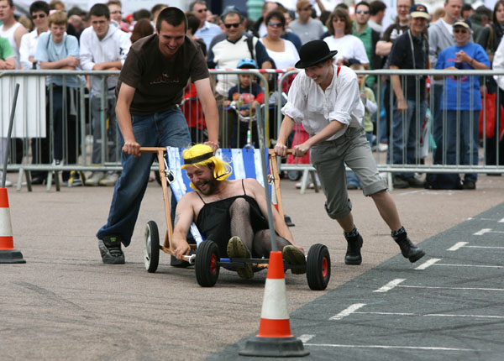
Thank you to everyone who took part & helped with the team events & the making of the club stand. I hope you had as good a day as I did! [Reported by Rachel]

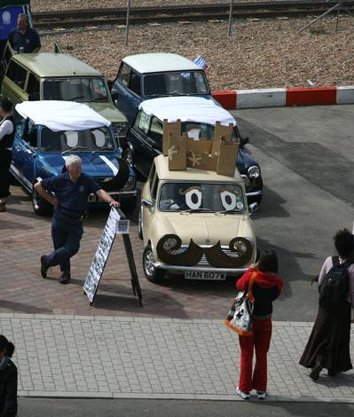
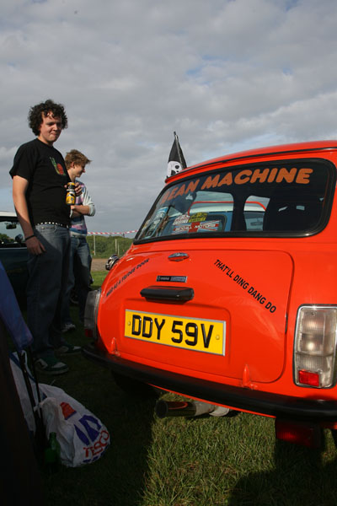

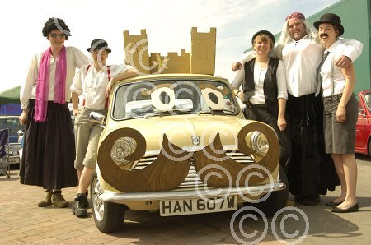

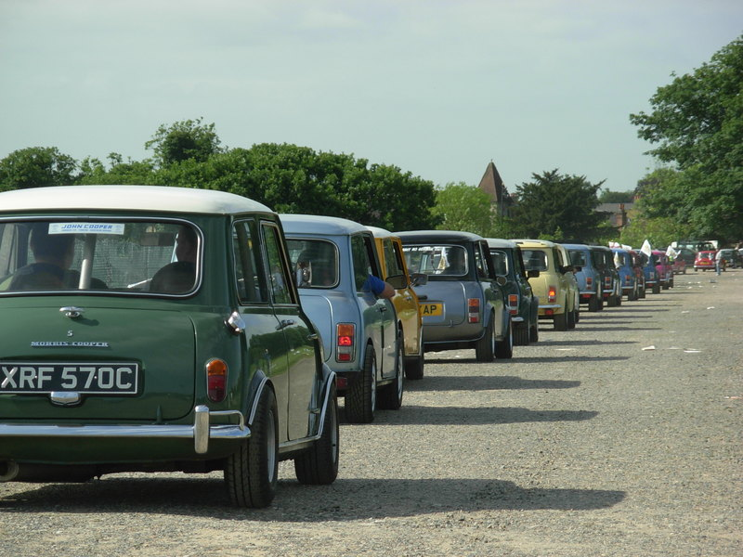

‘Pit Stop Pitting’
The EDMC girls against the boys were unfortunately the only teams up for the L2B Pitstop challenge at the start. The idea of the challenge is to drive a Bini into the show arena, 4 team members jump out, jack up one side of the car & swap the wheels from front to back, torque the wheelbolts to correct tightness before doing the same on the other side. Once all four wheels are swapped a short sprint (in some cases) is needed back to the finish line.
The girls had been practising, the boys had not bothered since the Pit Stop Challenge 2006, actually they did not for that either .....
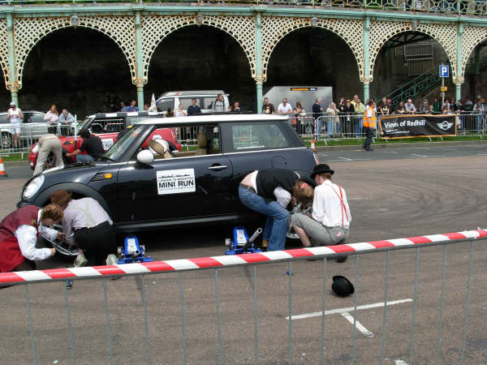
We chose our BMW Minis, the boys liked the look of the lock nuts on one car so they went with that one.
Josie got a good start…(for her), beating Paul of the line. The race was on! Speaking as member of the boys team it did not go exactly according to plan but apart from a couple of fumbles (typical males) we did ok & managed to finish in 4mins 10seconds just as the girls were starting to swap the wheels on the drivers side of their Bini. Loads of encouragement was shouted & the girls finished shortly after.
That was it, no other teams came forward to challenge EDMC; we were declared the winners until the organiser thought it wise to try & find another team. Eventually another team was found, cobbled together from LSMOC I believe.
Again we chose the same Mini as before, Paul gave it large from the line & we were off. I knocked the locking wheel nut key out of Darren’s’ hand & under the Bini, which slowed us slightly but we came through to win in a time of 3mins 47secs.
That’s a quick time: drive into the arena, swap all four wheels, torque them up & run back to the start! Not bad going guys! The other team were doing up the wheels on the first side of the Bini as Team EDMC passed the finish line.
A great challenge & we all had fun! Congratulations to all of Team EDMC; Alex, Josie, Rachel, Shirley, Paul, Alan, Daz & Dave.
(an account by Dave)
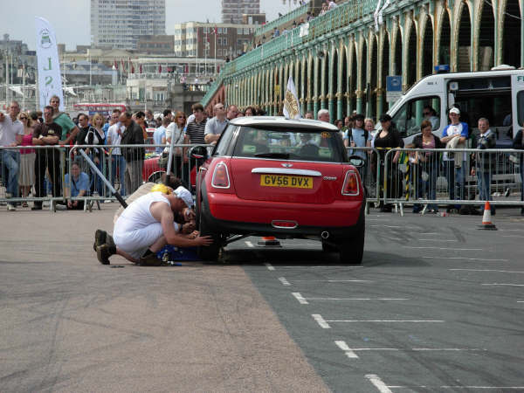

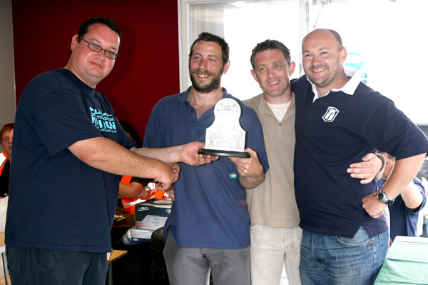
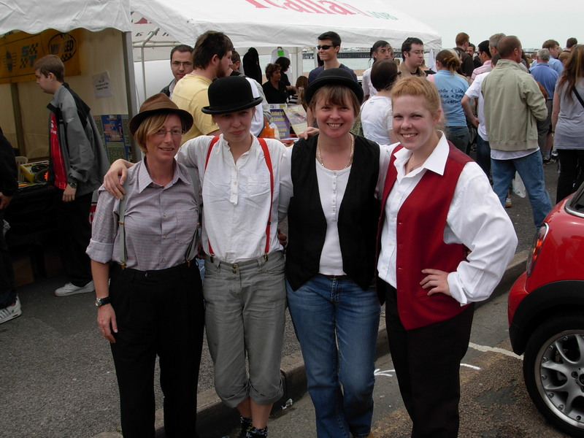
Dave’s Page – Events Co-ordinator. E-mail edmceventsco-ordinator@fsmail.net

Castle Coombe Track day
This year, this Mini World action day event will be taking place on Saturday 29th September at the famous Castle Coombe Race track near Swindon. Places are limited, so please talk to Dave (Events Co-ordinator) at the next club meet to reserve tickets. Priority will be given to club members so also make sure you have valid membership.

Minis on the ‘Wreck’ - update
Brighton Mini Club Show, "Minis on the Wreck”, will be held at the Adur recreation ground Shoreham on July 7th & 8th. Admission £7 for both days & includes camping overnight if required. There will be a cruise Saturday evening. If you would like to show your car, email the details & pictures to address below. Entry into the event will be half price if your car is on show. For more info checkout details in the Events section of the EDMC website forum or www.brightonminiclub.co.uk or email BMC events colm@brightonminiclub for more details.

Mini Cruise – 2nd Sept
Steve Medhurst is organising a charity event cruise to help support the Italian Job rally charity, NCH children’s Charity. The route will include stopping at Filching Manor grounds for photo shoots & even a stroll round the museum, which is special because it is not usually open to the public! Cost for the museum is £3. Also for a special price of £10, members can go on the Kart track 15 min's, which should work up an appetite for the meal at The Star carvey at the end of the run. Steve will need to know how many people would like to go for the karting, so they can keep the track clear for us. The run will also try to incorporate a stop at Heaver Castle. More details of the run will be given at a later date, but please let Steve or Dave know if you will be taking part.
Mini world have also be invited on the run so Montie may also be making an appearance!
If you are interested in taking part in any of the events, or would like to find out more, have a chat to Dave, or e-mail at the above address

Southern Mini Days ‘07
The theme this year for SMD as most will know is Hollywood! Thinking caps are already on & buzzing with ideas for club campsite & fancy dress theme. Dates are 3rd-5th of August, held at the Hop Farm, Paddock Wood in Kent. Pre-booking as a club will not be available, so please book individually. There are plenty of application forms around so ask at the next club meet or e-mail a committee member. Pre-booking is cheaper, but you can still buy tickets at the gate. See prices below, (those in brackets are at the gate).
For all weekend camping from 4pm Friday
Adult £12.00 (£15.00)
Child (3-15yrs) 7.00 (10.00)
Family (2 adults, up to 3 kids) £32.00 (40.00)
Single day ticket prices (sat or sun)
Adult £7.50 (£8.50)
kids £6.50 (£7.50)
Family £25.00 (£28.00)

Please note: if day tickets only are required, do not use the booking form/leaflet – please book on line (www.smoc.co.uk)or call the number provided on the form.
Pre-Booking closes July 25th!
Mini Pilgrimage – last call!
Pilgrimage run will be held on Sunday, 24th June. Monies raised this year will be going to The South Downs Community School, Eastbourne. The start will take place at the South Downs school & end at the Kent & Canterbury hospital. June club meet will be the last date for entry. Forms & more information are available on the main EDMC website, at the club meeting or contact Rob at edmctreasurer@fsmail.net or henrob6166@aol.com . There is no minimum for raising money, but every penny counts!

