
In The Summer Time…
* EDMC Newsletter *
Summer has pounced on us just when we thought there’s no chance after L2B! So much is going on & so little weekends spare to do everything in! The Minis are washed (regardless of the hosepipe ban!) the polish is out, BBQs are burning & plenty of summer fetes & charity do’s are stripping us of our money for good causes! Ah yes….Summer has arrived!
Regards, Josie.
Rosie’s Day Success!
Rosie’s Charity day fell in good weather & a fun day we had! After darting around between supermarkets handing out leaflets, the 7 Minis from EDMC parked up at the Rugby club in the blazing heat to find food, games, beer & music! The total raised during the day for Rosie’s charity support 4 pseudo was a whopping £1000 (£300 of which was gained from Jake’s leg waxing – although he seemed to enjoy it!) Rosie wishes to thank everyone who contributed. To find out more about Rosie & her illness please visit www.support4pseudo.co.uk.

Summer Fete – 16th July
Bean Machine (Al) & a group of scouts are organising a big summer fete to raise funds to send them to Poland for an award.
It is being held at William Parker school in Hastings 7 they are hoping that some of the club would come along to show off the cars & let people know about EDMC & what we do. There will be stalls with lots of different things going on & even possibly a bouncy castle for all those big kids out there! Brass band & other entertainment too. So if you’re looking for something to do during this lovely summer, take a drive to Hastings for a good day out with the family! (For more information chat to Al, or click on the forum)

Events coming soon…(plus organisers)
- 17th to 18th June – Mini Racing Festival, Leicestershire
- 18th June – Eastbourne classic car show (?)
- 25th June – EDMC mini Pilgrimage. (Rob)
- 6th July – Mod ‘n’ Mini night, Ace Café, London
- 7th to 9th July – Goodwood Festival of Speed
- 16th July – Brighton Mini Club Show – ‘Minis on the wRECk’
- 30th July – Mini World Show, Sanddown

Minis on the wreck! 16th July
12th June 2006
Issue 5
Brighton Mini Club have invited us to their first show planned for 16th July. All our profits will be going to The Rockinghorse Appeal, which is a charity run for the local children's hospital &helps them with buying much needed equipment. Camping is available from 5pm Saturday 15th, toilet facilities are limited.
The Show starts at 10am with clubs and trade arriving from 8.30. The day will finish around 5pm.
Activities for the day include:
Trade/Auto jumble stands, ICE clinic(Stereo Advice and tuning), IASCA UK Champion in rookie class will be there in his BMW Mini along with a few SQ cars, Radio controlled track - bring your own RC cars, Scaletrix track, Raffle prizes including mini parts, vouchers & a rolling road power run, Tombola, Fun Games, Children’s Fair rides, Bouncy Castle and an Entertainment tent(live band, comedian and magician. Also during the day there will be Hot food & Ice cream, Best club Stand comp, Car of the show, Wreck of the show……….
…………….and much much more!!
If you’re interested in taking part let Darren know.
For more information about the charity, please visit www.rockinghorseappeal.org.uk

Sussex Cruise & BBQ thanks:
Simon & I (Josie) would like to thank everyone who attended the cruise & BBQ on the 28th May. The weather held out pretty well & around 12 cars took part in the morning drive around our area. Apart from a little shunt there were no injuries & no food poisoning from the BBQ feast! Also thank you to Shirley for the wonderful deserts and Jim for providing the much needed shade of the gazebo! We managed to raise exactly £100 towards our Mini Pilgrimage entry for the 25th this month. If you missed out…don’t worry, as I am sure it wont be long before Simon gets withdrawal symptoms from BBQ entertainment!

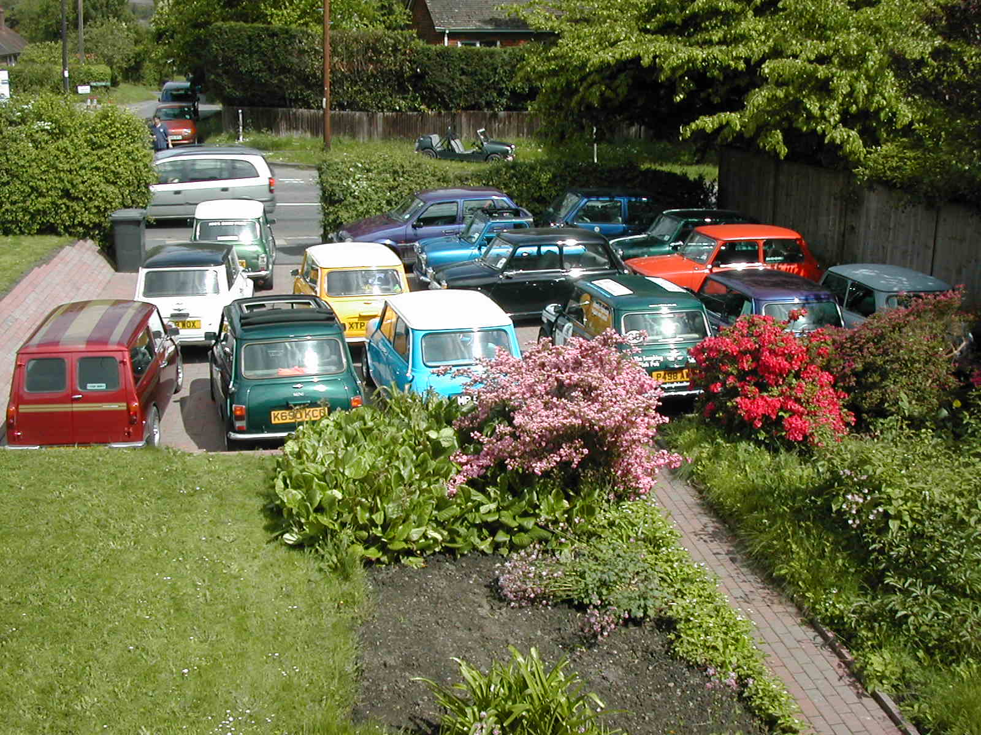

Mingie 3 Arrival:
A personal account!

The day is Friday 20th May; the sun is trying to break through the clouds. I have phoned in sick at work for two reasons, the first been I had a job interview in the morning and the second I had to travel to Birmingham to fetch Mingie 3.

Let me rewind a few days, while browsing eBay I came across a little blue number with a black leather top, I fell in love instantly, I bid not expecting to win the love of my life, sorry my third love of my life (the first and second being Heather and Marc). The bid stayed at £880 until the last few seconds when somebody bid £900, the auction ended, I was jumping for joy as I had won the auction with the highest bid which was £900.01.

Fast forward back to Friday, Tony & Rachel kindly offered to take me up to Birmingham to collect Minige 3 as they were going to Luton to pick up Bogey who recently had a new engine installed. Rachel couldn’t make the trip for work reasons but met up with us later on in the day.

We left Polegate around 1pm and was making good time until we hit the M40 where it seemed that at every junction we hit a queue, we carried on and this time in between junctions was a another queue, all it was a bit of rubber necking as people decided to slow down to have a look at the accident scene on the opposite side. We carried on and the queue on the other side went on and on and on and on. Tony was taking the Mick, and I said better shut up or it will happen to us. Anyway finally made it to the place we were going around 5.30 pm (rush hour traffic) Money crossed hands, paper work signed and I was the proud owner of Mingie 3.

We left Kinswinford and found the M5 for our return journey to Luton, but after a few miles Tony radioed and said we are going the wrong way, so a turn around later we were heading the right way (first delay). Finally got on to the M1 and this trip was straight forward apart from the slowing of the wipers the continuously on indicators, the dimming of head lights, and the gauges going down, didn’t think much of this until we arrived at the bottom of the slip road into Luton where Mingie 3 died. Tony went off and got Gav who only lived round the corner. Was towed onto the roundabout by Gav (wish I had taken a pic) and then hitched to Tony who took us the rest of the way. Gav tightened up the fan belt and put battery on charge. We went off for Chinese.
After Chinese we set off for home as Mingie 3 was working now, Rachel had Bogey back, and Tony had borrowed Gav’s Mini. The trip was pretty easy apart from the torrential rain, and we made it down to the M25. Approx 3-5 miles before we need to turn off for M23 Rachel’s voice is heard over the radio “Tone, my windscreen has shattered”. we pull over on to hard shoulder take a look and decide if Rachel is happy enough to drive the next few miles to Pease Pottage we would make our way there, I was in front Rachel behind me following my lights, and Tony behind telling Rachel to stay in lane. I must point out that the windscreen had stayed in its proper place. We gets to Pease Pottage services and get out and as Rachel shuts her door the windscreen let out its final gasp and collapsed over interior and bonnet.

After hanging around for Recovery people to tell Rachel they won’t get a window fitter out at this time of the morning (2amish) and waiting for recovery truck. Also after about 4 cups of coffee to keep us awake, we left again, Bogey on the back of a truck and myself and Tony in convoy back to Eastbourne.

I arrive home around 3.45am, but I can honestly say that it was well worth the trip.

And I would like to say a really big thank you to Tony and Rachel for there time and offering to take me to collect Mingie 3.
Darren Brown ‘Aka The Boss’

Darren’s Donation to the Pilgrimage Run:
“After seeing Jake have his legs shaved today for Rosie’s charity I have decided to get something done myself to raise money for our Pilgrimage run.
I will be having my chest and stomach hair waxed off in jake stylie.
So I need a volunteer who knows what they are doing to do it for me, and for the rest of you to give me a sponsor!
Look forward to a bare hairless chest.”
(Ouch! Good luck Daz!)

(Pictures removed due to the file being too big for emailing! Sorry!)

L2B –Washed Away!
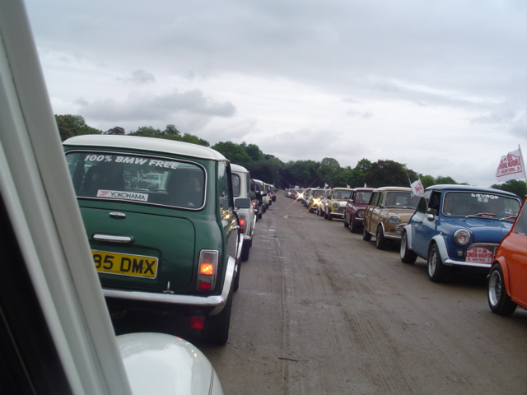
Rained a bit, but it was still a good day. If you didn’t go – you missed out on wet socks, wet carpets, wet ignitions, an entertaining soap box race and BMW mini wheel change race which we won hands down – but not the best times of the day sadly. It was our first outing using radios as a group, quote Neil to Josie over the radio, ‘I’ll have a pair like yours!!’
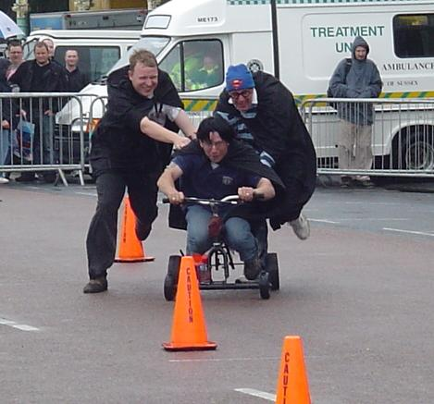
Simon B – The Mininutter

(Some Pictures removed due to the file being too big for emailing! Sorry!)

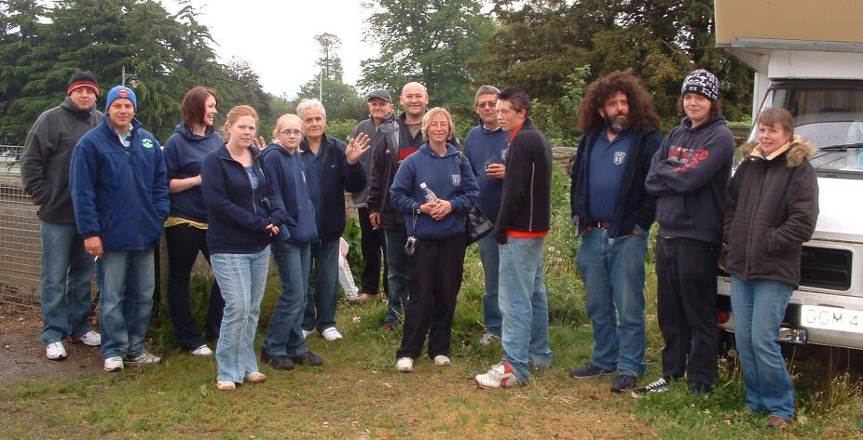
(For more pictures, e-you’re your request to edmcnewsletter@fsmail.net & I’ll send you some)

