
Is it really Summer?!
* EDMC Newsletter *
July ‘07
Issue # 16

I thought July was supposed to be sunny? Many are being washed away by the un-expected & un-wanted down pours – but the mini events still continue through thick & thin. Lets hope the weather improves soon as there are still many more events to come! Regards, Josie.
‘Hush hush’ – leaving the meetings
It was noted last time by the Sports club, that there was excessive noise after the last club meeting. Please can everyone respect the wishes of Langney Sports & Social Club by keeping noise to a minimum when leaving the club. For example; no wheel spinning, no handbrakes turns, no revving of engines etc.
If the noise continues we stand to lose the use of the hall.
Thankyou all for your co-operation
Regards, Darren, EDMC Chairman
Photo opportunity
Time for an updated club photo – on evening of 9th July before the club meeting, it has been arranged to meet up prior to arriving at Langney Sports & Social Club, at the Langney Shopping Centre car park between 7-7.30pm at the Kingfisher Drive end of the car park. When you arrive, Paul & helpers will be co-ordinating positions of cars & people so to get the best photo shot. We would like as many club members as possible to be there, so get the minis out & washed & get to Langney Shopping Centre about 7pm!

Simons’ Sunday Bomb!
Simon’s itchy fingers have caused him to organise another cruise for Sunday 22nd July! The route involves a run around the Sussex countryside & finishes at Barcombe Mills (just outside Lewes) for a cola & some fun in the boats!
Hire of the boats are £5 a person. Kids are £3 each. Check out http://www.anchorinnandboating.co.uk for more about the boating)
Simon’s plan is to meet in the 'Cruise Lay-by' at 1pm, Westbound on the A27, outside Eastbourne between the roundabout into Pevensey & the A22 bypass into Eastbourne. The route will end at Barcombe Mills no later than 3pm, for those who just want to come along for a drink & watch the boating.
After all the fun, we’ll head off about 5pm for the drive back to Eastbourne (maximum of a 45minute drive).
Please could you contact Simon in advance if you’re interested in the boating, so He can organise a group booking/discount. On the forum (Mininutter) or edmcwebeditor@fsmail.net
Or on the day, 07875 056610.

Mini Pilgrimage
Account of the day
On a wet, Sunday afternoon in June, the minis gathered at the South Downs Community School for special needs children for another Mini Adventure! Shortly after arriving, the gazebo was put up to keep the rain off the first (and only) repairs of the day. A quick wheel change for Lisa & Matt was required for their balding tyres, with Lisa getting a quick training lesson from Simon. After a photo shoot from the papers & the rest of the gang arriving, we all trundled inside to warm up with the tea, coffee & biscuits provided by the school. This gave introduction to Rob’s starting speech – explaining that the Vinyard was flooded due to all the rain & that we could not get in for the lunch stop! However, they had made arrangements for us to have lunch at Sissinghurst Castle Gardens instead.
The group then set off just after 10.30 with a wave good bye from some of the pupils & teachers, through the driving rain, following route notes & a cryptic quiz that was continuous throughout the trip.
The journey took us up through Pevensey, Battle, Sandhurst, Newenden & finally into Tenterden , where we were guided off to the new lunch venue – encountering a large coach up a very narrow lane!
We all arrived safely at Sissinghurst Castle Gardens – guess what, still raining! After parking up we wondered down to the restaurant where we were given vouches for lunch – of which the hot food was welcome on such a dreary day! With bellies full & drivers re-freshed, we set off again for the second part of the route: via Bethersden, Ashford then Canterbury. All arrived in one piece at the Kent & Canterbury Hospital; with Alan & Dale determined to arrive first & take the prize for it!
Another photo shoot, then all trundle inside the hospital kids’ ward to have a finishing speech from Rob. Prizes were given for the first to arrive (Alan & Dale), most fund raising obtained (Rachel & Tony), winners of the quiz (which was Tony again but prize was given to 2nd place winners Daz & his mumsie as Tony had already got a prize!) and the ‘breakdown’ award for breaking down was not given to anyone due to actually breaking down, but Lisa received the trophy for initially having the baldest tyres that we’d ever seen!
All the runners were presented with specially labelled Mini Pilgrimage bottles of wine in presentation boxes, which was a nice surprise for all.
As a finally, Rob requested some silly volunteers to play parts for a re-enactment of the original Italian Job – equipped with various cardboard cars & props! Once the hilarious 10 minute show ended, all runners slowly gathered together their things & set off home – some returning in convoy & ending at Jim & Shirley’s house for an afternoon cuppa before returning home.
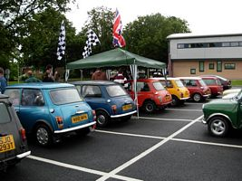
Thank you to all who took part & made the day how it was, & special thanks to Rob & Helen for all their hard work in putting together the Pilgrimage itself & the special bottles! Well Done!

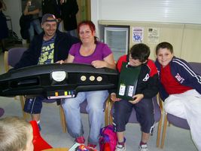

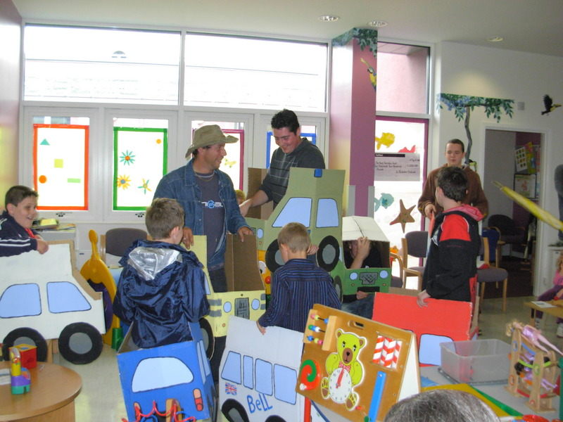
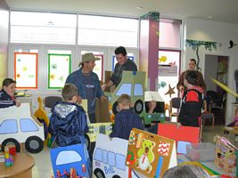

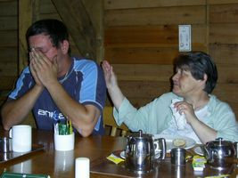
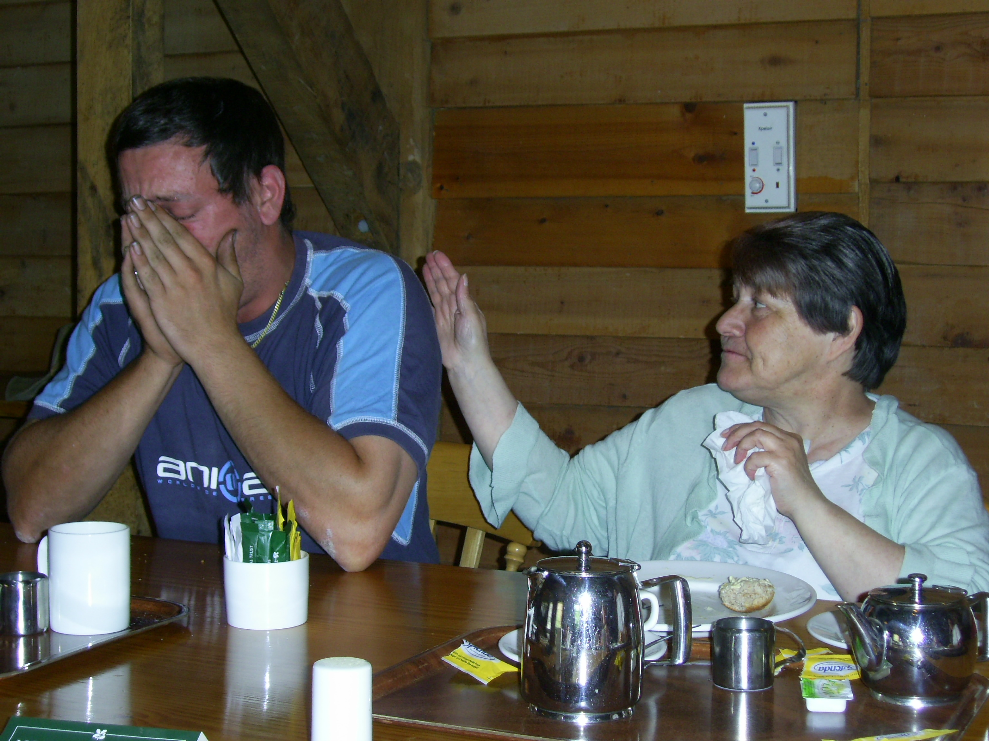

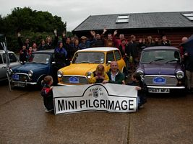

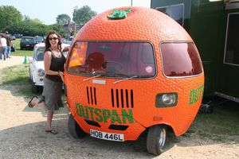
National Mini Cooper Day
Account by Paul Mellor
A gorgeous sunny Sunday morning saw us up at the crack of dawn to venture down to the New Forest to attend the Mini Cooper Register’s annual show & concours at the National Motor Museum Beaulieu. Myself & Sophie set out from Eastbourne in my freshly polished Cooper S to trundle down the A27 to meet up in the now traditional layby at the Newmarket Inn.
There to greet us were Des in his clubby estate & Jim & Alan in the family’s tidy little Clubman Saloon. An exchange of greetings & then we were off towards Rownhams Services for our rendezvous. This part of the journey went smoothly, we all made it through Shoreham Tunnel without running out of fuel, the roads were nice & quiet & an hour later we were pulling into the services to meet up with the Southampton contingent of the club, Tom & Sarah.
A hearty breakfast beckoned, but my stomach shrunk after seeing the price we were expected to pay for a manky sausage & some shoe leather bacon… “£8 !?!” was my cry followed by “Mango Mango Mango” for reasons that can only be explained by hours of drunken internet surfing the night previously…
After making do with a coffee, we were off again for the short final leg to Beaulieu, about another 10 miles. The first 5 miles went well; only after turning off the motorway did I start to notice my car starting to misbehave, stuttering at higher revs. We managed about another mile before it cut out altogether coasting to a halt by the side of the road. Up with the bonnet to be greeted by the live wire for the coil broken at the connector. Easy, a quick delve in the boot, a bit of crimping & we were off again. Another short cruise later & we were entering the Museum, with me wondering why Jim was struggling a bit in the queue to pay. Oh well, we made it in anyway with the Marshals directing the various cars to themed parking. I was separated off to park amongst a glorious row of Mk1 and Mk2 Coopers, with the others sent off to park in the Minis only parking elsewhere in the field.
It wasn’t until I met back up with the others until I found out the real reason for Jim’s struggles; the clutch slave had failed almost upon entering the site. B****r!
Oh well, at least we were in the right place for buying spares, a nice line up of Traders & Autojumblers greeted us with Jim heading off to buy clutch bits while I headed off to buy a tyre & my postponed breakfast. A full tummy saw me off to have a look around the show proper, starting with the cars entered into the concours. Wow! The standard of the cars in the Cooper Register Concours has to be seen to be believed, these cars are better than new in most cases, with probably the hardest judges in the mini scene. Hats off to the entrants, but not my idea of having fun with a mini!
After the concours a wander around the cars in the themed parking showed up some gems. First row was given up to a stunning array of works Coopers, from 1962 up to 1997; I shudder to think what the value of that row of cars might have been! Next, the Mk1 and Mk2 Coopers, then the Mk3’s & then the Rover Coopers. All lovely cars, & a lot more realistic than the concours stuff. A few clubs had stands around the edge of the main parking field with the members chilling out in the hot sunshine that the Cooper Day seems to be continually blessed with. A few Mokes caught my eye with one supercharged example making me particularly excited, & then Sophie’s favourite; the Outspan Orange Mini at which point she refused to leave it until numerous photographs had been taken!
Back to Jim’s, Des’s & Tom’s cars where they had set up the club banner & broken out the toolbox for the clutch slave cylinder change. This went fairly smoothly with just a couple of very tight bolts slowing things down, while the girls (and some boys) sunbathed on the grass next to the cars.
By this point the day was drawing to a close, the banner was wrapped up & we set off on the way back home. A stop off at the services again to say goodbye to Tom & Sarah & to fill up with water (us & the car). Back on the motorway next where it felt so good to overtake a couple of the pristine concours cars being driven home on their trailers….a satisfying end to a great day at one of the gems of the mini scene.
(For those who don’t understand where Mango came from, visit http://www.weebls-stuff.com/toons/mango/
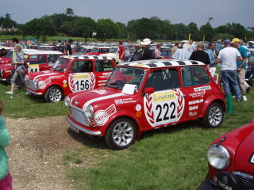

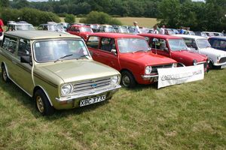

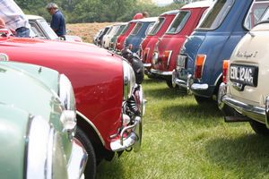

Castle Coombe Track day
Attention: all those who want to go to this event on September 29th, Dave needs the money in by August meeting. Places are limited, so please talk to Dave (Events Co-ordinator) at the next club meet to reserve tickets. Priority will be given to club members so also make sure you have valid membership! Free entry passes are also available.

Southern Mini Days ‘07
REMINDER: Deadline for pre-booking tickets – July 25th. Pre-booking as a club will not be available, so please book individually. If you need an application form, Pre-booking is cheaper, but you can still buy tickets at the gate.
Dates are 3rd-5th of August, held at the Hop Farm, Paddock Wood in Kent. Some of us will be there at 4pm on the Friday to setup ‘EDMC - Boot Hill’ to the left of the entrance into the main camping area.
The theme this year for SMD as most will know is Hollywood & the official club theme is …
Westerns!! Cowboy’s & Indians.
Outlaws, Bar Tenders, Show Girls, Sheriffs, Big Chiefs, Sioux Warriors, Cherokee Princesses, Cavalry Quarter Masters & gringo Mexicans - its up to you! All you need to do is chuck on a cowboy hat to be part of the scene. But we do ask that if your coming with a mate or partner, that one of you is a Cowboy/Girl & the other an Indian/Mexican – if possible. A cowboy/Indian stand off is expected… Toy rifles & bow’s recommended!!
Prior to the event, we have access to some land to use, in order to build the club stand & prepare a few Western theme bits, as well as learn how to put the Tipi up! This will be on weekend of 21st/22nd (Simon’s Sunday Bomb in afternoon) of July, in Nutley. If you are available to help out on either or both days (camping overnight is fine too), then please contact Simon or Josie for more details.
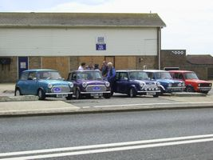
Sunday Beach BBQ
Daves’ Birthday 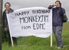
A great day was had for those who could attend the short notice of a Sunday Cruise in the name of Dave’s ‘21st’ Birthday.
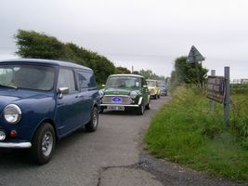
A few cars stared off the run from Peacehaven taking a coastal route & some bits inland, to then end up at Beachy Head where others were waiting to greet us! As the convoy grew, the cruise continued on coastally over to Bexhill, then looped back up towards Ninfield, to then finally drop down & ending at Normans Bay for a beach BBQ & party food! The gazebo decorated with balloons etc gave some shelter from the wind, but thankfully the rain held off long enough for everyone to have food, cake & a bit of bubbly!
Thank you to Jim, Shirley, Rachel, Tony & Justine for your contributions to the day!
Result – one happy
Events Co-ordinator!
