
Happy New Year!
* EDMC Newsletter *
January ‘08
Issue # 19

Hello everyone, & welcome to the first newsletter of 2008! I would like to say a Happy New Year to everyone & hope you all had a good Christmas.
2007 was a great year for us, we won 3 awards over the year, yes I said 3, which was down to the hard work of the people who helped out in the thinking; for the bottle of bubbly, signed by John “smoky” Rhodes, the pit crew for their expertise of handling nuts for the 2007 L2B ‘Pit Stop Challenge’ trophy, & the dodgy cowboys of the western camp site for the “best club stand” gold mini & framed certificate at Southern Mini Days.
Now, in 2008, we have a lot to live up to, with the usual shows taking place & a couple of new ones for us to try out. Another brilliant show season awaits us!
But it couldn’t happen without you guys; the members! As we enter our 4th year I look forward to spending it all with you. Whether it will be at our monthly meet, or at a drunken barbecue down Cornwall.
So I will take this opportunity to raise my glass (dandelion & burdock, as it’s what I’m drinking as I write this!) to you all & again thank you for the past 3 seasons of joy!
As I am on a roll, I would like to welcome Roger back to Sussex after his long time away for repair. In addition, I would also like to welcome our youngest member, Hollie Faye Brown, who was born on 26th Dec 07 at 18.00! Though maybe I should have put Hollie first… LOL! Anyway, to 2008!
Regards,
Darren Brown, Chairman

AGM meeting minutes
Held on Monday, 10th December at Langney Sports and Social Club:
The new committee was voted for & a list of committee members with their role titles can be found on the main website under ‘Contact Us’ (as well as shown below)
Financial report - Due to Rob B leaving the club, the financial report will be made at the January meeting when Rob H has received all the details he needs.
Merchandise - Club merchandise will now be organised by Shirley. The range will be reduced to standard basics, which will be ordered using club funds & then reimbursed. If you would like to make a purchase please speak to Shirley.
Pilgrimage - A meeting has been arranged for Monday, 21st for anyone wishing to help with the organising of the Pilgrimage 2008. (see details below). The charity has been confirmed as the Lee Spark NF Foundation.
Club Fees - Club fees will remain unchanged at £5 per member per year & associate membership at 50p per person per year. Under 16's will still be free. Membership fees need to be paid by the February meeting if you wish to keep your current membership number.
Magnificent Motors - Steve Medhurst has volunteered to be point of contact for Magnificent Motors which is to be held in Eastbourne on 3rd & 4th May 2008.
London to Brighton – (Details shown on pages below). Will take place on Sunday, 18th May. There will be 6 club stand places & 20 run places allocated on a first come first served basis.
Steve Medhurst is making enquiries to Eastbourne Council to see if it would be possible for us to hold our own show on the Western Lawns, Eastbourne for a date hopefully in July, yet to be confirmed.
Membership re-newal
For those who need renewing, please either download & complete a new membership form from the main EDMC website, or collect one at the club meeting from out new Membership Secretary , Alexandra. We ask for you to fill out new forms in order to ensure our database has the correct details & to amend any changes if necessary. If you have any questions or need help with the form, please see Alexandra or any other committee member. Thank you.

Pilgrimage Plans
A meeting will be held on Monday 21st January, at the Red Lion pub in Willingdon. (This will also coincide with the committee meeting). Anyone who has some ideas, &/or wishes to be involved in this year’s Pilgrimage run planning, please come along at 7.30pm. All are welcome. If you cannot make it, please pass your ideas to a committee member, who will discuss them on your behalf.

Xmas Party! Account by Rachel
Saturday, 24th November saw members gather at the Community Centre, Polegate for the annual Christmas/End of season "do"!
Tony and Dale provided the disco & karaoke with members bringing enough food & drink to feed an army let alone a mini club!
Once everyone had had enough to eat & drink, Josie started the main attraction of the evening; our very own Awards Ceremony of 2007! This was in the form for a very professional slideshow, along with commentary showing all the nominations for each category along with the winners.
The prize for each category was a certificate & a chocolate snowman "Oscar".
The categories & winners were:-
Best Male Fancy Dress –
Carl Frizzell [SMD cowboy]
Best Female Fancy Dress –
(Gypsy) Jim Mayatt [L2B]
Best Group Fancy Dress –
Alan, Sarah & Tom [SMD, the 3 Mexicans]
Best Dressed Mini (Rebuild) –
Matt Dawson [Austin City modified]
Best Bodge Job of the Year –
Simon Bell [with ‘The Ugly Duckling’]
Best Developed Mechanic – Rachel Cornell
The ‘Sods Law Award’: most unlucky with Minis – Dave Ward [with the Sidewalk & Mk1]
Most Memorable Phrase –
Alexandra Bowley
Best Club Pose – Marc Brown
Most Entertaining Spectacle –
The EDMC Club!
The ‘Jumping Right in it Award’ – Lisa & Matt
Best Food contribution – Shirley Mayatt
Memorable highlights included Daz & Dave receiving their "bodge kit", which comprised of a candle, matches, gaffer tape, hammer, screws, no more nails, blue tack & of course a can of lager (amongst other things). Also, Alexandra with her prize lettuce for all her famous quotes & phrases!
Once the awards had been handed out, the karaoke began with some very unique renditions of classic songs.
All too soon it was time to pack away & divide up the mountain of left over food.
I hope everyone enjoyed themselves as much as I did, & I look forward to doing it all again next Christmas!
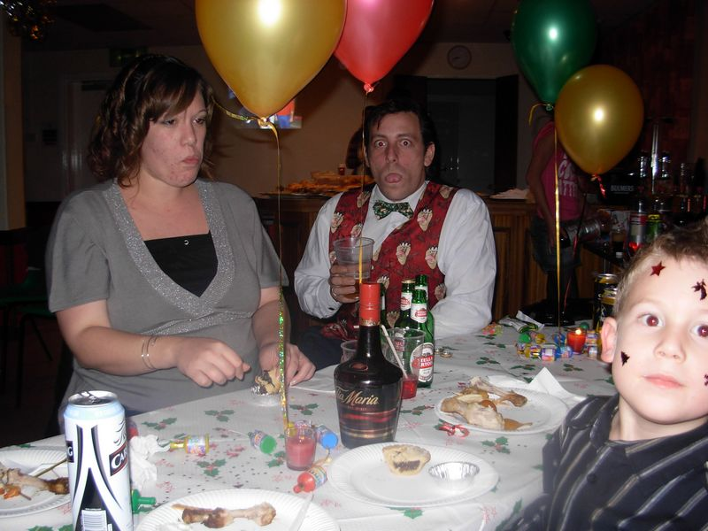

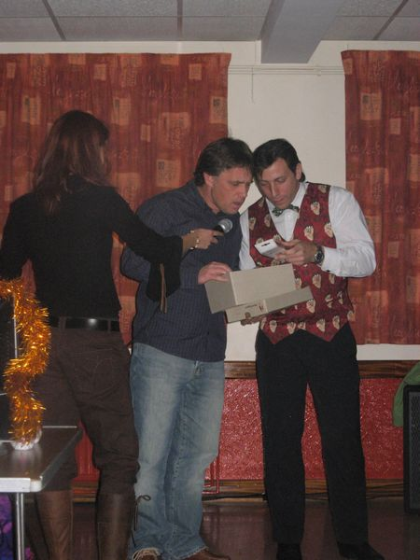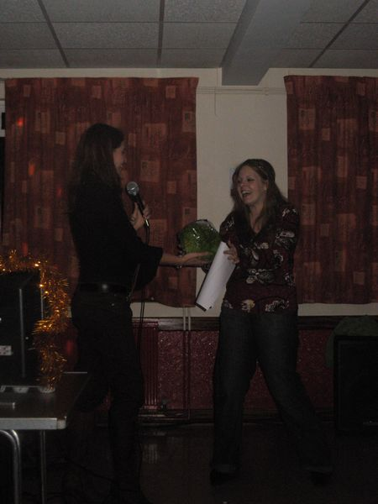

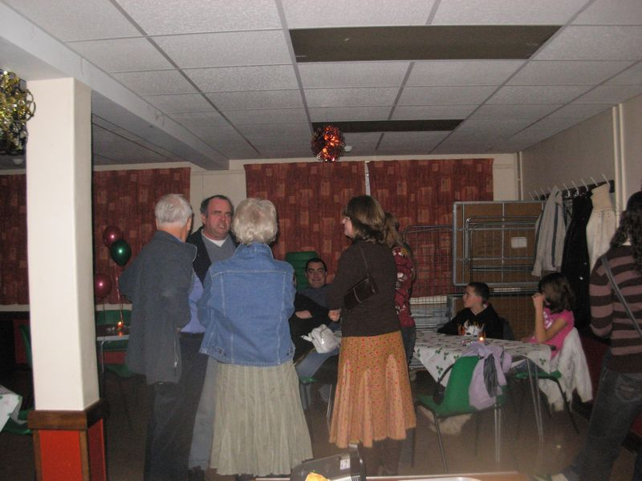
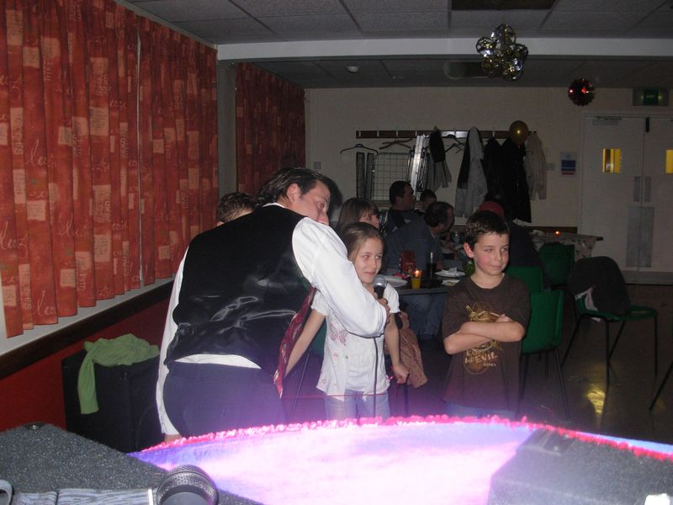

Rolling Road Results
What a good way to end the season in 2007! A strong turn-out of members & their minis made for a busy day at Gerald Dale's.
Thanks to Simon for organising the day, Paul for manning the BBQ, Daz for marshalling, & all those who turned up & took part!
Gerald & his team worked hard to get all the cars through with minimum fuss & advising owners, where necessary, about performance issues.
Thanks finally to Monty from Miniworld for taking photo's & info for a future edition of the magazine.
Name | Peak BHP | Peak Torque (lb/ft) | Car age | Make/Model | Capacity (cc)
Alexandra B | 24.0 | 25.9 | 1979 | Austin, 850 | 848
Sarah P | 42.3 | 52.2 | 1982 | Austin, City E | 998
Simon Bell | 49.3 | 56.0 | 1983 | Austin, Mayfair | 998
Tony C | 52.3 | 63.5 | 1983 | Austin, Mayfair | 998
Lisa D | 52.3 | 59.4 | 1989 | Austin, City | 998
Viv B | 56.8 | 70.6 | 1992 | Rover, British Open Classic | 1275
Alan M | 56.9 | 60.4 | 1980 | Austin, Clubman | 1098
Josie C | 58.3 | 70.5 | 1996 | Rover, Equinox Spi | 1275
Martin M | 60.3 | 59.2 | 1969 | Austin, Cooper Mk2 | 998
Simon Blick | 63.8 | 70.7 | 1993 | Rover, Cooper Spi | 1275
Carol B | 66.7 | 69.6 | 1989 | Rover, Sky | 1275
Jim M | 67.8 | 80.7 | 1978 | Austin, Clubman, 1275 GT | 1380
Rachel C | 68.7 | 78.7 | 1983 | Austin, Mayfair | 1275
Kelly S | 72.2 | 73.8 | 1984 | Austin, Mayfair | 1275
Mick R | 73.9 | 66.0 | 1989 | Rover, Sky | 1275
Carl T | 74.0 | 72.5 | 1994 | Rover, 35th | 1275
Gary B | 75.6 | 77.6 |  | Rover, Studio 2 | 1275
Matt D | 78.0 | 71.9 | 1982 | Austin, City | 1275
Simon H | 78.2 | 83.7 | 1968 | Austin, Cooper ‘S’ | 1330
Ricky B | 123.2 | 106.5 | 1985 | Austin, (Big Bastard) | 1450
Lynn P | 132.8 | 115.5 | 2001 | BMW, Cooper | 1600
Lee G | 222.3 | 221.5 | 1973 | Morris, 1000 | 1800
Committee Members Contact Details:

Chairman – Darren Brown – edmcboss@fsmail.net
Secretary – Rachel Cornell – edmcsecretary@fsmail.net
Events Co-ordinator – Dave Ward – edmceventsco-ordinator@fsmail.net
Membership Secretary – Alexandra Bowley - edmcmembership@fsmail.net
Club stand co-ordinator – Paul Mellor – edmcstandco-ordinator@fsmail.net
Web editor – (Vacant) – edmcwebeditor@fsmail.net
Forum administrators - Darren, Stephen, Neil
Newsletter co-ordinator – Josie Cockerton – edmcnewsletter@fsmail.net
Social secretary – (vacant) – [e-mail TBC]
Treasurer – Rob Humphries – edmctreasurer@fsmail.net
Merchandise – Shirley Mayatt - edmcmerchandise@fsmail.net
Committee meetings are held roughly every 3 months. If you have any ideas or input to how You would like the Club to be, please contact any Committee member, who will discuss it at meetings. It is Your club, so you run it! ☺ Thank you.

Dave’s Page – Events Co-ordinator edmceventsco-ordinator@fsmail.net
-------------------------------------------------------------------------------------------------------

L2B – Names for tickets
London to Brighton this year is held on the 18th May. EDMC have managed to bag a club stand again – this year the theme is ‘Heroes’, so get your thinking caps on! However – this year there are only 12 club stand places, so we will require ticket money no later than February meeting (cut off date 29th Feb)
This year all tickets are £25 per car (whether run or stand) plus 36p p&p. This includes all the usual t-shirt etc. There will be the usual Soap Box Challenge & Show ‘n Shines, but no mention of a Pit Stop Challenge, so we can’t defend our title!
We require 6 cars for stand & up to 20 cars for run. At time of printing, we need 2 more cars for the stand. If we don’t reach 6 cars, then EDMC will only apply for run tickets as we wont be allowed a stand with less than 6.
These spaces are first come first served. If we reach our limit then others will have to apply through MiniWorld Magazine in March & April issues.
Any questions, further information or to put your name down, please speak to Daz (Chairman).
For ideas on this year’s theme, please see stand co-ordinator, Paul Mellor.
Club Meeting Dates:
Every 2nd Monday (except May)
Jan 14th July 14th
Feb 11th Aug 11th
March 10th Sept 8th
April 14th Oct 13th
May 19th Nov 10th
June 9th Dec 8th - AGM
Magnificent Motors - interests
If you are able to attend this event, please speak to Dave or
Steve Medhurst, as Steve will be the point of contact & organiser
for the weekend.

Brooklands Mini Day - Places
We have managed to bag ourselves a 10 car club stand, in the
same area as last year. Tickets will be first come first served basis,
though priority on club stand space will be given to those who couldn’t get on last year. Other cars
can park in general parking. Please let Dave know ASAP as places are filling. Cost is £7 pre-booked adult & £6 Seniors, £5 Children, under 5s are free, £20 Family ticket - 2 Adults & up to 3 Children. Adult at the gate is £8. Any questions please see Dave.
2008 Diary Planner – Dates for your Diary!

30th March - Brooklands Mini Day, Surrey,
3rd/4th May - Magnificant Motors, Eastbourne Seafront
2nd-4th May – Riviera Run, Newquay, Cornwall
9th-11th May – International Mini Meeting, Holland
18th May – London to Brighton Run
24th -26th May – Cuckoo Fair, Laughton
21^{st -}22nd June – BMC ‘Minis on the Wreck’
29th June – EDMC Mini Pilgrimage rally
12th/13th July – Eastbourne Motor Show, Easbourne Seafront, (Set up on Friday 11th)
1st-3rd August - Southern Mini Days, Hop Farm, Kent
17th August – Mini in the Park, Santa Pod Raceway
27th September – Mini World Action Day, Castle Combe Race Track

Other events to be aware of:
Roger’s ‘Welcome home’ run – February Worthing ‘Minis by the Sea’ - September
Festival of Transport – August Laughton Country Fair - September
Old Git’s Rampage – October

