
Happy New Year!!!
* EDMC Newsletter *
If you thought 2006 was full on…you don’t know what’s coming this year! And as it’s EDMC’s 2nd Birthday, we’re at the ‘terrible 2’s’ stage! So look out world, here we come! Regards, Josie.

London To Brighton 2007
20th May, the theme this year is ‘British Seaside in the 1920’s’, so get your thinking caps on…or shall I say ‘bathing’ caps! There are still some places available for the run itself. £25 per run ticket. Please pay for your entry at January’s meet, or arrange to pass it to Daz to be sent off.
The soap box & Pit stop challenges will be taking place again, so if you have any ideas or would like to volunteer, please speak to Daz or Paul (our new Club Stand Co-ordinator!)

Mini Club Cruises & Fun Runs!
Last year, between club members we managed to put on around 8 local Mini Cruises around the roads of Sussex. For example, Rachels’ ‘Fish ‘n’ Chip Run’, The Pilgrimage BBQ fundraiser, Rosies’ Charity Day, and not forgetting the ‘Old Gits Birthday Run’, where we had the best turnout of club members!
This year, many more are being planed up by club members; including the ‘Nansie Tea Run’ &, in secret planning, a Navigation exercise!
The best thing about a Mini, which we all love, is the fun of driving it! So, if you would like to organise a fun route of your favourite bendy roads, go for it! Pick a good day, (what’s best to get a good turnout) then advertise your cruise on the EDMC forum, or get it printed here in the monthly Newsletter.
Photos & sometimes videos are taken on every run, so that they can be posted on the website, to re-live the fun & frolics of our Mini Adventures!
AGM Minutes
If you missed our 2006 AGM, please view the minutes, which can be found on the Club Forum. 2007’s AGM will be held on the 10th December.

New Committee member
8th January 2007
Issue # 11
After Decembers AGM, we now welcome Paul onto the Committee who’s new job for 2007 will be Club Stand Organiser, for such events as L2B, Southern Mini Days, & many more events that EDMC will be attending. Prizes can be awarded to ‘Best Club Stands’, so lets see if we can win some for the Club and mark EDMC on the mini world map! You can contact Paul by email at edmcstandco-ordinator@fsmail.net
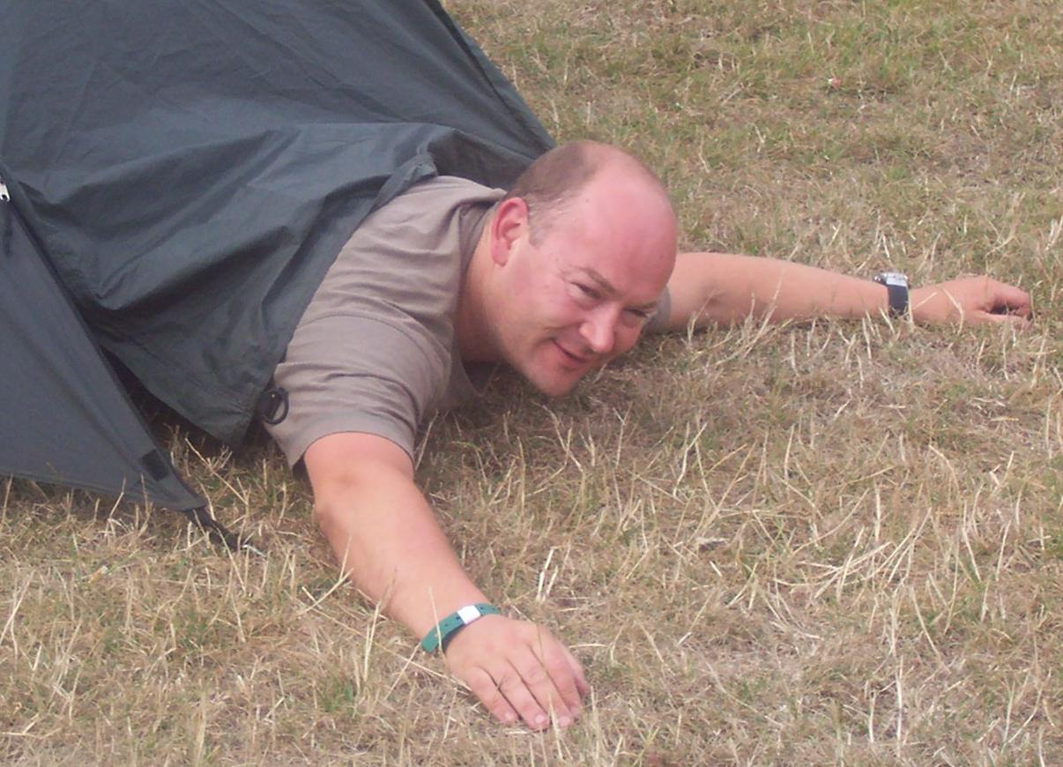

Autograss Racing…What’s it all about? Written by Rick (aka ‘K1’)
At first glance it looks very simple style of Motorsport to get to grips with, I mean how hard can it be to get a car to lap an oval circuit of between 300-500yrds for 4-6 laps? Simple! If you could see the time, effort & money that is spent on the cars, to set it up to only have to turn right on rough ground & to not self destruct! It’s unbelievable. It’s very exciting with a variety of classes containing many different concepts, some defying belief!
I am sure with all the press he has received since the mini films DVDs, performance, extreme & madness, you have all heard of Mr Chris Alinson. He started ‘Zcars’ from knowledge he gathered while spending many years of autograss, (oh yes its called "Z" cars because he used to be a policeman.)
It’s hard to keep up with all the rule changes; these happen every year or so to allow for new engine & valve configurations to become available, but still allow existing cars to compete on an even keel.
I will give you a rough outline of the classes & what sort of cars you may see;
Class 1) FWD; mainly mini 998 +60, NASA cam shaft, K&N in standard air box, pretty standard entry level.
Class 2) FWD & RWD run through a 32mm restrictor, RWD can run a locked diff, mainly novas & Mk2 escorts.
Class 3) RWD 2500cc limit anything goes, 250hp Toyota starlet or 2.4pinto Mk2 escorts.
Class 4) FWD 1130cc engine in original position & no body profile changes, all the best are mini's saloons & pick up's you never heard like these, not unusual to see £7000 swiftune engines.
Class 5) FWD & RWD1430cc no restrictions mainly nova's with 2 speed £2000 trans axles in the boot.
Class 6) FWD pretty much anything goes; metro's with rover 620ti engines in them, Mk2 Astra's with 2l red top.
Class 7) RWD anything from the absurd to the ridiculous but must be in a car based shell, we have seen 7000cc v8 Hillman imps, 5000cc supercharged v8 metro, nova with 2x Hyabusa engines in the back, even RWD v12 mini pick up mad buggers.
Classes 8,9and 10 are all purpose built space framed specials.
Class 8) 1400cc limit single bike engine
Class 9) 2400cc mainly Vauxhall power or twin bike engines
Class10) Absolutely anything mainly 3 (three) R1 motorbike engines or twin Hyerbusa or twin Honda blackbird, on occasions a v8 or v12.
There is a ladies category that is run together on a staggered start in a handicap fashion. Also juniors from age 12 to 16 run class one mini, this often sees father & son sharing a car.
It’s hard to explain but you will have to see it for yourself, it’s not for everyone but few things are! But I know you will be able to appreciate the Mini's in Class 1 & especially Class 4 you will not believe the sound they make. Who knows, it costs between £300-£500 to build a Class1 & anybody can have a go & see what its like inside the cars.
The local club is IK (Invicta Kent) which race at Ivy Church at between Brenzett & New Romany, they race roughly once a month with the occasional two-day meet.
This year it looks like we will be having one round of the BAS, which will see 600 cars & the best drivers in Britain, so this will be one not to miss!
I hope this gives you an insight into this form of motor sport, a map & race meet fixture list will be published here sometime in the New Year.
The Rockinghorse
Appeal Run

Michelle Allen, from Bognor Regis, has contacted us to tell you about the charity mini run she is planning. It takes place on 30th June to help raise money for the Trevor Mann Baby Unit to help with funds to buy new equipment.
As a previous patient herself of the baby unit, based at the Royal Alexandra hospital in Brighton, she is strongly determined to raise the vital funding needed, especially with the decline in funding for Hospitals as we well know.
The proposed run is to start from Maderia Drive Brighton, with hopefully 100 Minis. The Press have also been arranged to be there for the send off. The route will travel along the south coast to the New Forest; to Moors Valley Country Park. Two mini supplies have also agreed to donate items for a charity auction to be held on the day.
Visit her well informed website, www.baby2nds.co.uk or email Michelle at adelante82000@yahoo.co.uk for more information and application form for entry. [Alternatively, if you cannot access the web, contact myself (Josie) & I will post one to you.]
The entrance fee (£10) will ALL go to the charity, however in your entrance pack there will be information on personal sponsorship for your family & friends to enable you to raise more money if you wish. You can enter as many cars as you like, with as many people in them as you can fit!

“If you would like to tell your story of a mini event or want to add your views on anything, please send your subject& write up to the contact details on the bottom of the page – Thanks”

Dave’s Page – Events Co-ordinator. E-mail: edmceventsco-ordinator@fsmail.net

Riviera Run 2007 – Plans part 3
The annual EDMC Miniworld Riviera Run Adventure to Newquay Cornwall takes place from May 4th to Bank Holiday Monday, May 7th. This is one not to be missed! Everyone who went last year had an amazing time. We will all be camping. The trip is about 280 miles each way. Can those going please make sure cars are in tip top condition for the journey, its a good few months away enabling plenty of time to get things sorted, we were blessed with no major mechanical problems last year & I hope that will continue on the 2007 event.
The cost for the Weekends Camping & MiniShow on the Sunday is £25.00. For each booking there is a £5.00 booking fee whether that be for an individual or a group. To get round the booking fee I will book us all in as a club at the same time. That £5.00 will then be divided up between those going.
The deadline to be booked in with the club & save money is the February club meet. After that you will have to book yourself & pay the booking fee.
Please make cheques payable to ‘Eastbourne District Mini Club’. Any questions see myself.

Brooklands Mini Day
Sunday March 25th 2007.
This is the first great Mini show of each year & it is not one to miss. We had a good club turnout last year & it would be great if we can better that with our third visit to Brooklands in 2007 with more member's; new & old taking, part. Brooklands is situated at Weybridge in Surrey, a short drive from the M25, only a few junctions clockwise from the A23. Brooklands are promising great things at the 2007 show: including the now familiar notorious test hill! Put your Mini up against the stopwatch & the steep ascent! See www.brooklandsmuseum.com for more details.
I will be pre-booking entry tickets as a club. You can pay on the day, although please add £1.00 to pre-booked prices as listed below.
Pre-booked Prices: Adults £7.00, Seniors £6.00, Children £5.00 & under 5's are free. Cheques made payable to ‘Eastbourne District Mini Club’
Please note: The deadline for pre-booked tickets will be the February Club Meet.

Dates for your Diary:
(Those in purple are events that were attended by EDMC members in previous years)
28th January - British Mini Fair, Bingley Hall , Stafford.
25th March - Brooklands Mini Day, Brooklands Museum , Weybridge , Surrey.
9th April – French Race Track Day, Bois-Guyon race-track at Dreux
5th – 6th May - Magnificent Motors, Eastbourne Seafront.
5th – 7th May - Miniworld Riviera Run, Newquay, Cornwall.
(Riviera Run dates To be confirmed, as a club we may leave on Thursday or Friday prior)
20th May - 22nd annual running of the London to Brighton Mini Run.
10th June - National Mini Cooper Day, Beaulie, New Forest, Hampshire.
23rd – 24th June – Gaydon Mini Festival 2007 with Miniworld
30th June – The Rockinghorse Appeal Run, from Madeira drive to the New Forest
26th – 29th July - 30th International Mini Meeting, Denmark.
25th June - EDMC Eastbourne to Canterbury Mini Pilgrimage, charity run. Organised by Rob.
31st Aug – 2nd Sept - Goodwood Festival of Speed, Goodwood House, Goodwood near Chichester West Sussex.
3rd - 5th August - Southern Mini Days, Paddock Wood, Kent.
TBA - Mini Magazine's Mini in the Park , Cornbury Park, Oxfordshire.
1st - 3rd September - Goodwood Racing Circuit Revival Meeting, Goodwood , Near Chichester, West Sussex.
9th September - Miniworld sponsored National Mini Owners Club Show, Stanford Hall, Leicestershire.
29th September - Miniworld Action Day, Castle Coombe racing circuit, near Chippenham, Wiltshire.
26th October - 3rd November - The Italian Job Charity Run.
10th December – EDMC AGM
Other dates to be confirmed:
- Peacehaven Classic Car Show.
          - Eastbourne Miniature Railway Classic Car Show.
          - Mini's By The Sea, Worthing Seafront, (by The West Sussex Mini Owners Club)
          - EDMC Rolling Road Day, @ Gerald Dale Motorsport. (will be in December)

