
Roll Up, Roll Up!!!
* EDMC Newsletter *
12th February ‘07
Issue # 12

After filling in the diary with this year’s mini events, I’ve realised there’s so much to do! To make life easier, as a Club we are booking early to avoid disappointments. This way there will not be any last minute rushes. Also, we are doing our best to keep you informed of what’s coming up, but also relive the moments passed (or what you’ve missed out!) Remember, if you know of an event you would like to attend, let us know, & we’ll spread to word! Don’t be shy now! Regards, Josie.

Mini Pilgrimage 2007
EDMC’s Mini Pilgrimage run, organised by Rob Byrant, will be held on Sunday, 24th June, & this year will be raising money for The South Downs Community School, Eastbourne. The start will take place at the South Downs school and end at the Kent & Canterbury hospital, like last year but with a better finale! The school are keen to get the kids involved & even want to do a project on Minis! There is no minimum for raising money, but every penny counts! Registration forms are available on the EDMC website, or contact Rob at edmctreasurer@fsmail.net or henrob6166@aol.com for more information.

French Race track
There is talk of a potential trip over the water to a race track in Bois-Guyon race-track at Dreux, France! Club Mini France are celebrating their 20th birthday, at the track & would like to invite minis from all over the globe to partake in the parties! The event will be held on 9th April
Dreux has a strong link to this club’s history so would like to celebrate its special year. The track has been refurbished & said to be a pleasure to drive on, however, only if you have a roll cage. Safety specs require any car on the track to have a roll cage fitted. But for those of you who don’t have one, can still enjoy the usual club stands, traders & entertainment. Entry is a whopping €3! To see the track, visit its website, www.pro-pulsion.com
Rachel has been looking into travel & accommodation costs, so if you’re interested in this event, keep an eye on the forum or have a chat to her. You can obtain details direct from Mini club France by sending an English e-mail to Muriel at clubminifrance@orange.fr
Forms need to be in by the 25th of March, & there are a limited number of placements for the track.

A Magical Mini Adventure!
Some may have noticed that MiniWorld are now advertising ‘The Magical Mini Adventure at Disneyland Resort, Paris’. Said to be an ‘utterly unique mini show’, the show is part if an ‘All British Day’ and is the first time ever the resort is holding a mini event.
The event starts on the 29th June until 1st July. Minis from all over the UK and Europe are invited to gather their Minis in a special VIP parking area in the Disney Village. Usual items like Show 'n' Shine, trade & club stands will be available & there will also be a live Beatles tribute band & other entertainments happening.
Greatdays Travel Group is offering a holiday to take part in the event to all MiniWorld readers at a discounted price for just £199 per adult. Plus there are also some great discounts if you are bringing children and if you can get a group together of at least 20 cars you will receive €100 of Disney vouchers. For more information call Rob or Jess on 0161 928 4422 or email disney@greatdays.co.uk.
New Club Clothing
Samples of new club clothing will be available at February Meet to show the quality & cost of items from a local printing company, Kitprint, in Hailsham. A variety of clothing can be chosen & there is no set-up fee or minimum orders.
Polo – normal quality, £10.50,
Polo - heavier quality, £12.50.
Large window stickers - £5 each
We are awaiting prices for smaller car stickers (designed like the website banner), sweat shirts & other merchandise to be confirmed. They also do large banners full colour & photographic for £55 per metre length. If you are interested in ordering any of these items or if there is something else you would like to enquire about, please let Rachel know. edmcsecretary@fsmail.net

Dave’s Page(s) – Events Co-ordinator. E-mail: edmceventsco-ordinator@fsmail.net

Events to book pre-payment, Feb:
  - Riviera Run, Newquay - £25 adult, younger kids go free
  - Brooklands Motor Museum - £7 adult, £5 kids, under 5’s Free
Mini In The Park – Santa Pod!
Some of you may already know that Mini Mags’ headline show, ‘Mini In The Park’ will have a new venue from 2007.
Instead of being in a park it will now be next to the old runway also known as Santa Pod!
As a club, EDMC haven’t attended this one before, maybe it’s time we made an appearance.
For those who do not know, Santa Pod is a drag raceway. Mini owners will be able to put their Mini against the clock on the dragstrip, but if that’s not your cuppa, the usual mini show, club stands & other entertainment will also be there.
Santa Pod is a few junctions up the M1 & is easy to get to. If you’ve ever been to Santa Pod before you will know the buzz of the place! The facilities are basic camping in the field stuff so do not expect great facilities, .
Visit the venue website at www.santapod.co.uk , for more event details, www.miniinthepark.co.uk
Advanced booking prices are as follows: Entry ticket £9.00, Camping Ticket £5.00, totalling £14. Under 14's go free.

Castle Coomb – 29th Sept.
Details for 2007’s Castle Coombe Race track day have now been realised. EDMC members who attended last year were buzzing after the event, even if it did rain; some saying it added to the effect! There are a couple of changes from last year though: all drivers must now show a full current UK driving license when they sign on & passengers will be charged £5 each. The passenger charge is to cover rises in insurance & admin costs. However, on the reverse of the passenger pass is a £5 discount voucher for the Castle Coombe racing school or products available at the shop.
The half price package of 6 track passes for £90 is available again & additional passes are still £20 each. Don’t miss out!
If you are interested in taking part in any of the events, or would like to find out more, have a chat to Dave, or e-mail at the above address

Goodwood Revival
Goodwood Revival meeting is being held from August 31st until September 2nd, 2007 at the Goodwood House nr Chichester.
It has been suggested EDMC to go on Sunday 2nd.
This is the event that takes place at the Goodwood Race track. Only vehicles that raced or were on the road from the 30's up to when the track closed in ‘66 are allowed. That will include classic saloon car racing with Minis Lotus Cortina's, Jaguars & more!
All things around the circuit relate to those years too. The course car is an original road going Ford GT40. Old Land Rovers tow in the breakdowns from the track & the public are encouraged to where period clothing.
The greats from Motorsport, Motorcycling & showbiz attend & drive; people like Stirling Moss, Martin Brundel, Jack Brabham, Rowan Atkinson, many of the F1 guys from the past 30 years & many more! They are driving some very rare & expensive cars around the track, like the Ferrari GTO for instance, is worth millions & these guys are racing them!
The public are allowed into the pit enclosure to get a close up of the cars & their famous drivers.
For those plane spotters out there, during lunch there is an excellent air display from World War 2 aircraft! Goodwood has an airfield in the middle so the aircraft can be seen on the ground up-close too.
The event is a highly recommend. It is not cheap though at £47 for the Sunday. Children under 13 get in free. Tickets are only available in advance.
Find out more by checking out www.goodwood.co.uk & click on ‘Motorsport’ then Revival meeting. On the website you will find loads of info about the meeting, each particular race & also loads of pictures so you know what to expect; a great day out that’s what to expect!

‘Laughton Fair’ Events
There are 2 more local shows that EDMC members may be interested in going to either as a club, or just to check them out! They are both held at Laughton, which is situated between the A22 & Ringmer. Some people may already know of these fairs: The Cuckoo Fair is on 26th – 28th May,(bank holiday weekend). The other is The Laughton Country Fair, on 8th & 9th Sept. If attending as a club, overnight camping is available & also noted it’s the beer tents are good! For more details see www.heritagefield.co.uk.

Mag Motors, Eastbourne
If you’re not planning to go to Cornwall for the Riviera Run on the May Bank holiday weekend, think about attending a more local event – the Eastbourne Magnificent Motors show!
This will be the 3rd year the Club will attend the Magnificent Motors Show. The venue will be the Lawns on Eastbourne Seafront, held over the first May bank holiday weekend of May the 5th & 6th. Over 25 thousand spectators are expected. There will be a cavalcade of cars starting the proceedings on both days; time for a lot of air horns, wheel spins & larking about in our Mini's along the seafront route to the show area! The public love it! This is a free show, which doesn’t happen often. The last 2 years have been very well attended by the club & public alike. Last year was a great turnout, so it looks like the 2007 event will be no exception!
THIS EVENT IS A MUST IF YOU ARE NOT GOING TO CORNWALL!
So please watch this space for more club details.
Also see www.magnificentmotors.co.uk for event details & programs.
Entry applications need to be in by 12th April. I will book us all in as a club.
Next Month :
  - Minkie’s Alive! And some thought she’d never make it!
  - What not to buy when looking for a Mini for the first time
  - Favourite picture of the year! Submit & vote for your favourite photo of 2006!

16Valve Mini Shop Open Day
On 17th March, the 16valve Mini Shop will be having an open day to celebrate their 1st Birthday! If you want to find out more about fitting non-standard mini engines, this will be the day for you! Open from 10am to 4pm, it will be a chance to ask questions & and get some ideas
The shop is situated just off the A272 at Cowfold. Some members are already talking about going sometime in the afternoon, but if you are interested or want to find out more, speak to Dave, or visit www.16vminishop.co.uk
Riviera Run 2007 – Reminder
There’s still a chance to make bookings for this blast of a weekend! Cost for the Weekend Camping & MiniShow on the Sunday is £25.00. Bookings are being taken at February meet so to make a group booking, but there is still an opportunity to book individually at a later date. For each booking there is a £5.00 booking fee whether that be for an individual or a group. You will need to contact Trevelgue campsite if booking individually. For more information, contact Dave. Don’t miss out!
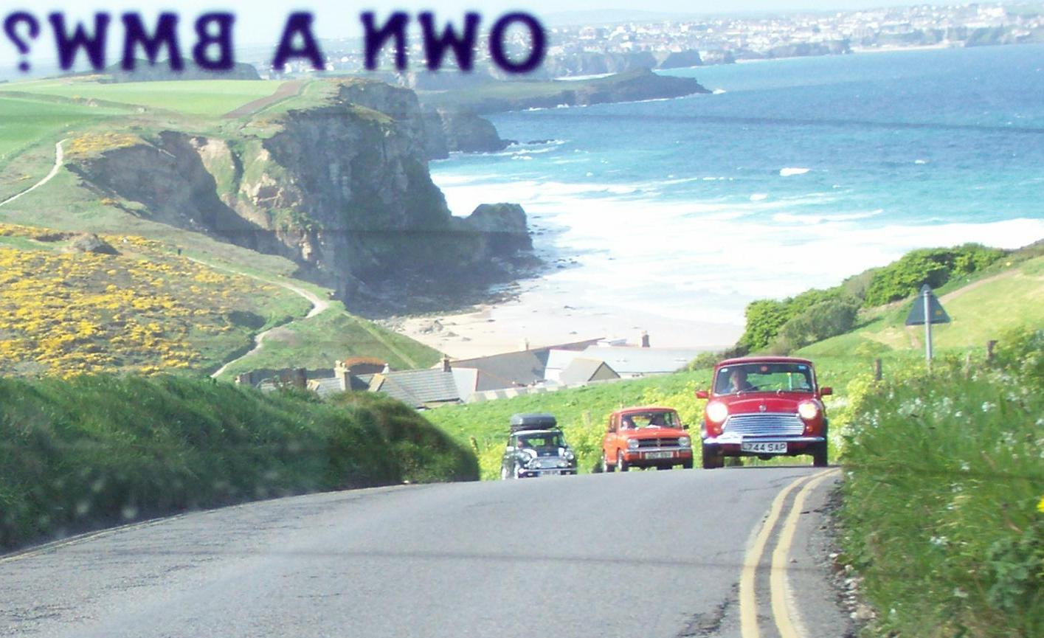

“If you would like to tell your story of a mini event or want to add your views on anything, please send your subject & write up to the contact details on the bottom of the page – Thanks”

