

* E D M C Newsletter *

My first news letter so no bumper issue.  Well here we go again the start of another year means the start of another season. Last year as a club we had our ups and downs so this year we need to get back to the fun side of things.  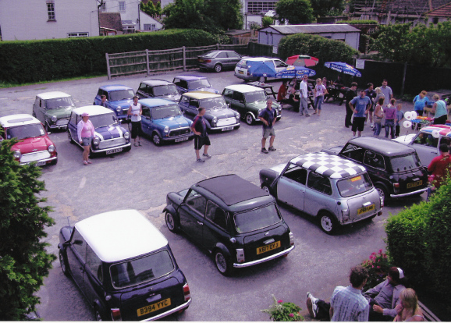  As you know this is my first year of doing the newsletter and, after Josie, I have got such a hard act to follow.  Due to work commitments I might not be able to do so many shows this year so I am going to need help with the newsletter from as many of you as possible. Pictures and a few words is all | I need to be getting on with. so any help you can give will be really appreciated.  MAIN EVENTS FOR THIS YEAR.  29th March Brooklands Mini Day  2nd -4th May Miniword Riviera Run  17th May London to Brighton Run  14th June Beaulieu National Mini Day  28thJune EDMC Pilgrimage  July Eastbourne Motorshow 31ST July-2nd August Southern Mini Days  7th-9th August IMM 2009  6th September Mini’s by the Sea  26th September Mini World Action day  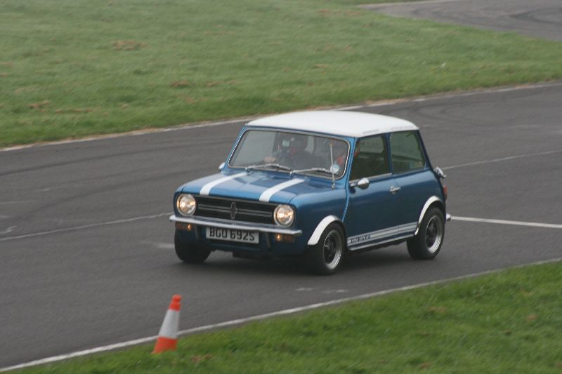  THE OLD GIT

Page 1
E-mail: edmcnewsletter@fsmail.net
Feb ‘09
Issue # 23

Brooklands  As per last year we will be meeting at " The Newmarket " layby on the A27 south of Lewes at 8.00am and will be leaving at 8.15 .  Prices as follows:  Adults £8 , children £5 , under 5's free.  Family ticket £20 (2 adults and upto 3 children)  If we pre-book we will get £1 off above prices. All those who wish to pay in advance through the club must pay by the February club meet at latest .We can only have eight minis on club stand so its first come first served.  Lisa is this years event co-ordinator.  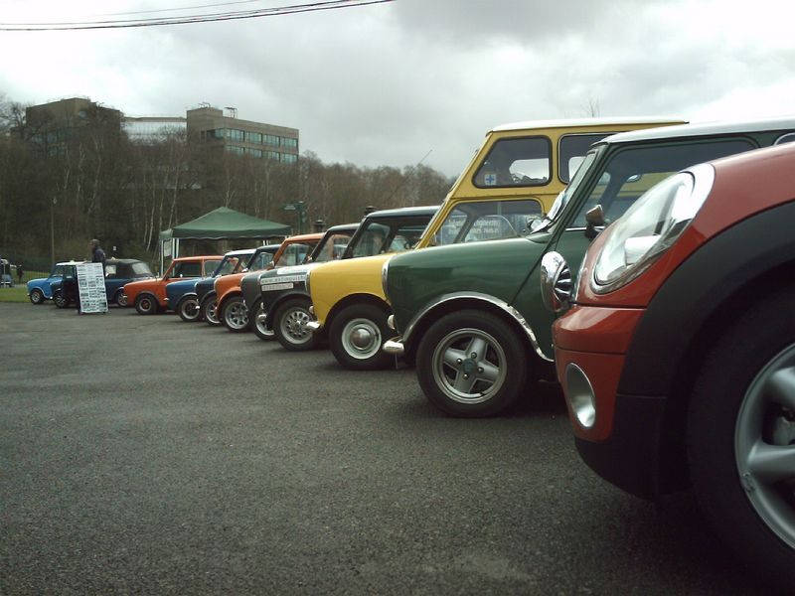  PILGRIMAGE  The Pilgrimage will be held on Sunday, 28 June. We will be leaving Beachy Head at 10.30am. Registration will start at 9.30. Lunch is at the Kent and East Sussex Steam Railway, Tenterden and we will finish is Canterbury, at a destination to be confirmed. | The entry fee is £10 per car and registration forms will be available from March. For 2009, we are raising money for Polegate Children with Cancer Fund. www.childrenwithcancerfund.co.uk  This local charity raise funds to help the children and their families by purchasing gifts such as specialist equipment, family days out or special toys. Our aim is to raise enough money to send the children and their families to the pantomime at the end of the year.  Some of the fundraising will be done by attending a car boot sale, taking some kids to their school prom and washing cars. Josie is also looking into doing a mini push along the seafront in Eastbourne.  If you would like to help with any of these events, or have ideas for fundraising, please let me know. If you can’t spare the time, perhaps you have some items you can donate for the boot sale.  We will also be having a raffle on the day of the Pilgrimage, and all donations will be gratefully accepted.  I am sure you will agree this is a really worthy cause and I hope to see you on the Pilgrimage.  Rachel

