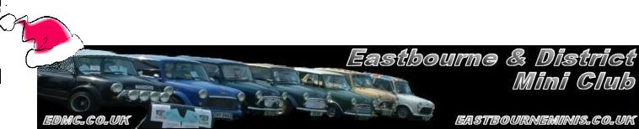
Seasons Greetings!
* EDMC Newsletter *
Pictures speak a thousand words, therefore just look at the photos in this month’s newsletter & see what we’ve been getting up to! So…
Merry Christmas &
a Happy New Year!
From all of EDMC Committee

Club Memberships: 2007
As the New Year comes in, those who would like to re-new their club membership please fill out the membership form found on the main EDMC web site or collect one from Ian, the clubs’ membership secretary. Cost for the whole year is £5; which goes towards public liability insurance, club stand materials & possibly some social events during the year. Filling out the form again enables us to make sure we have your correct details in order to keep you in touch with what’s going on in the Mini world!

Riviera Run 2007 – Plans part 2
Plans are coming together organising the Riviera Run 2007 in Newquay set for the 1st May bank holiday weekend. Tickets will be pre-booked as some discount is available. As chief organiser, Dave would like deposits for this event by the February meet (12th). For more information about this great Mini weekender, take a look at the related posts on the forum or have a chat to Dave.

Brooklands Motor Museum
This event is held on 25th March & will be EDMC’s first main show of 2007 so a club stand is being organised. Last year saw a good turn out & with the attractions of trade stands, concord, the test hill & of course the museum itself, it proves to be a great day out even for the rest of the family! As it is only in Surrey, plans for leaving early Sunday & cruising up through some nice country roads makes to journey as fun as the day itself. If you’re interested in attending, keep your eyes & ears open on the forum, at the meet or here in the news for further details.
December ’06 Issue No. 10
(visit www.brooklandsmuseum.com )

EDMC Xmas Bash!
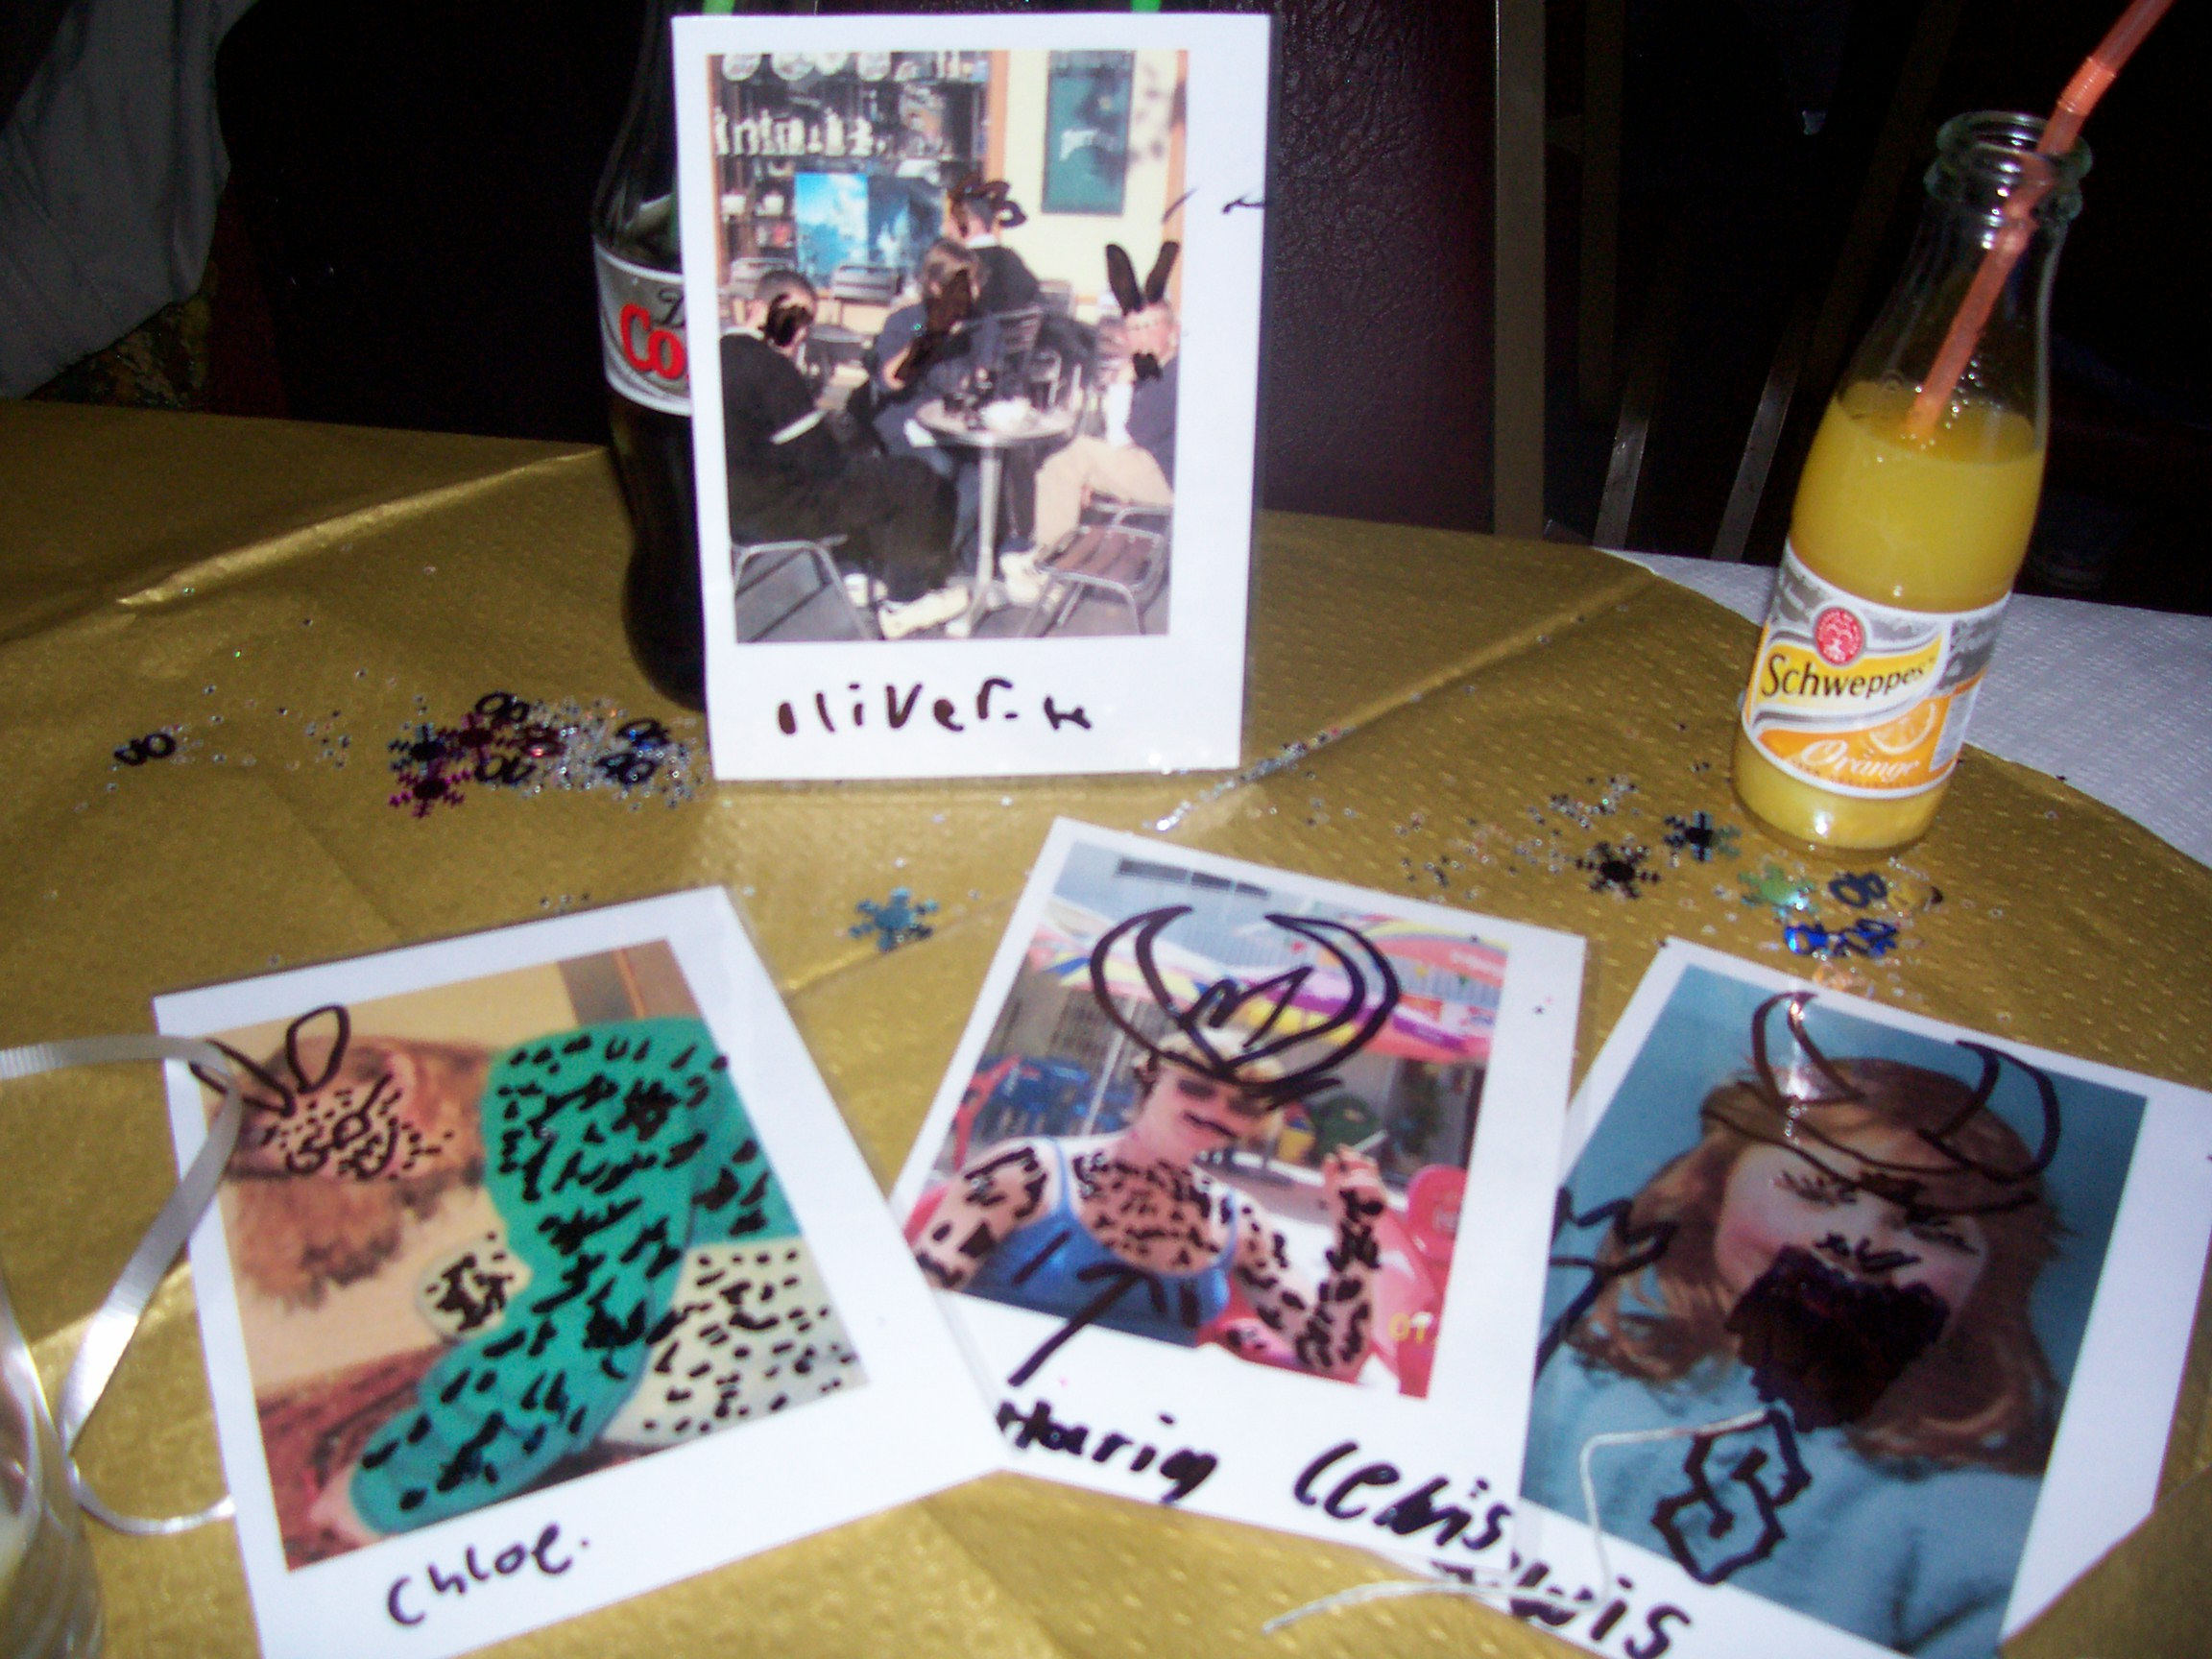
Well done Rachel, Tony, family & associates who made a great evening! From food & Disco to drink & photos to doodle on, fun was enjoyed by all those who attended! Here are some memories of the occasion!

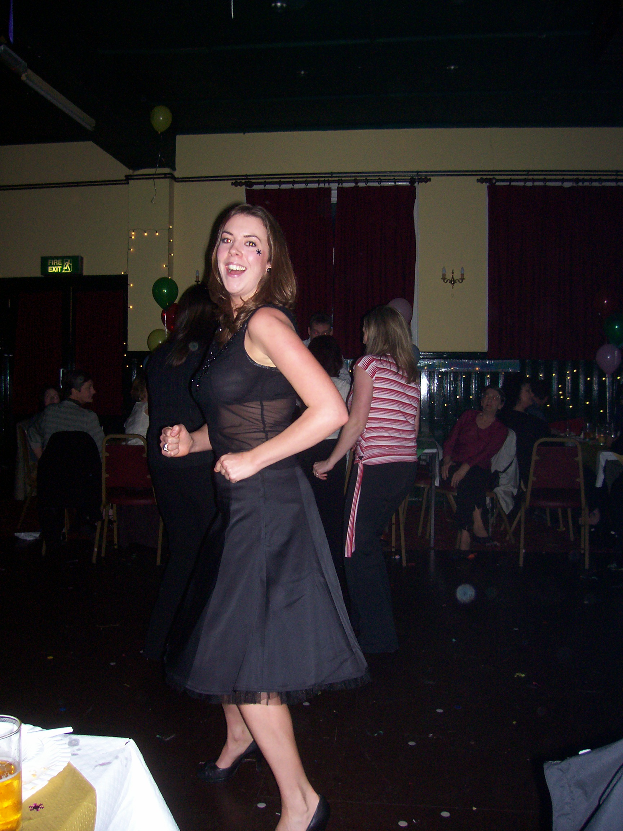

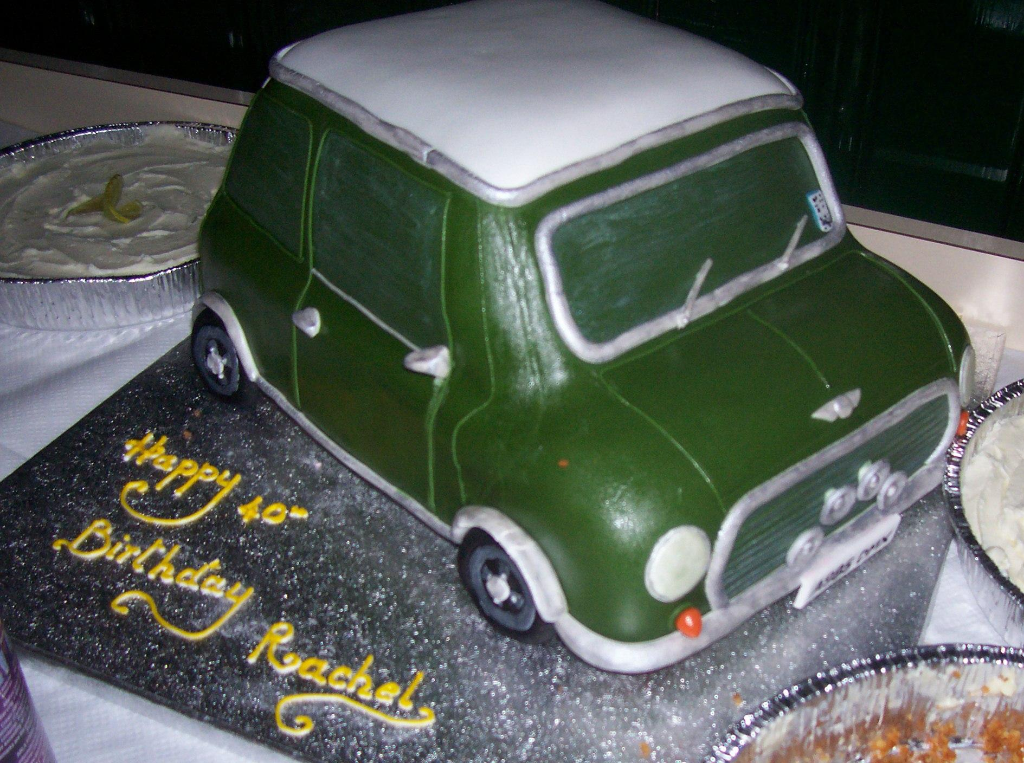

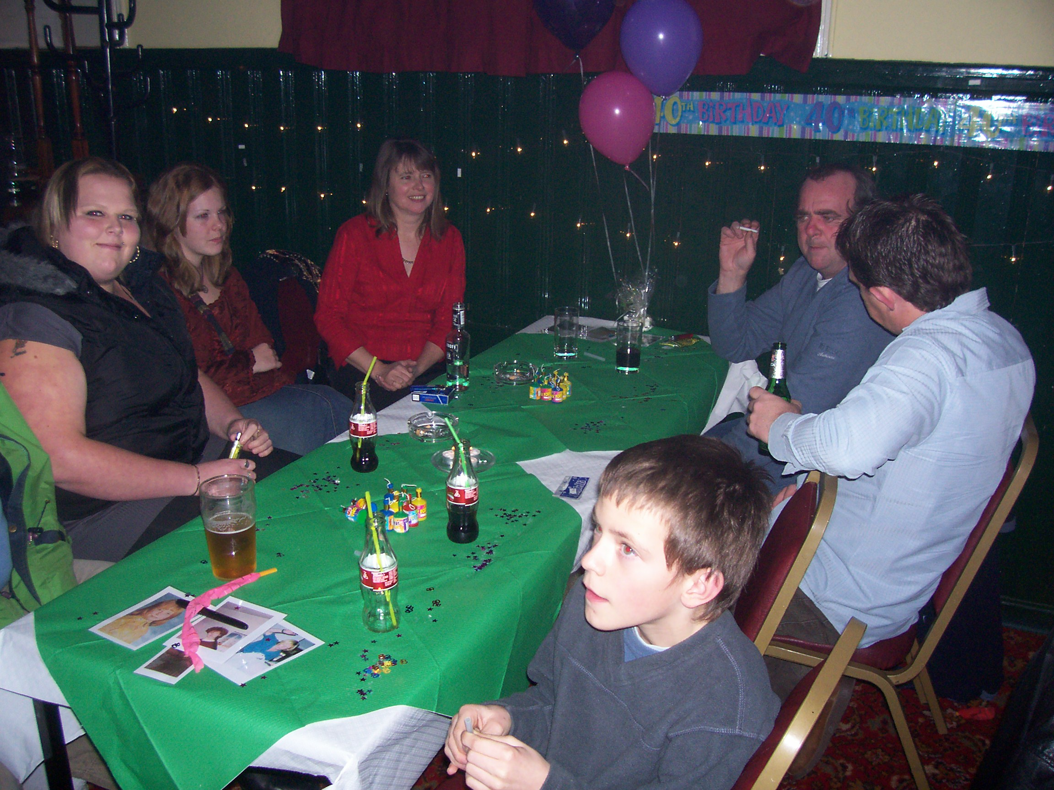

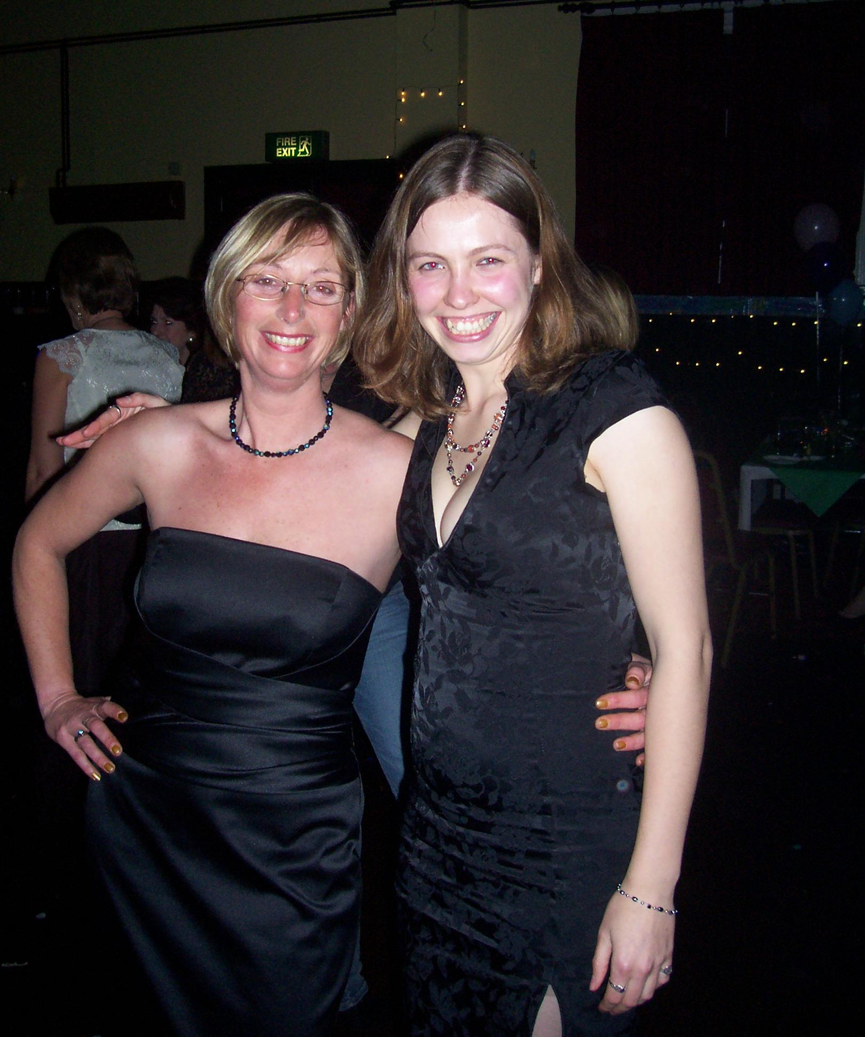

Club Expo: Report of the day
By Rachel (& some bits by Dave!)
On Saturday, 25 November, Darren, Dave & myself set out very early in the morning for our trip to the Motor Heritage Museum at Gaydon for their annual club expo. The roads were clear & we made good time, only a downpour on the M40 slowed us up for a while.
We began by having a look around the museum & were disappointed to find only the minis on display were three Monte winners. The others in the collection had been moved to a large marquee to make way for the Autoglym Concourse final. Other vehicles on display caught our attention, including a Land Rover with tracks instead of wheels & Lady Penelope's pink 6 wheel Rolls from the Thunderbirds film, (with Ford badges on it!). The car was built by ‘Curley Mouldings’ in Kent, who sell all the carbon fibre body panels for race and road minis. Other classic rally cars on show included Triumph TR7'S, Mk1 Escorts, Austin 1800's & Metro 6R4.
Full of expectation, we made our way to the exhibition hall where we were greeted by about a dozen stands & a similar number of club representatives. We had a chat with some of the exhibitors & Daz took the opportunity to take samples of stickers & run plaques. Unfortunately, much of what was on offer was aimed at larger or richer clubs. We did take away information regarding public liability insurance which may come in useful when it comes to renewing our current policy & Daz has some information offering discounted car insurance for any member of a classic car club. Clothing suppliers were deemed too expensive & there are sticker suppliers closer to home who offer similar prices.
All in all the day was a bit of a let-down, with the organisers blaming the weather for poor attendance. We concluded that the day was worth the effort if only to persuade us not to attend next year.
If anyone in the club can help with, t-shirt, sticker or flag & banner supplies let the committee know. Thanks.
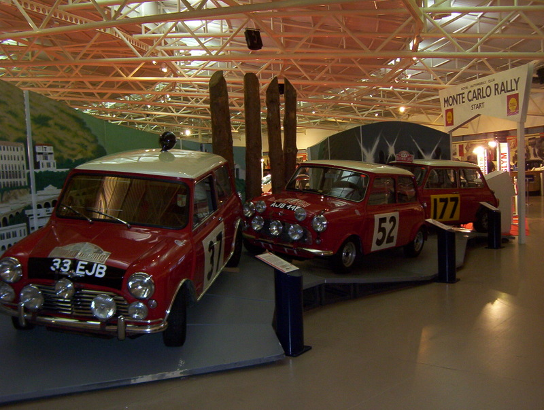

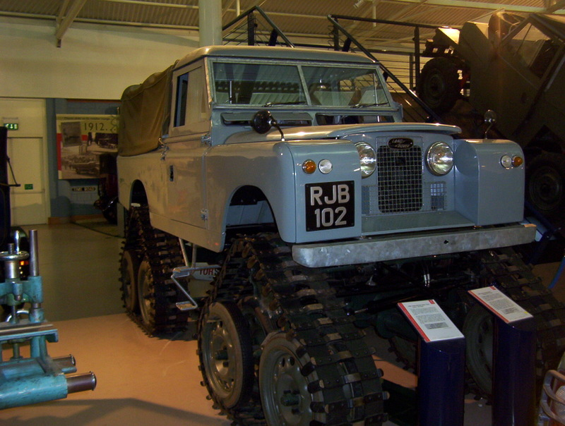

London to Brighton, 20th May
Payment/deposits for this annual event are required at January’s meet in order to book places & save disappointment. Camping is available, as always at crystal palace for those on the run, otherwise an EDMC cruise will travel up on the morning along the usual fun windy route. Most places are taken for the club stand but numbers are yet to be confirmed, stand tickets are £18. Run tickets this year are £25 per car. For more information, see the forum posts or chat to Daz who’s organising it.

Message from Club Chairman
“Make I take this opportunity to say that we as a club have had an outstanding year. Having lots of fun on our local cruises to going away for weekends to take part in the fun of the big events, right down to the smaller events.
And it couldn’t be done without you - the members.
So a very big thank you from me. Here’s to looking forward to next year!
Oh one more thing…

Merry Christmas and a Happy New Year
Darren Brown – Chairman”

Rolling Road – Results!
“If you would like to tell your story of a mini event or want to add your views on anything, please send your subject & write up to the contact details on the bottom of the page – Thanks”
Thank you to all those who attended.
Compliments from Monty himself:
"Deeply impressed with club organisation and friendliness of members" & “Many thanks for inviting me to the dyno day. 20 cars is certainly a good result. I was fascinated by the n850s (as usual) and amazed at how the front of that awesome Vtec powered Mini seemed to bend upwards at full bore! Scary!”
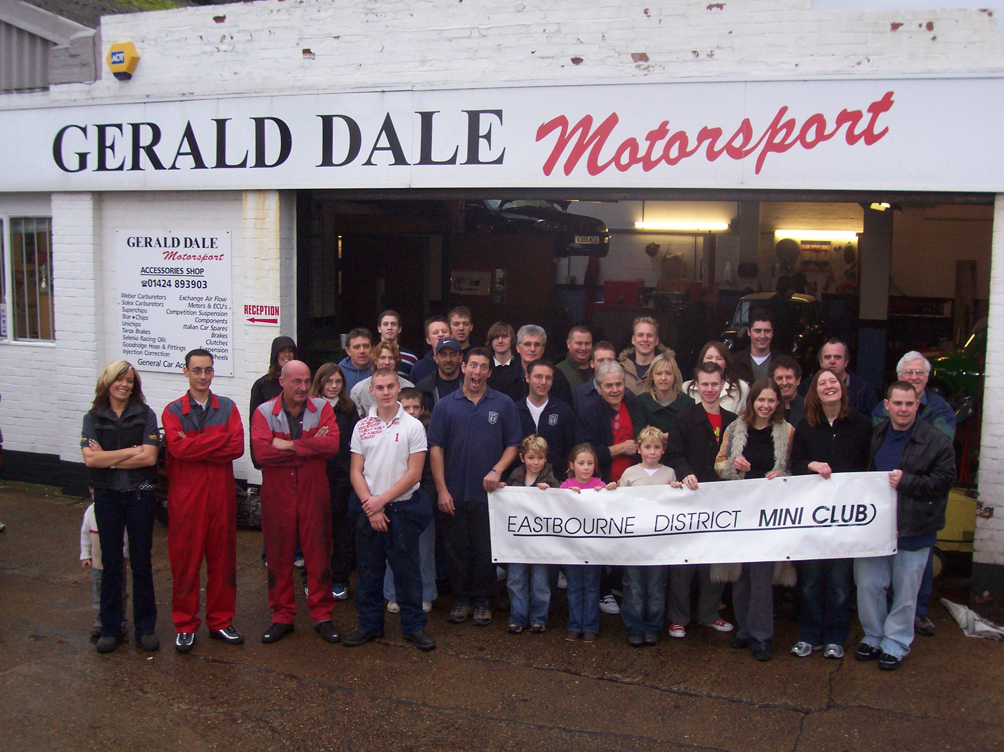
Monty will send free copies of the ‘Mini World’ with the article, for each car on the roller about next March/April. Gerald & his crew did a great job, so many thanks go to them.
From an 850 doing 36Bhp to a Honda 1.6 clocking 196Bhp, I think we saw some good action.
Interest is showing for possibly putting together a day in February for those cars who missed out, as Monty is keen to come back for more! December 2007 date to be advised.
Again - thanks all, for helping, taking part, and enjoying the day. If you have some good pictures you wish to share on the website, please PM me (Simon aka Mininutter).
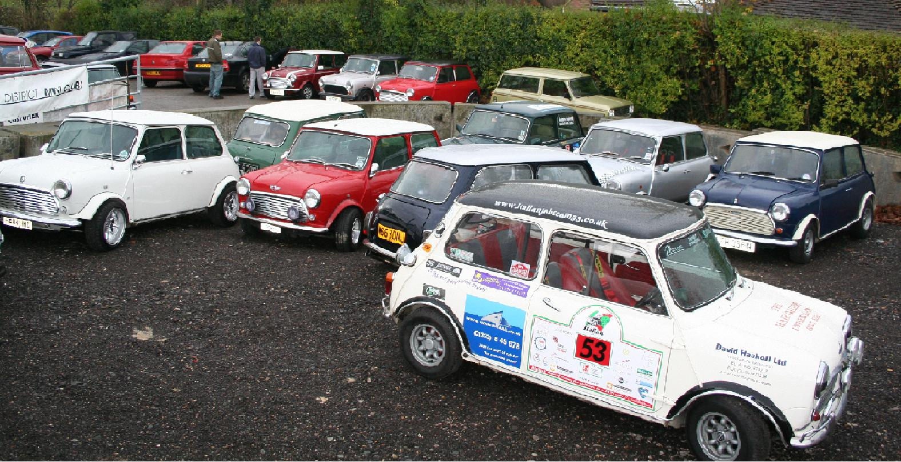

Name | Mini | Peak power | Mph | Peak torque | Mph
Neil | 850 pick-up | 34.9Bhp @ 4961Rpm | 51.6 Mph | 42.7Lb ft @ 3942Rpm | 41.0 Mph
Clive | 850 | 42.1Bhp @ 5168Rpm | 60.3 Mph | 47.0Lb ft @ 4028Rpm | 47.0 Mph
John S | 998 | 48.9Bhp @ 5070Rpm | 66.6 Mph | 57.9Lb ft @ 3517Rpm | 46.2 Mph
Alex | 998 | 54.6Bhp @ 5472Rpm | 70.6 Mph | 62.6Lb ft @ 3906Rpm | 50.4 Mph
Martin | 998 Cooper | 60.6Bhp @ 5931Rpm | 60.9 Mph | 57.4Lb ft @ 4178Rpm | 42.9 Mph
Ricky | 998 Cooper | 66.2Bhp @ 5419Rpm | 60.7 Mph | 66.4Lb ft @ 4883Rpm | 54.7 Mph
Bill | 1275 auto | 55.5Bhp @ 4950Rpm | 57.6 Mph | 63.8Lb ft @ 3781Rpm | 44.0 Mph
Dan | 1275 MG | 70.3Bhp @ 5414Rpm | 66.6 Mph | 81.2Lb ft @ 3991Rpm | 49.1 Mph
Josie | 1275 spi | 61.8Bhp @ 4892Rpm | 61.0 Mph | 72.3Lb ft @ 3809Rpm | 47.5 Mph
Dez | 1275 | 71.2Bhp @ 5776Rpm | 67.4 Mph | 79.1Lb ft @ 4259Rpm | 49.7 Mph
Shawn | 1275 spi | 58.4Bhp @ 4815Rpm | 61.0 Mph | 72.6Lb ft @ 3828Rpm | 48.5 Mph
Ian | 1275 mpi | 63.0Bhp @ 4610Rpm | 70.7 Mph | 80.3Lb ft @ 3267Rpm | 50.1 Mph
Simon | 1275 mpi | 70.2Bhp @ 5539Rpm | 77.0 Mph | 75.0Lb ft @ 3597Rpm | 50.0 Mph
Steve S | 1275 mpi | 84.2Bhp @ 5506Rpm | 77.1 Mph | 85.8Lb ft @ 3649Rpm | 51.1 Mph
Ben | 1330 A series | 86.2Bhp @ 6110Rpm | 77.0 Mph | 82.3Lb ft @ 4801Rpm | 60.5 Mph
Paul | 1330 Cooper S | 101.2Bhp @ 6480Rpm | 78.2 Mph | 87.2Lb ft @ 5610Rpm | 67.7 Mph
Pat | 1380 | 93.0Bhp @ 5384Rpm | 70.0 Mph | 97.0Lb ft @ 3961Rpm | 51.5 Mph
Steve M | 1380 | 96.6Bhp @ 5771Rpm | 83.7 Mph | 100.4Lb ft @ 4110Rpm | 59.6 Mph
Toby | 1.6 K Series | 150.9Bhp @ 7040Rpm | 96.7 Mph | 115.8Lb ft @ 5730Rpm | 78.7 Mph
Steve T | 1.6 VTEC | 196.5Bhp @ 7289Rpm | 92.1 Mph | 143.6Lb ft @ 7052Rpm | 89.1 Mph

