
Feeling hot hot hot?
* EDMC Newsletter *
August ‘07
Issue # 17

I am! Especially after the scorcher at the weekend for Southern Mini Days! Let’s hope the summer is finally here & gives us the chance the polish up those minis & rev those engines for some great laughs & fun rides! Regards, Josie.
Committee meeting minutes
After the recent committee meeting, a few points were made, including the following items:
New flyers are now being produced to make it simple & friendly to potential new members. We are also looking to promote the club better as Bini friendly, so someone hold back the Old Git! We have welcomed BMW Mini owners in the past but none have stayed with us. We hope to encourage more in the future, building a diverse range of club members.
As a reminder, associate member forms are available on the website & at club meets so that friends & family are covered by insurance during club events. It only costs 50p for the year. The organiser of an event will be responsible to check that all parties are covered by the insurance, or delegate the responsibility to another club member.
In addition to the membership package, new members will be introduced to the club in the form of a welcome pack – which includes welcome letter, current newsletter, flyers & potentially a sticker (subject to costing). This is aimed to give good initial info to new members about the club & who’s who.
Other points were made at the committee meeting; please find full minutes on the EDMC Forum. The next committee meeting will be held on 3rd December, before the AGM on the 10th.
Online Trophy Cabinet
EDMC are slowly, but surely, building a reputation within the mini community (whether good or bad!) & we are getting more & more noticed. With recent events this year, as a club we’ve managed to gain a few trophies & trinkets along the way. And as we don’t have an actual trophy cabinet, it has been suggested to make a ‘virtual’ cabinet on the main website. This will show pictures & describe where each item came from. Any other suggestions are welcome though, so if you have an idea, please tell a committee member.

Have you read it?
Quick reminder to all – please ensure you read the club Constitution, as it is there to help us run a safe & friendly club. From 2008, new & re-newing members will be asked to sign/tick box to state they agree with the constitution.

Xmas Party & End of season dinner
Suggestions were made to do an end of season dinner in Oct/Nov rather than organising a large Christmas dinner. Some are still keen for this so info is being gathered on places & prices. If you have any suggestions, please let Daz know.
In addition, Tony has invited all EDMC members to a disco/karaoke evening at the Windsor Club, Polegate, on Saturday 1st Dec. This is not particularly an EDMC event, but all are welcome. Cost is round £2 for membership for the night, but drinks are at club prices.

September Meeting – Reminder
Just a reminder that September’s club meeting will be held on the first Monday, 3rd, as we are unable to use the club house on our usual second Monday of the month. Instead, on the 10th September, a local cruise is being organised which will end at a local pub, so watch out on the forum for more details!
Simons’ Sunday Bomb!
It was one of the first sunny days of the summer & perfect for a Sunday cruise. Though most members were working on their cars, a few came along to meet us at the lay-by! This was not going to stop it from happening though as Simon was determined to get to the boats! The route took us down some great narrow country roads with lots of twists & turns. I enjoyed driving the mini a bit too much & got carried away, putting my foot down, but everyone kept up well & it wasn’t too long before we were navigating down the narrow lane to the Anchor Inn at Barcombe! The sun was still out & just as well; after long refreshments of drink & ice cream, the ‘kids’ headed off to the boats. My decision of not going in Simon’s boat backfired, as I got more splashes from my nephew’s paddling than anything else! Even new members Sam & Steve (incl. kids & dog) took to the water & enjoyed the paddle down stream, laughing at Si & Alan’s water antics! A good day out & lots of laughs! Thanks to all those who could make it.
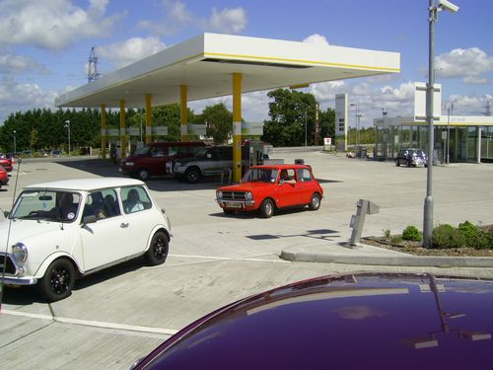
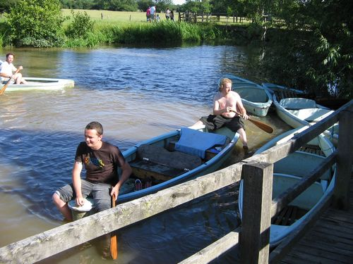
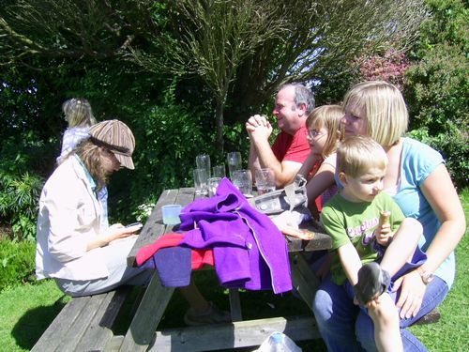
Eastbourne & RAM club
Simon has been to investigate the local Eastbourne & RAM club, who also meet at Langney Sports Club, but on the last Wednesday of the month. In addition to their meetings, they have at least 1 other event each month; which include Autotests, sprints, production car trials & 12 car rallies. There are a few members who rally, grass track, historic rally, track day & all out race, but only a few Mini owners. The club are always keen for new members & cars to take part, & so have been in touch with EDMC, inviting us to some upcoming events.
In order to take part in the events, you must join ERMC at a cost of £7 per year & an extra 50p for registration. Events normally cost between £5-£20 on the day, depending on the activity. This is non-profit & covers rent of the land used & insurance from the MSA, (Motor Sports Association), an organisation which the club is fully affiliated with.
They have invited us to their Quiz Night on Wednesday 26th September at the Langney Sports Club from about 8pm. Please let Daz or Dave know if you would like to attend so we can put a few teams together.
Their next event is an auto test on Sunday the 12th August at Knowle Farm, Burwash Common, from 9am to 4pm. If you want to take part, turn up at 9am & it’ll cost £15 to take part for the day (though you would need to become a member at the same time).
The two clubs (EDMC & ERMC) hope to interact more, so if you would like more information, have a chat to Simon or visit their website on www.eastbourneandrammc.co.uk

Basic Training Plans
Previously known as ‘Ladies Training’ (Reference to thread on forum), as a club we are still planning on putting together some training evenings & potentially a 1 day course on the basics required for simple motor mechanics & services. Items to be covered will include subjects like fluid levels, tyres, jump starting, bump starting, wheel changing, brake & clutch bleeding, fan belts, points etc & also some fault diagnosis of road side breakdowns.
The aim of this is to encourage those of us mini owners (Male & Female) who are not mechanically minded, to get under the bonnets & help ourselves, especially when broken down at the side of the road! Basically, it is going to be like an emergency 'First-aid course', but for minis, so no complicated mechanical problems!
Some question forms have been made up for those who are interested in taking part. The input from these will help identify which particular areas or mini service/repair people want to know about. These forms will be available at the August club meeting & will shortly also be on the main website.
If you would like to find out more, check out the forum thread under ‘Ideas & Comments’, or contact Josie on the e-mail address at the bottom of the page.

Nansie’s mini Mini Run 12th Aug
In honour of Nansie (Viv’s Mum), this little run has been organised for those tea loving people! This event is known as 'Nansie's mini Mini Run', as it will be a relatively short but hopefully entertaining event amidst beautiful scenery in honour of Viv’s Mum! Viv will be taking Nansie to the Litlington Tea rooms in the afternoon about 4pm, & they hope to get there before any other minis so as not to spoil the surprise! Meanwhile, a set off cruise will start from the British Queen pub around 3.45pm. All minis aim to arrive at the tea rooms about 4.15 - 4.30, no earlier! (The tea rooms don’t close until 5.30)
We will then be leaving Littlington at 5.30 for a short cruise, then arrive at our final destination (The Ash Tree Inn) at its opening time of 7pm.
Please note that both start & end locations do provide excellent food & drink, but nothing has been laid on, so it’s every man for himself! Hope to see you there!

Rolling Road – 27th October
Simon has application forms for the rolling road event at Gerald Dales’, & again like last year, will be featured in the Mini World magazine. Last year was a great success & you only need to see the magazine report & the comments on the forum to see that! The application forms are also available on the main website & are there to ensure we have the correct details of the owner & spec of the Mini for ‘Miniworld’. Cost for the rolling road & printout will be £20. A BBQ will be put on again like last year & potentially other activities will be going on during the day. For more information, speak to Simon or e-mail edmcwebeditor@fsmail.net

SMD – ‘Fort Apache-Mini’!
Account of the weekend
A great fun weekend – lots of hard work done by all but it was well worth it!

After a lot of planning & leaving everything to the last minute as usual, EDMC set off to the Hop Farm for SMOCs Southern Mini Days!
Those who were going on the Friday made there own way up there as the club stand was strewn across Sussex & was easier to meet at the venue. Upon arrival a suitable spot was located & the build commenced; amongst all the tent building a tipi was slowly coming together, once up Simon & Josie made a quick departure to a prior engagement, leaving the rest of the club to carry on the good work.
Phase 2 started - all tents were up & the saloon bar slowly came together bit by bit. Eventually the saloon was up & ignited & “Fort Apache-mini” was up & running in full swing…well, almost! As the normal alcohol had been consumed on arrival & people started to think about food. A few went off for curries, whilst the rest tried to get the generator to work - but to no avail! With darkness setting in, we waited for Shawn to come back, only to realise that the generator had to be on the ‘off’ position to make it work!
In no time at all, the lights were on & disco playing; we enjoyed the company of some rampant rabbits & Brighton Mini Club members, as we sang & danced the night away!
On the Saturday hangovers were treated with bacon sarnies, & phase 3 was put into action. The ‘Wagon’ was made, & some got dressed up in character, while others looked around the show or relaxed in the blistering heat. Once the wagon was done we had to find a trustee steed. With the help of BMC, we borrowed there shortie, dressed it up & then proceeded to drive around the show – getting us very noticed!
The evening brought out the birthday cakes for Shawn, Heather & Sophie, followed by food & beer consumption & more fancy dress was put on. Some of us travelled down in style to the ‘Awards night’ while others walked (or minced) down, following behind the steed & its wagon!
People were short listed to appear on stage for the ‘fashion show’ & Simon managed to blag a place for best Male in his fully painted Indian, but did not win anything. The whole group went up in our Cowboys, Indians & Mexican outfits, with ‘Gayle’ & Paul taking the limelight with there rendition of ‘Broke back Mountain’!
We did not win the best group category, but I’m pleased to say that our own Toby & Steven won with their ‘Oscars’ performance, well done guys!
More partying happened back at “Fort Apache-mini”, whilst some members decided to enter the Wagon into the Glow show – though flashing hazard lights & beeping the horn didn’t impress the judges! Later on back at the Fort, BMC came over & ‘stole’ our steed & wagon. I thought I would be clever & jumped into the wagon without them noticing, so to ‘steal’ it back when nobody was looking, however, Simon had other plans - shutting the door on me, therefore could not get out! So we bounced around the field until BMC got bored & I was let out after giving them a huge shock with my pleas of help!

The Sunday brought the last day & more hangovers - but another relaxing day walking around the show.
Dismantling of the club stand happened for most of the day. Some of us wandered over to the prize giving to see who had won what. Dave came 23 in the overall top 45 motors with his Porsche blue Mk1 mini. Stephen came 3rd in the Sound Off in his mini. Bognor Mini Club came second in the best club stand, leaving EDMC 1st Place in the best club stand award! Congratulations!

It was a brilliant weekend from start to finish, & I would personally like to thank everyone who took part, & had a part in making the club stand. Without all their help we would not of won. Again, another fun filled EDMC weekend!
(Report by Darren, chairman)
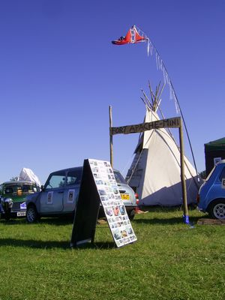

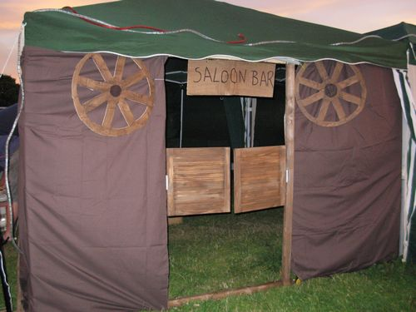

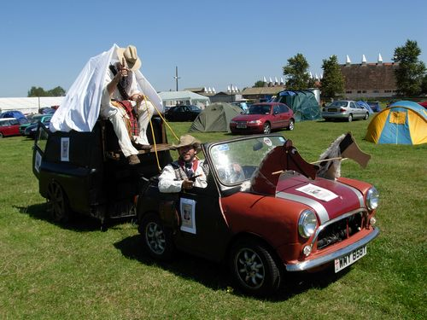

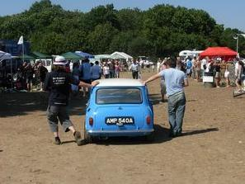
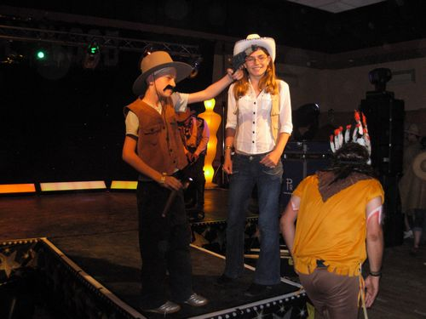

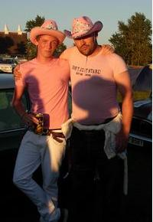

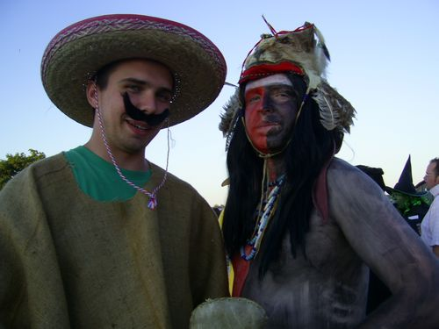
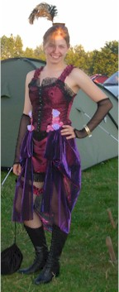

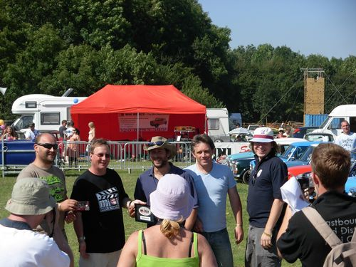
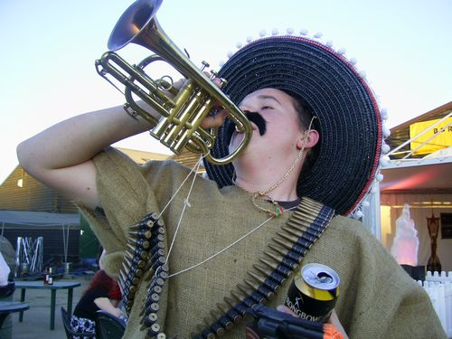
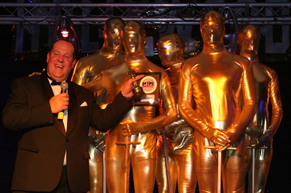
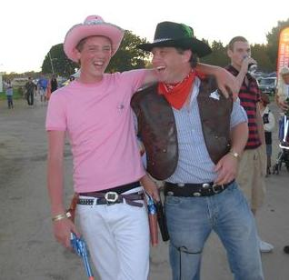

Dave’s Page – Events Co-ordinator edmceventsco-ordinator@fsmail.net
-------------------------------------------------------------------------------------------------------

Castle Coombe REMINDER:
August club meet is the last chance to book your Castle Coombe racetrack passes. Please bring your money to secure your pass. Track passes are £15 each, but others can be purchased through the club or direct from Castle Coombe at a higher price. Please see/contact Dave (edmceventsco-ordinator@fsmail.net) for more details.
This is a recommended event by many. All cars need to be road worthy & crash helmets are required on the track (which can be hired from Castle Coombe). Priority will be given to club members so also make sure you have valid membership! Free entry passes are also available.

Laughton Country Show
This show is a local event held at in Laughton, just off the A22 near Ringmer on 8th & 9th September. It is a large local show with exhibits of all kinds & is a great family event. Entrance is adults £7, kids £3 or £17 for family of four. Though if you would like to exhibit your car with the club, admission is FREE for the weekend!
Deadline for bookings is August 20th. Please see Dave at the club meet as he will need names, addresses, reg numbers, & vehicle details are also required as well as your EDMC membership number. Camping is available overnight Saturday.
For more details on the show, visit www.heritagefield.co.uk/whatsonlaughton.html
Mini in the Park – Santa Pod
Held on Sunday 19th August at the famous Santa Pod drag strip. Arrangements are still to be made for a convoy to go there on the Sunday morning. Keep your eyes & ears open as more info will be available at the club meet & on the forum. See www.miniinthepark.co.uk or www.santapod.co.uk for full event details.

Worthing ‘Minis by the Sea’
This is a free event held on September 2nd, on the lawns at Worthing. This is a laid back event; a case of park up & chill out! Take a walk on the prom, check out the other minis on show or go into Worthing for a bit of window shopping!
However, take your own food & drink, as there are no catering vans available at the venue.
For more information, please see Dave at the August Club meet.

Italian Job cruise – 2nd Sept.
If you’re not going to Mini’s by the Sea,’ Steve Medhurst has a navigational cruise, raising money in the name of the Italian Job, fund raising for the National Childrens Homes (NCH) charity. He has plotted a fun route through the heart of Sussex; maps will be issued on the day & the day will include:
11am Beach Head Pub, Meet up and cola.
12pm Farmers Pub, Scaynes Hill, for nibbles
2pm Hever Pub, Next to Hever Castle, for a chin wag,
3:30pm Filching Manor, Nr Eastbourne
[Optional Tour of the private Campbell Motor Museum £3 and Go-Karting £10 for 15minutes]
5:30pm Star Inn, Normans Bay, for a Cavery at a special price of £4.99 pp.
Please feel free to join in at any part of the route or even just part of it! Miniworld have also been invited to join in the fun & take pictures.
Any enquiries contact Dave or Steve himself at stevemedhurst3@hotmail.co.uk
Other dates for your diary
Festival of Transport ~ 25th – 27th Aug
Goodwood Revival Meeting ~ 1st – 2nd Sept
Jim & Shirley’s Rampage ~ 14th Oct
EDMC Committee meeting ~ 3rd Dec
EDMC AGM ~ 10th Dec

