
* EDMC Newsletter *
April ‘08
Issue # 21

“You shall go to the ball…”
As part of the clubs efforts to raise money for the Mini Pilgrimage, Lisa has been organising ‘mini chauffeur’ bookings with a local school for year 11 students wishing to arrive at their prom venue in “style”…. A mini way!
We are looking for mini owners to volunteer, polish up their pride & joys, and join a convoy round Eastbourne picking up the students along the way. Already there are 10 confirmed bookings for the 26th June. The students are asked to donate £10 per car for the Pilgrimage and also could have the option to choose a colour mini that matches their outfits! Ribbons, bows & other fancy stuff is being organised for the cars to make it bigger & better!
If you can help out & enjoy a fun drive round town – whether you volunteer as chauffer or just join the convoy for fun, please contact Lisa (edmcsocial@fsmail.net).

Departure Plans for Riviera Run!
Leave times are as follows: Meeting at Newmarket Lay-by on A27 around 4am – in order to leave by 4.30am no later. The basic route details will be issued before set off. Planned stops are as follows; Rownhams services, Bridport, Exeter M5 services & possibly on A30 for quick fuel stop.
Dave will be collecting phone numbers at April meeting so that an emergency list can be provided for the journey. However it is recommended to make a small investment in some handheld radios for quick communication and general chit chat along the way!
For those who may not make it to the April meeting, please contact Dave via the forum or e-mail (edmceventsco-ordinator@fsmail.net) with your phone number & he will keep you up to date with any changes to the plans.

A great ‘Spooky night’
For those who went to be ‘spooked’, the evening was not a disappointment! Although windy, the walk round Pevensey Castle guided by the ghost telling historian was thoroughly enjoyed by all! Thanks to Lisa for organising, hope to do it again later in the year maybe!

BMC’s “Mini’s on the Wreck”

Last year’s event organised by local club Brighton was a blast, & this year they’re doing it again! To be held on Sunday 13th July (with camping overnight on the Saturday) at the Adur Recreation Ground, Brighton Road, Shoreham-By-Sea. Show kicks off on Sunday 10am-4pm.
This is a non-profit making event with all money raised going towards their chosen charity, the Chestnut Tree House. (For more information on the charity visit www.chestnut-tree-house.org.uk) There will be lots of entertainment in store & plenty to do, buy, watch & play!
Entry is £7 per car. The camping on the Saturday evening is free for those who want to start the party early! For more details, please contact Faz Scrivens at faz@brightonminiclub.co.uk, Tel: 07875 284076, or visit the BMC website (www.brightonminiclub.co.uk)
Additionally, if you would like to enter your mini into the Show’n’Shine, e-mail colm@brightonminiclub.co.uk for more details.
Non-smoking sweepstake!
Well done Rachel for her no-smoking marathon, which she decided to use to help raise funds for the Pilgrimage run – raising funds for the Lee Sparks Foundation. There is currently a sweepstake on for which day she may succumb to the ciggies: previously, her track record for giving up was no more than 5 days – though as of printing, she is on day 33! She started at the age of 14!
You can track her progress on the forum under ‘Mini Diaries’. The sweepstake involves placing a £1 on whatever day you think she’ll give in, between now & the Pilgrimage (29th June). The winner receives half of the kitty, with the other half going towards the charity.
Please help support the Pilgrimage & equally Rachel! Thank you.

Brooklands Mini Day Report
What started as a wet morning, the first mini show of the year was brightened up with a bit of sun & Mini fun on Sunday 30th March.
For the first show of the year there wasn’t as many stands or traders as usual, though we had a good 12 cars for the EDMC stand! After arrival & initial complicated set-up, it didn’t take long before people scampered off in search for some bargain tyres or cheap ‘bling’ for their cars. Daz’s new shiny dust caps were prey to thieving fingers whist other memorable moments included ‘Mullet Man’ stalking & my amazement at Tony saying no to a cup of tea!
The Brooklands motor museum was open as usual; sporting relics from bicycles to grand Prix cars, to WW2 fighter planes & of course, Concord!
With the threat of rain diminished, the organisers opened the ‘hill climb’ for those who… well… were allowed to! This year’s regulations ruled out all BINIs & under 21’s (much to Alan’s disappointment) only leading to 18 cars attempting the steep slope. Simon raced to be front of the queue in order to show the ease of which his MPI Balmoral could do the hill!
All in all, it was a good day out, with some members heading off early on their own steam, the rest of the group packed up around 3.30 & set off on the Sunny journey home… which was interrupted with a tad of rain (note for Daz – make sure your poppers are secure properly before joining the motorway!)
(Pictures from club members)

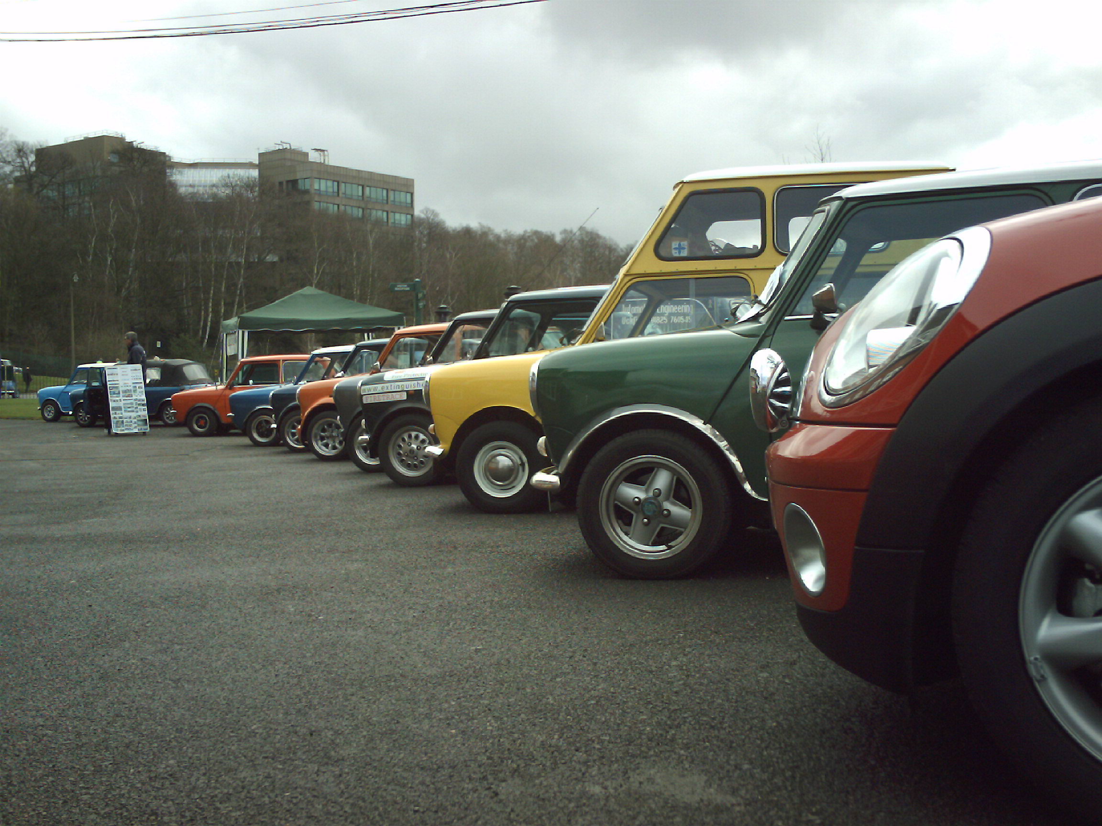
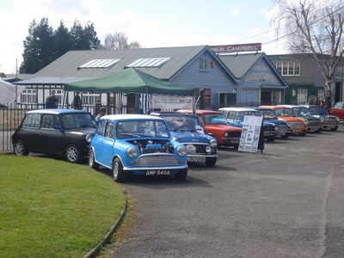

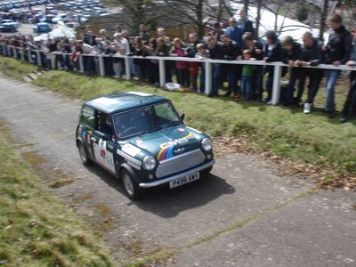

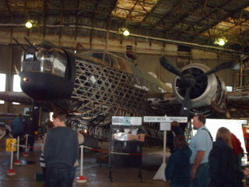

June Club meet date change!
The June meeting will now be held on Monday the 2nd rather than the 9th as previously planned, due to the Happy Jack’s bar not being available for us.

Basic Training Session –
12th May No.1
At May’s club meeting (after Daz’s usual chat) we will be holding our first ‘Basic Training’ Session on “Tools, equipment & suggested literature”. This will be held inside the bar (probably in the corner out of the way) & will consist of the following items:
- Recommended tools & importance levels
- Recommended spare parts to have at home & in the car,
- Recommended books to have (incl. examples)
(The above items will also have estimated costs)
Session number 2 will be held at June’s club meeting (outside weather permitting) – titled ‘Survival Crash Course’; which will include jump/bump starting & changing wheels.
For more details on each session, please see forum link, or speak to Josie (or another committee member). Those who have filled out a details form will have the full Basic training planner sent to them.

International Mini Meet
Leaving times & plans

For those who are venturing further afield for the International Mini Meeting in Holland, the following details are for you!!
Friday the 9th May will be an early morning start! Meeting at 3.30am at the Little Chef on the roundabout at Pevensey on A27, in order to leave at about 3.35am. Heading for Hastings where you’ll make another pick-up point at Glyne Gap Retail Park at around 3.50am. It’ll take a couple of hours max to reach Dover ferry port in order to catch the 6am crossing to Dunkerque.
Although the pre-bookings are closed, it’s still not too late to tag along so more are welcome if you fancy the last minute holiday abroad!
Simon will be going through details at the April club meeting. If you cannot make the meeting, or for any more details on the trip, please see the IMM thread on the forum, or contact Simon (AKA Mininutter) via PM, e-mail (edmcwebeditor@fsmail.net) or on 07717267252.

Have you seen this car?
Lost - E738 HRE

“She wasn't pretty, but she was mine!
”I'd been storing this car at my Mums place, (you know the idea, big plans of a full resto but no time or money to make it happen!!).
”Now my mum is getting on a bit and when two nice young lads came round and offered to take the car away she managed to forget that the car actually belongs to me and let them have it.
”Does anyone know what has happened to this car? It's a bog standard 1987 Mini Mayfair, in blue, I believe the colour was called Moonraker Blue.”
If you have any information, please contact ‘Tiz’ via the EDMC forum, or any committee member. Thank you.

Magnificent Motors – 3rd/4th May

For those who aren’t making the trek to the far West, there is another more local show EDMC needs to be represented at. Mag Motors will be held on the Lawns on Eastbourne Seafront, on the 3rd & 4th of May. Steve Medhurst is organising the club stand & will need names & contact details, including volunteers to help put up the marquee. Further information about the event will be discussed at the April club meeting, with details to follow on the forum. Contact Steve if you are able to attend one or both days & help out in any way. (stevemedhurst3@hotmail.com)

Winter in Spring? Your Snow Scenes!
With the temperamental weather changes in this country, its hard to predict at the best of times when to work on the cars! Here are a few ‘Snowy Pics’ from EDMC members from last Sunday!

