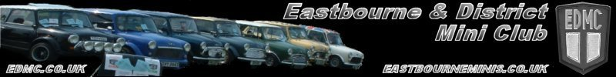
Apr ‘09
Issue # 24
* E D M C Newsletter *

Hi, and welcome to April’s newsletter. The season has now officially started with Brooklands a couple of weeks ago. The club flag had it’s first outing and certainly got us noticed!! There are a few events coming up before the May meeting - Riviera Run and Eastbourne Magnificent Motors are on the May bank holiday. Hope to see you at one of these.  If there is anything you would like added to future newsletters, please contact me on the email address at the foot of the page.  Happy Easter  Tony  Pilgrimage Table sale  As some of you are aware there will be a table sale held at Polegate community centre on April 20th from 9am till 12am.We are looking for volunteers for this event but if you have not got the time to help out could you please search through all your junk and see if there is anything worth selling.  This does not have to be mini related it can be any thing from baby clothes to books etc.  All proceeds will be going to our chosen charity for this year children with cancer. I am sure you would all agree this is a very worth while cause and as a club any support you can give will be very welcome.  If you have got anything you want to donate and can’t get there on the day you could always drop it round to Rachel’s house as we got no room to move anymore anyway. | Brookland the flags first outing  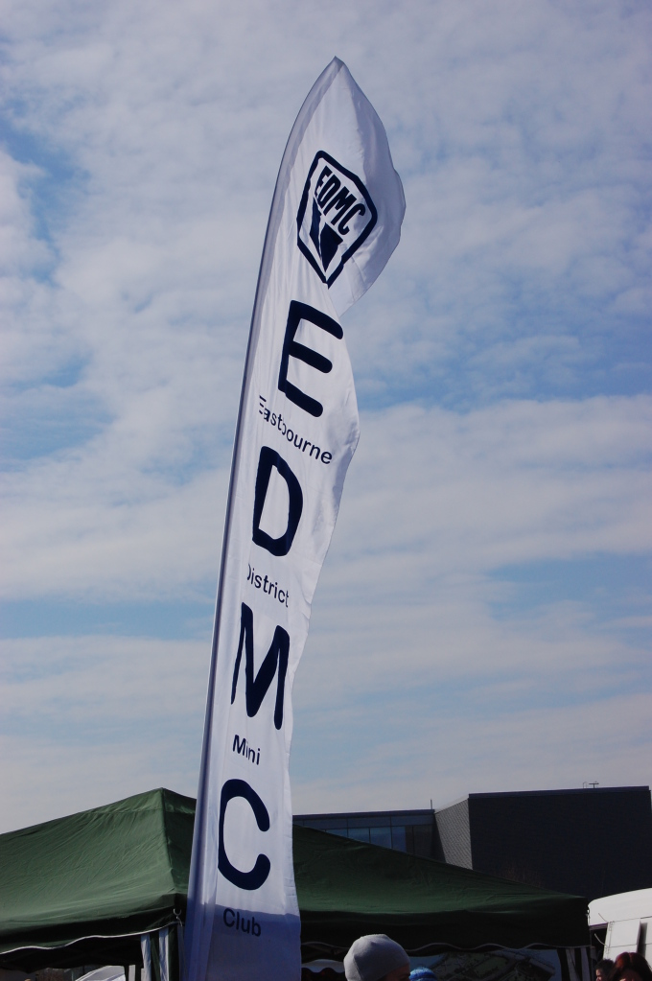

Page 1
E-mail: edmcnews@fsmail.net

Brooklands  .  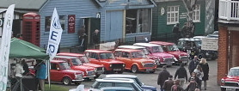  After much deliberation and good hearted banter as to what time to meet and where, amazingly fourteen mini's appeared at the Newmarket lay-by around 08.00 am on the Sunday.  It soon became clear that the early-birds were the older members who probably hadn’t been out the night before and by the time Sarah arrived as number thirteen the eyes had gradually got blearier. Having said that, the overall winner of the bleariest eyes of the morning has to go to Steven when he did eventually turn up at Brooklands.  The weather turned out really nice after a frosty start with plenty of warm sunny spells and just a couple of showers of drizzle.  It was a nice feeling taking up two lanes of the M25 with minis from other clubs converging on Brooklands at the same time.  Once in I think we got as many as twelve or maybe more onto the club stand which was a bonus. We then put up the Gazebo and the all important first erection of the new sail banner. Very impressive it looked too although a couple of teething problems need sorting out (nothing serious).  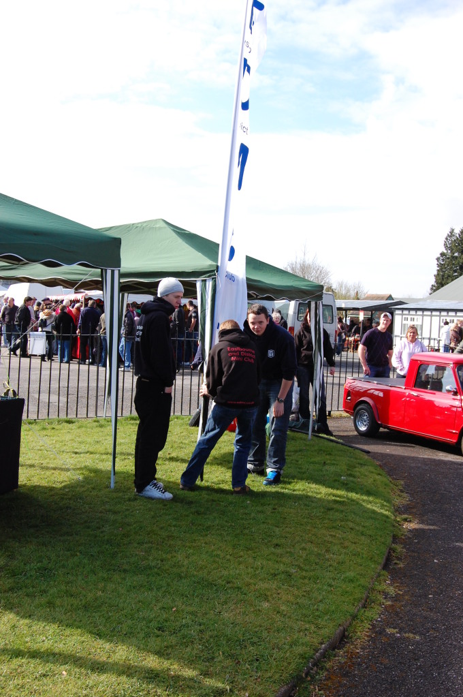  At least it did not blow away this time! | There was a really good turnout overall and a few new over-winter projects had there first outings.  Paul (1275s) was the only EDMC member brave enough to tackle the test hill and a respectable run it was too.  Traders were a bit light on the ground but a few bargains were to be had as usual at most shows.  All in all everyone appeared to enjoy what was a nice relaxing show and a good run out for the cars.  Kind regards to John ( 3pops ) for the write up and Gareth( Garfie ) for the Pictures  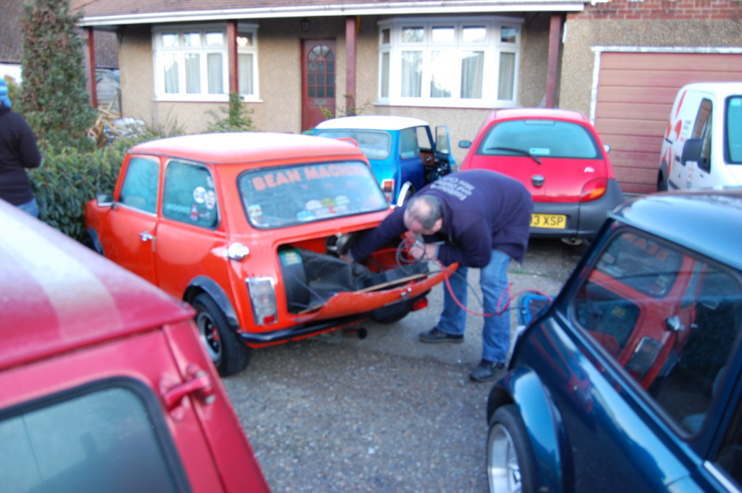  You are going to have to teach Alan how to use jump leads Jim.  And Finally……………..  Well done to all those that took part in the rolling road last October, you did the club proud and moved us up to 4th in the mini world power test league. Gonna take some beating to knock us off of there.  Don’t forget to keep an eye on the forum for all the latest news and updates. www.edmc.co.uk

