
It’s a never ending story…
* EDMC Newsletter *
We’re mid way through the summer & it’s not over by far! There are still events to attend to shouting the EDMC name, letting the Mini world know we’re here! So please show your support and sign up for events before the summer is out. Remember, if you want to promote or shout about the event, just drop me a line, PM or catch me at the club meets or events. Also, I try to take lots of photos at the events I can get to, but cant print them all so if your looking for any just ask & I may have what you’re looking for! Cheers!
Regards, Josie.
Southern Mini Days – 4th-6th Aug
EDMC will be invading this year’s ‘Southern Mini Days’ at the Hop farm in Kent. Money & and numbers need to be given to Rachel so she can book our placement as a club, however, we are not doing a club stand as such. Instead our camping area will be our club stand! As there is a glow show over the weekend too, bring your fairy lights & coloured bulbs to decorate the area! The weekend promises to be lots of fun and a good laugh, especially as it’s 60s theme, so you’ll need your fancy dress items too! We are planning to set up a club BBQ on the Saturday night with our own music & entertainment! Cost for all weekend adult is £12 (£14 if paying at the gate from Friday 4pm)£7 child (£9 at gate). Day tickets for Sat or Sun £7.50 adult (£8.50 @ gate) & £6.50 child (£7.50 @ gate)
For more details on the event talk to Rachel or visit the EDMC forum.

Hastings Summer Fete – 16th July
More Info on the Hastings summer fete, from Alan (Bean Machine), raising money for helping the scouts with their Duke of Edinburgh awards:
Basically there is going to be a mini raffle where you will need your car to enter. There will be prizes of course for winners. There will also be 2 bouncy castles & lots of other things to see & do as well as admiring minis from all over Hastings! The event is being held at William Parker school Hastings at 11am-4pm on Sunday 16th of July.

Events coming soon…(plus organisers)
- 16th July – Brighton Mini Club Show – ‘Minis on the wRECk’
- 4th to 6th Aug – Southern Min Days, Hop Farm, Kent (Rachel)
- 13th Aug – Worthing ‘Minis by the Sea’ (Dave?)
- 20th Aug – Mini Magazines’ ‘Mini in the Park’ (Simon?)

Hastings Cruise & Fish Supper!
Rachel & Tony are organizing a mini cruise to Hastings via the nice windy country roads to end up at the sea front at Hastings, just in time for fish & chips for dinner!
If the weather is good there’s a possibility of invading the amusement area for a spot of crazy golf and a few laughs along the way. Of course there will be plenty of pubs with outside seating for the alcoholics who want a drink and aren’t driving!
The 30th July has been penciled in for the event. If you are interested in taking part please let Rachel or Tony know, (e-mail edmcsecretary@fsmail.net). Depending on numbers, parking is still to be debated (although we know of one EDMC member with a drive…Jim! ☺ )

Worthing ‘Minis by the Sea’
This event is set for the 13th August. Details are still to be announced but if you are interested in attending let Dave know (see contact detail below)

Mini World Action Day @ Castle Coombe.
Dave (Monkeyjim) is looking for numbers for the 30th September show at Castle Coombe racing circuit. It will be £10 per adult on the day (£8 for advance bookings), under 16’s free. To go on the track itself (not compulsory) is £30 on the day (£25 in advanced) for a 15min track pass and then £15 (£10 in advance) for 3 parade laps behind a safety car. On the track crash helmets are compulsory & can be hired from Castle Coombe. If you’re not interested in the track, there are other activities for kids & plenty of traders for all the ‘bling’ & useful parts!
For more information, visit the EDMC forum under events, or chat to Dave
(edmceventsco-ordinator@fsmail.net)

The Mini Pilgrimage:
A personal account!

The Mini pilgrimage started off with a Bang!…well, lots of drink & BBQ food anyway, provided by the organizers and hosts; Rob & Helen. The next day with heavy heads after the night before (mine mainly) we set off early to start our fund raising Pilgrimage from Eastbourne District General Hospital onward to Canterbury. A good turn out of 13 cars arrived to pose for the camera & ponder over the route maps & quiz.
We set off in groups out of Eastbourne up towards Battle via Wartling & Pevensey; along route trying to answer the head scratching quiz. The drive was great with lots of fun mini windy roads!
From Battle, the route took us though the country side of Sandhurst & Newenden, up towards Tenterden & onto Biddenden Vineyard where we stopped for a bit of Lunch, a walk round the vine fields & a nose round the shop full of cider, wine & country food. All the minis arrived safely, apart from Daz & Mingie3, whose brakes had started to seize & out of all the drivers, no one had the right tool at hand! D’oh! The line of minis in the car park showed interest by other visitors, although the view was spoilt by the Lotus Elise parking in front of them (& yes, I know I’m not allowed one!). Anyway, the Vineyard staff made us quite welcome by feeding & watering us before starting up the minis & having to set off again on the last stretch of the journey to Canterbury.
From Biddenden vineyard the group headed for Canterbury…after doing an impressive ‘U’ turn half way up the road in the wrong direction…towards Bethersden, then Ashford & heading into Canterbury city. It was at this point that we remembered there was a prize for getting there first, so Simon & I (with co-driver Mumsies) had it in our nature to fulfill the challenge…so left everyone behind! (Sorry to those who were trying to follow us!)
After arriving at Canterbury & Kent Hospital greeted by Helen, all the minis rolled in gradually & the party were refreshed with tea, coffee & bubbly to celebrate a great day out!
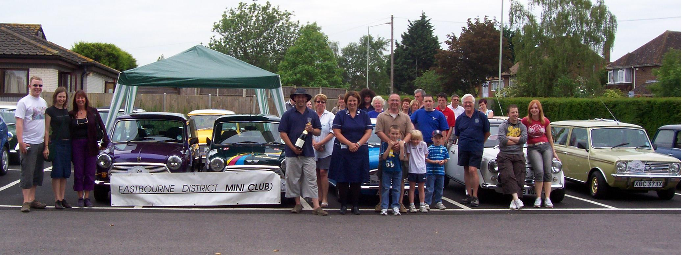
Mum & I scrapped a win by one point over Ian & Gabriel on the route quiz, whilst Simon & Viv won the first to arrive prize (☹) and the prize for the most money raised went to Alexandra, well done! Daz received the ‘Mni with character’ prize due to his brake failure & no one wanting to drive in front of him, although I think any mini Daz owns has a certain ‘character’!
The rough total raised by all for the two hospitals
was a great £1200, with still more to add up!!!
Although there wasn’t much support from the
local papers & news as we hoped,
the main support came from the teams themselves, which made it a great day, and especially the organizers themselves! So a BIG thank you to Rob & Helen for putting the event on, we hope that next year will be as good and more successful next year!

For more information about the Pilgrimage or photos from the event, visit the EDMC forum or e-mail me at the address below.

[Just so people aren’t disappointed with the review…yes I did get very drunk the night before & yes I was feeling S**t the next day!)

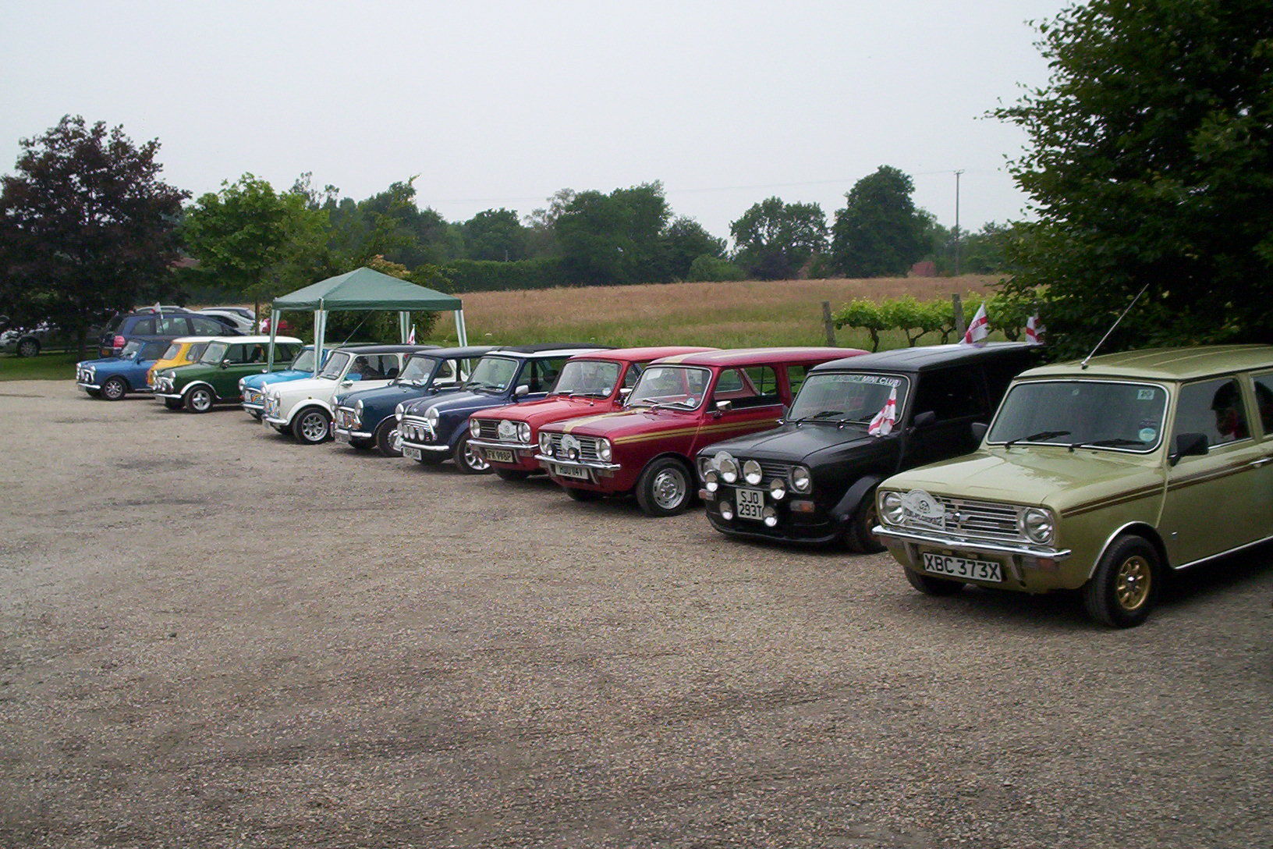

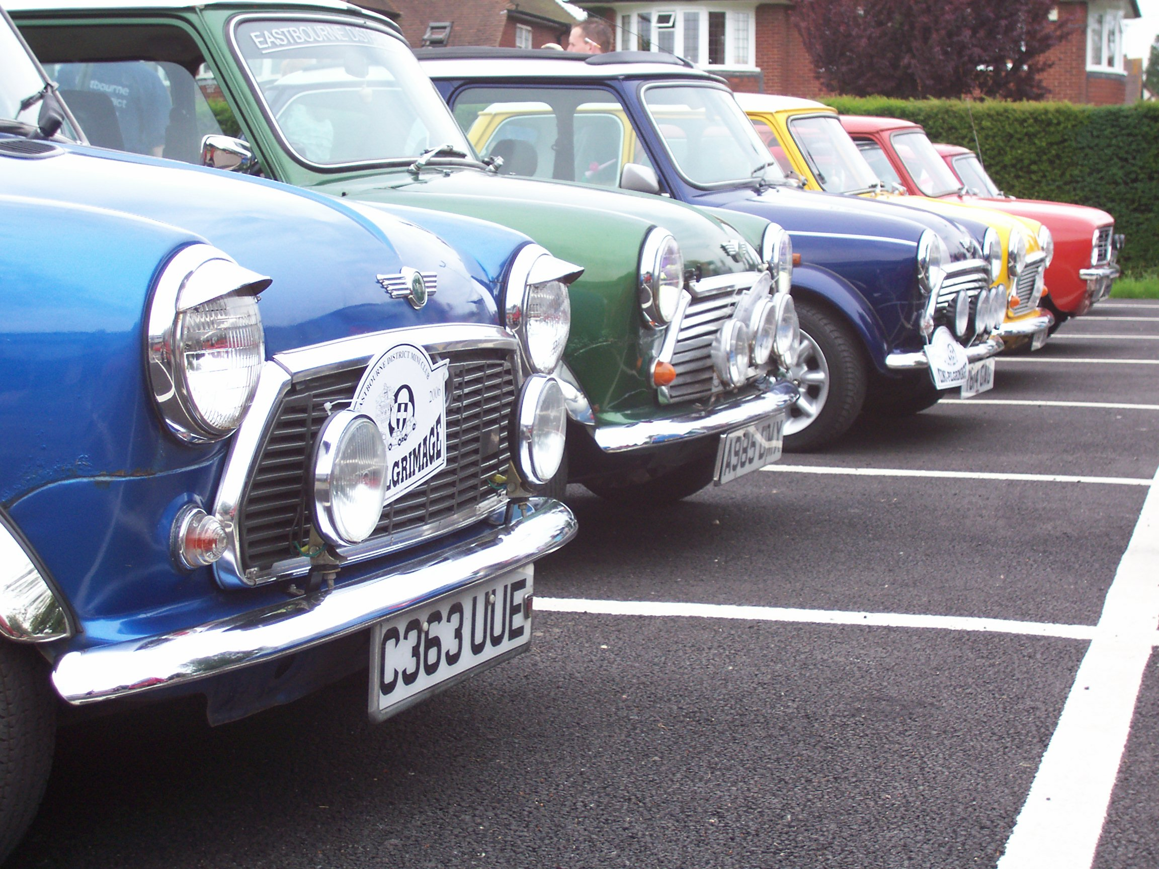

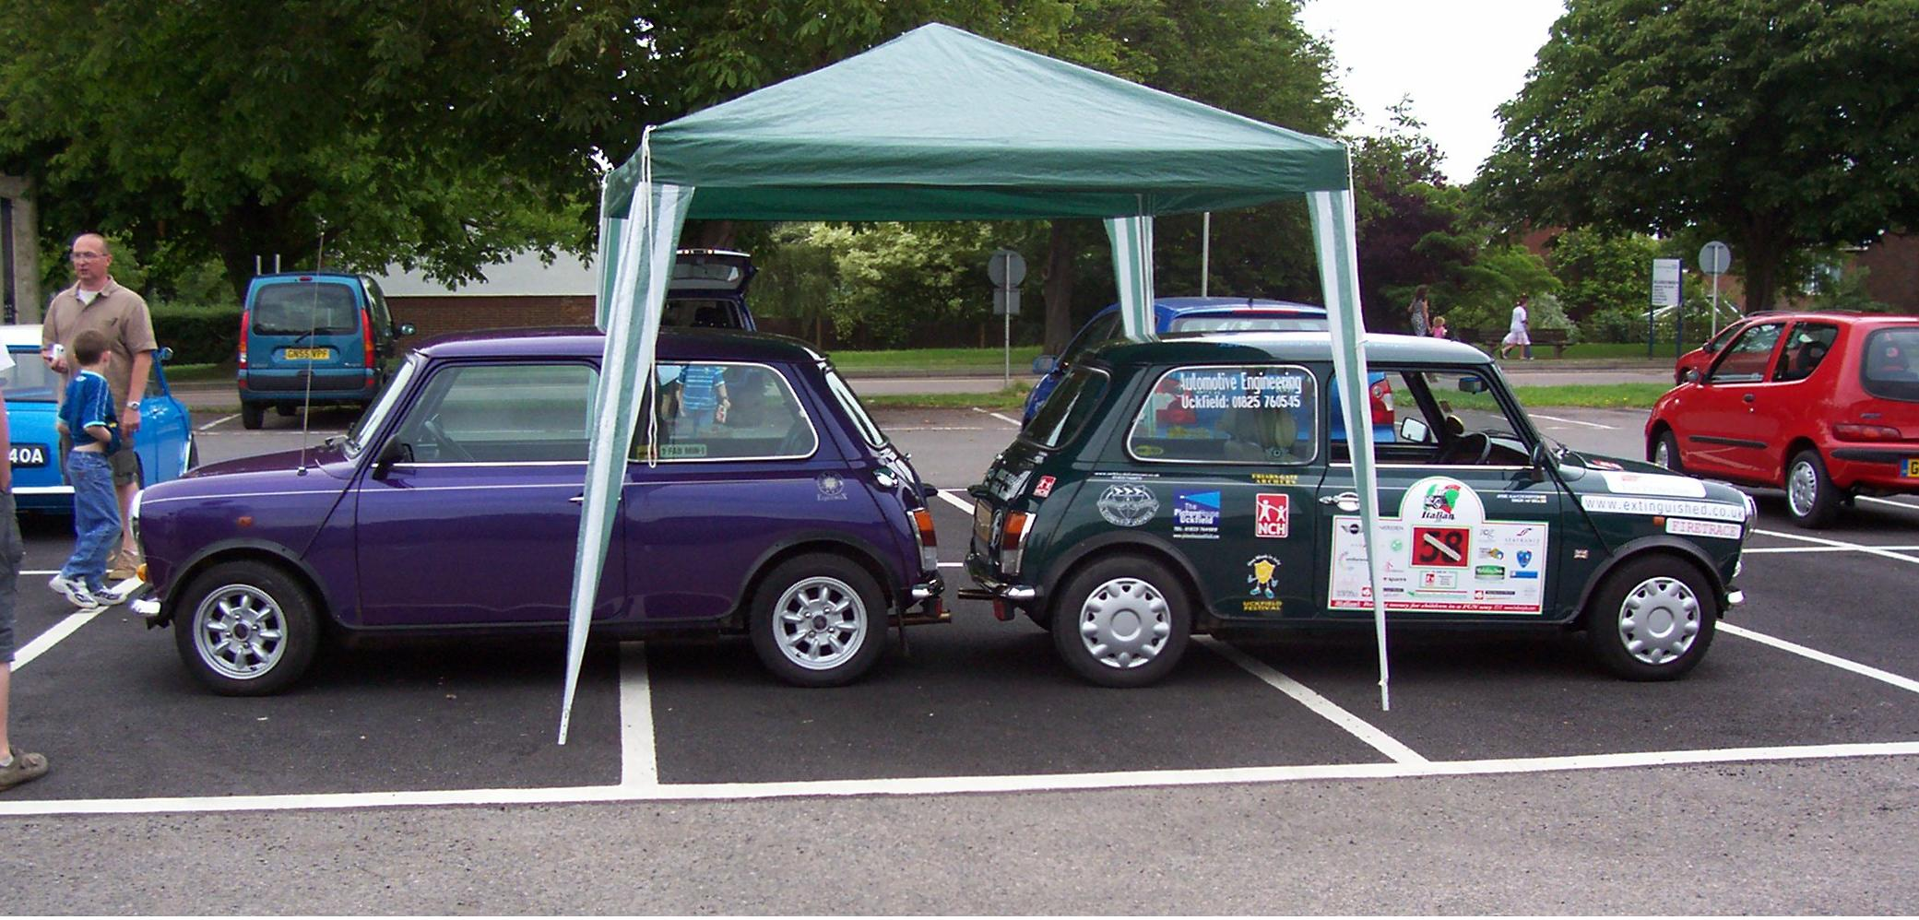

Cooper Days at Beulieu:
An account of the day, Sunday 11th June

The day started at a very weary 530am we all got up & got ready for the day, sandwiches, cold drinks & sun cream packed into the cool box with the frozen ice packs. Go out to the garage move cars around so the mini is ready, check oil, water & park on the road ready. Off we go to the petrol station fill up & continued to the rendezvous to meet the unknown (wasn’t sure who was coming).
When we got there we saw Jim, his clan & a very despondent looking Daz …all looking as if they wished they were in bed still! I asked Daz what was wrong, he replied Mingie was not well, she was over heating!
I took a look & assessed the timing was struggling to keep up with the revs due to the vacuum pipe being off. I loosened off the dissy & got Daz to start the engine, then reconnected the vacuum pipe & raised the revs to about 3k & peaked the revs by rotating the dissy found the peak & advanced by a degree, tightened it off sorted checked the water & topped up with coolant. Now the engine can respond to the rev range with the advance retard connected should reduce the over heating. (Handy tech info for you!)
Dead on 7 o’clock we headed off to the new forest.
It was a pleasant drive with no problems sometimes peaking at a cruise speed of 70 or so.
We arrived at Rownhams at about 9 am & all retired for a leisurely breakfast and coffee. We then set off refreshed & topped up our fuel on route. We arrived at Beulieu around opening time of 10am & parked up.
A good day was had by every one with no complaints, the bar was too inviting for quite a few of us & we partook in a nice very cold refresher, during what seemed like a very hot day!
We saw the Scrapheap challenge crew there doing their filming which was a real treat. We all at some time purchased some kit of some kind from the stands at the show; the commentator stated it was a record turn out with excess of 2000 cars. After lunch in a shady part of the field we then went to the motor museum.
We all left at around 5-ish & there was a small smattering of rain so Daz put his top up, funny really as we had fixed his heater to dissipate heat from the engine so the poor bloke was cooking in his car!
We all stopped at Rownhams again for a caffeine boost & fuel (bloody good stuff that double espresso!!) then set off for home. We all had a good trip home with no adverse events having had a completely successful day out at Beulieu!

Write up by Shawn ‘Aka Minibizz’
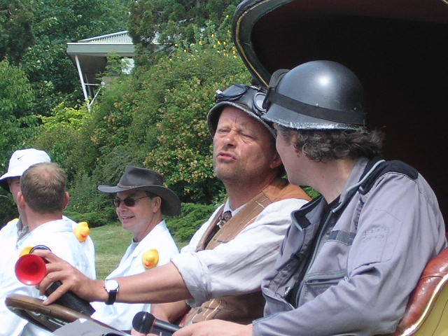
(Picture from Sarah, AKA ‘Hank the Tank’)

Uckfield Festival
Acoustic Evening - Friday 14th July
I know it’s not anything to do with Minis, but I though as there was space on the page I’d plug my Acoustic Evening event, as part of the Uckfield Festival 2006!
The Festival has already started but there’s still lots going on. This is the 5th year myself & my friends have performed an evening of acoustic music; some covers & some own compositions. This year I’m not playing as much as before but there is some great local young talent to see & hear! So if you are at a loss for something to do Friday, you know what’s going on! ☺
For more information on the Uckfield Festival, visit www.uckfieldfestival.co.uk

EDMC events to be organised:

Rolling Road Day – Possible 'Shoot Out' between EDMC & Brighton, for the MiniWorld Magazine

Go-carting day - at Filching Manor?

EDMC Photo shoot – to get some new photos for the club.

