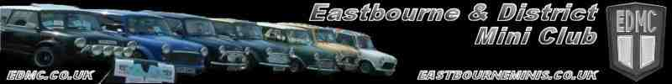

The long awaited show season is fast approaching with our first show being brooklands on Sunday the 28th march 2010. This has always been a good show with a large turn out of minis and a fantastic motor museum which is well worth a visit. Also a large selection of planes all this and more is spread around the legendry brooklands race track.

This year they will be having a special display of the Van, Traveller and Countryman vehicles in the Paddock outside the Clubhouse as this is the 50th anniversary of these vehicles.

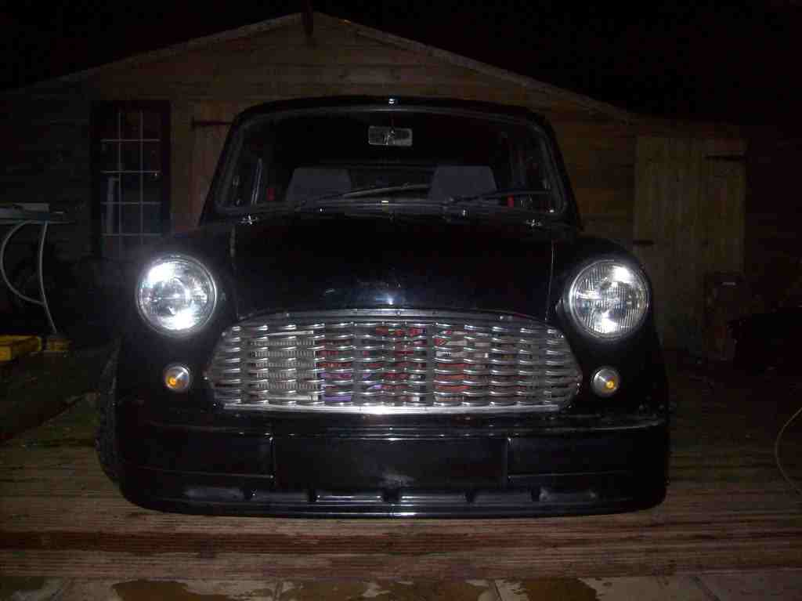
They are also having their first show and shine with prizes for the top two cars in each of the nine classes, as well as a prize for the MiniWorld car of the show.



PILGRAMAGE

Unfortunately this year Brighton mini club have decided to hold their annual event on the 27th June, the same day as the pilgrimage. This may affect our numbers this year, so as much local support as we can get would be appreciated.

For all updates please visit the pilgrimage news updates at www.edmc.co.uk

FIVE YEAR PROJECT

Congratulations to matt for completing a five year project and now he has his mini on the road.
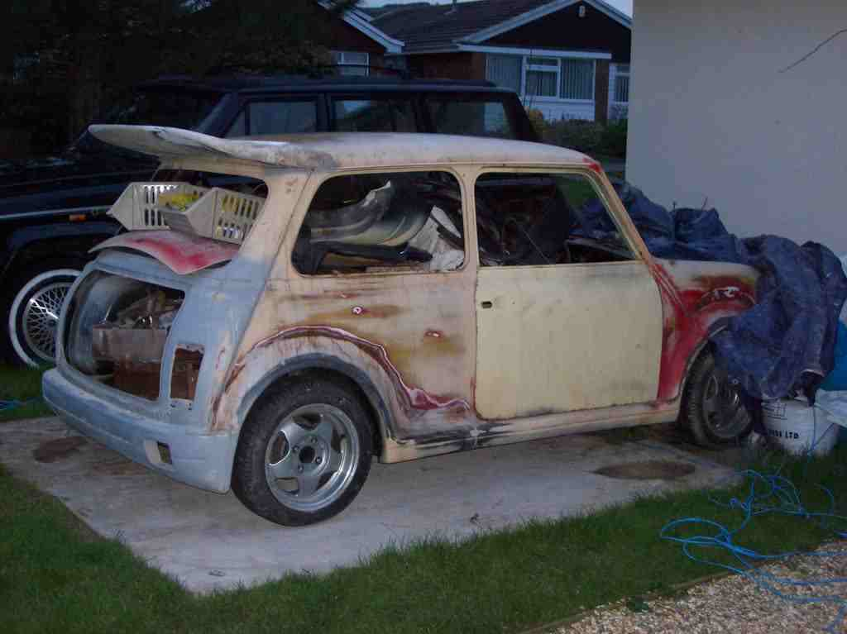

RIV RUN

Riv run is under final preparation. Please ensure your mini is well maintained, as it’s a long challenging drive and would go smother without maintenance problems. If you require any further info on this event please speak to Dave.
Congratulations to Kate and Tel winners of the free entry tickets and Gareth winner of the caravan.

NEW MEMBERS

New members will soon be welcomed with a welcome pack. This will include
A free gift
Relevant info about club
Committee contact info
And a news letter
Memberships are 5 pounds and additional members can be added for a small fee. This is to cover the club insurance.

ROLLING ROAD DAY NOV 2009

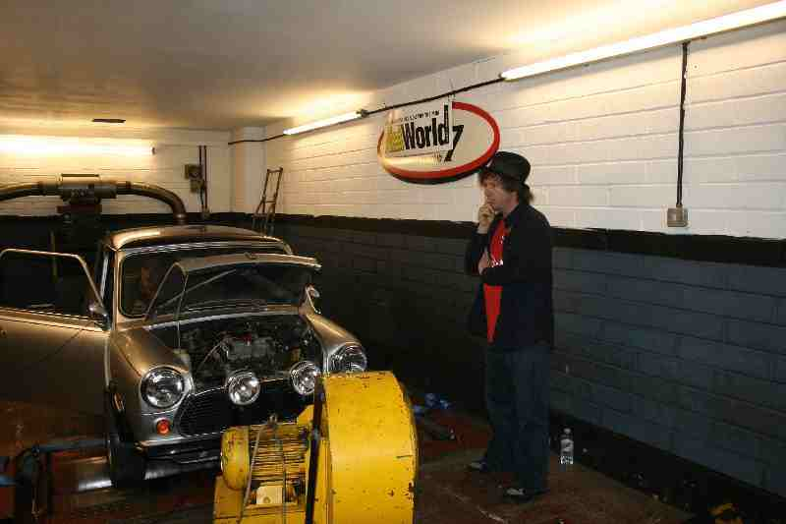
The rolling road day was a great success
and a good day had by all at Gerald dale motor sports. I have been informed that the results will be in mini world mag May issue out in April.

NEWSLETTER TOP TIP

Rubber suspension cones should be replaced approx every 7 years due to wear. Your mini could be riding lower than intended or even on the bump stops, causing damage to other components. By replacing worn cones you dramatically improve the ride and handling of your mini. Always buy genuine cones as aftermarket ones have a tendency to collapse and fail.
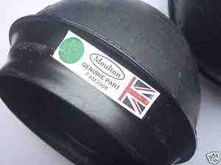

LONDON 2 BRIGHTON

London 2 Brighton last year was a great success for edmc being double winners. This year the theme is silver and we are open to all suggestions on how to dress the club stand. Please post ideas on the member’s forum. To access this and guidance how to get there, please contact a committee member with your membership number, as this is only available to paid up members.
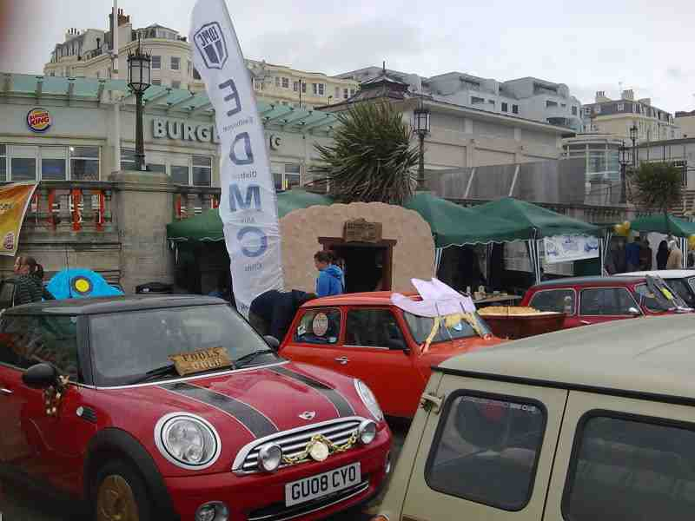

PROM RUNS

Lisa is organising the club to do some prom runs this year. Last year this event alone raised 200 pounds for our chosen charity and was a great success. If you would like to be a part of this, this year please speak to Lisa.
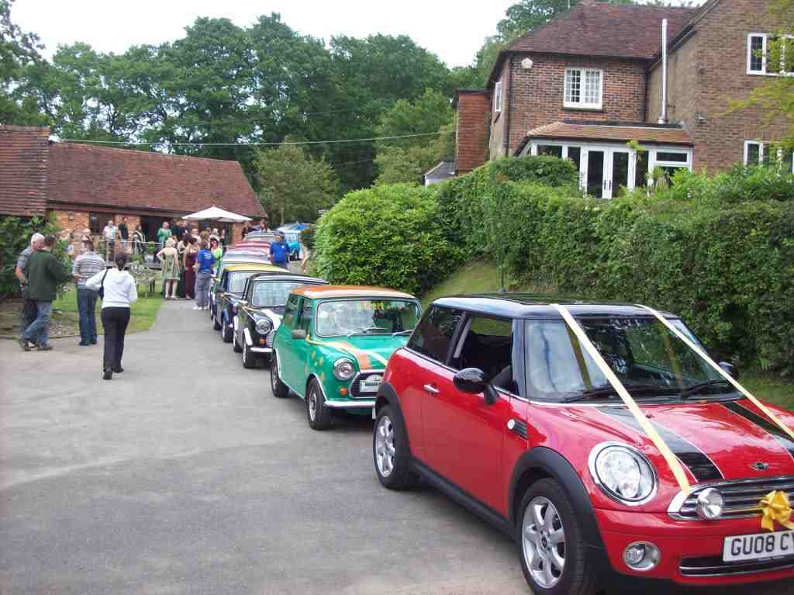

NEWS LETTER INFO

As I can’t get to all shows over the coming season it would be much appreciated if I could have some pics and a few words about the event you attended. Please send to -

edmcnewsletter@hotmail.co.uk

